**5 PNM USING UPSTREAM EQUALIZATION**

**5.1 Reactive versus Proactive Network Maintenance**

In this document, the definition of reactive network maintenance is a stringent one and, in the era of multimedia, business and advanced services, is perhaps one that the cable industry should follow. Reactive network maintenance consists of network maintenance practices that are initiated by metrics which show service performance has been impacted. Under this definition, it is not assumed the need of customer feedback/calls for network maintenance to be reactive. As long as conditions such as FEC statistics, power starvation, CPD, narrowband interferers, laser clipping, impulse noise and other service impacting symptoms are detected, the response to such is reactive. In the case of distortion that is completely corrected by pre-equalization there is no performance impact, therefore maintenance actions that arise from these impairment discoveries are considered to be proactive. If there are symptoms that combine performance impacting conditions with distortion detected through equalization, the maintenance that arises from it is still considered reactive.

Impairments that result in network maintenance classified as reactive would likely be given higher priority for resolution because they are already impacting performance.

In most scenarios, upstream pre-equalization mechanisms can completely compensate for certain problems in the network and no symptoms are detected in FEC statistics or through other metrics. The fact that equalization can fully compensate for network linear distortion can buy the operator time in resolving the issue before there is service impact, thus enabling a proactive network maintenance strategy.

**5.2 Linear Impairments**

In the upstream portion of the CATV network there are different types of impairments. These can be classified based on the impact these impairments have on the signal as linear as well as nonlinear impairments. In the case of a “linear” impairment, the impact on the signal will be given by a change in amplitude and phase of the original signal. In the case of a “nonlinear impairment“, the signal generates distortion components, including harmonics of the original signal or multiplies the original signal with other energy present in the return band. For example, in the linear distortion case, transmitting information across the upstream channel will result in an amplitude and phase deviation for a given frequency point. A micro-reflection, which is analogous to a wireless multipath signal, could result from the bouncing back and forth of a signal between two interfaces that have impedance mismatches, generating an amplitude and phase distortion of the signal as summation of a time-delayed signal copy– the reflection or echo–combined with the desired signal. A second example of a linear distortion occurs at the diplex filter rolloff that marks the upper edge of the upstream frequency spectrum around 42 MHz. At this rolloff frequency, the amplitude and the phase suffer considerable distortion. In particular, the phase distortion is noticeable prior to reaching the band-edge. This phase distortion is more easily shown when expressed as group delay which is defined as:

*GroupDelay* = − *d*φ *d*ω

whereφ is the phase in radians, ω is the frequency in radians per second, and group delay is in seconds. Group delay is ideally constant across the band of interest. Group delay variation across the band is known

as group delay distortion. Additional discussion about linear impairments can be found in the tutorial material in Appendix I.

One thing to keep in mind is that even impairments that are considered “nonlinear” such as common path distortion (CPD) may have associated linear distortion elements. For instance, the corrosion of a center conductor that generates a mixer effect also results in an impedance mismatch that can generate a noticeable micro-reflection.

Examples of impairments that are nonlinear include the previously mentioned CPD, as well as composite second order (CSO) and composite triple beat (CTB) distortions, cross-modulation, and laser clipping. Ingress and impulse noise are considered additive impairments, although if an impairment such as impulse noise is high enough to cause laser clipping, it can be considered nonlinear in nature too.

**5.2.1 Micro-reflection Types**

The following sections describe multiple scenarios in which micro-reflections may be generated within the HFC network. Micro-reflection Example 1 describes a case where there are HFC components whose low return loss (R) values are contributing to the micro-reflection source. Micro-reflection Example 2 describes a case where an HFC component whose isolation performance and an impedance mismatch are contributing to the micro-reflection source. Lastly, micro-reflection Example 3 describes a case where the micro-reflection impairments represent a combination of the two previous cases. Micro-reflection sources are not limited to the examples presented here. For more information about micro-reflections, refer to the tutorial section of this document.

***5.2.1.1 Micro-reflection Example 1***

This type of commonly experienced micro-reflection is exhibited when the upstream signal encounters impedance mismatches somewhere in its upstream path to the CMTS, causing redirection of a fraction of the signal’s energy back towards the CM. Once the redirected signal becomes incident on another impedance mismatch, it is then directed back toward the CMTS. Figure 1 illustrates an upstream signal, labeled Upstream Signal #2, on the cable originating between two reflection points, Γ1, and Γ2. However, the upstream signal may originate anywhere downstream from the first reflection point, Γ1, illustrated in Figure 1 as Upstream Signal #1. The majority of the upstream signal passes through the impedance mismatch and continues toward the CMTS and is labeled Main Signal in the figure. A fraction of the upstream signal is reflected back towards the signal source at Γ1. This reflected signal encounters a second reflection point, Γ2 which reflects a fraction of the reflected signal energy back into the direction of the original signal, represented as Reflected Signal in Figure 1.

This general case describes the signal passing through two reflectors, neither of which is the CM itself. One technique to determine whether the CM is one of the reflectors is to add a 3 dB inline attenuator at the CM port (upstream output). If the micro-reflection magnitude is lessened by 6 dB or more, because of the reflected signal passing through the attenuator twice, then the CM is indeed one of the reflectors. If there is no significant change in micro-reflection magnitude, then the pair of reflectors lies remote to the CM location. This technique of adding attenuation would work equally well to isolate reflections elsewhere in the network, but it is much more difficult to install attenuation between line passives.

The reflected signal from Γ2 proceeds upstream and again encounters the reflection point Γ1. This causes yet another reflection back downstream, and the process repeats endlessly. (It is analogous to looking at one’s reflection in a mirror, when there is another mirror behind. There will be an endless sequence of images, each one progressively smaller.) Each passage between Γ1 and Γ2 is called a transit. The main micro-reflection echo results from the triple transit, up/down/up. The next echo is from the 5th-order transit up/down/up/down/up, and so on. This type of response, which goes on forever, is called infinite impulse response (IIR). It consists of a geometric series of echoes, separated by equal delays (equal to twice the propagation delay between the points Γ1 and Γ2), with each echo value smaller than the last (by the same ratio Γ1 Γ2 or, dB difference 10 log Γ1 + 10 log Γ2). The decaying micro-reflections may quickly be lost in the noise floor after two or three trips through the micro-reflection source.

Conversely, the adaptive equalizer response, which is approximately the inverse of the channel response, will have only a single tap after the main tap for this case.

Though the reflector examples in Figure 1 are feeder taps, it should be noted that many devices can produce similar results, including damaged cables or corroded splices, which are often causes of micro- reflections as well.

Note that the delay between echoes equals twice the propagation delay between the two reflection points Γ1 and Γ2, so the distance between the two reflectors is known. However it does not relate how far along the plant these two reflectors are, that is, the location of the impairment in the plant. To determine the location of the fault, additional information is necessary as described in Section 6.6, Fault Localization.

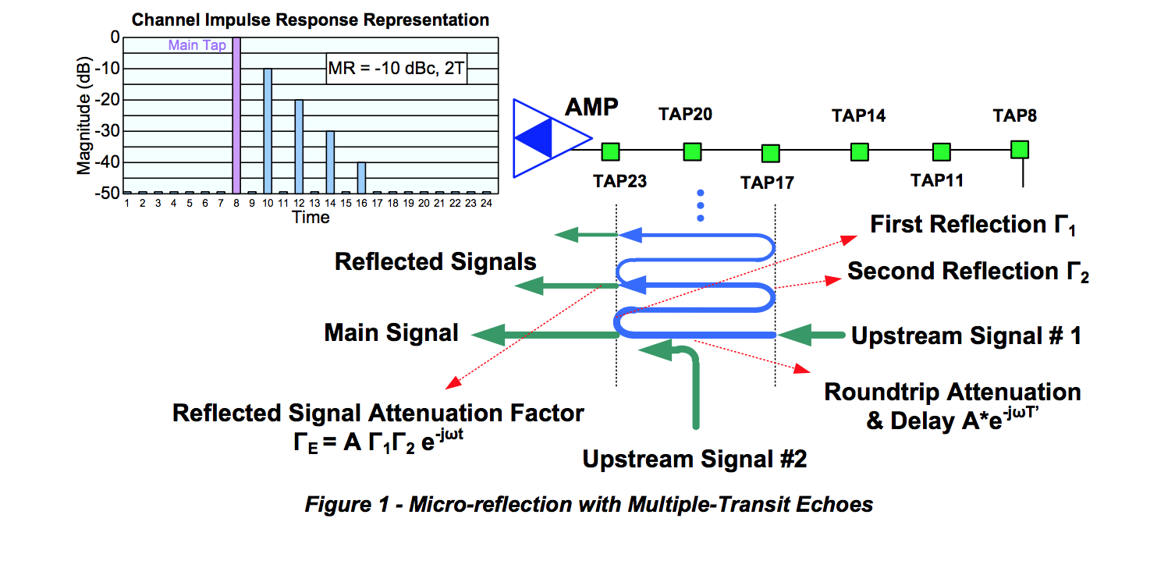

***5.2.1.2Micro-reflection Example 2***

The second type of micro-reflection may occur anywhere in the network, but its magnitude is most noticeable in CMs located off the highest value feeder taps. Figure 2 describes the upstream signal flow from a CM sending its upstream signal into the port of the 23 dB feeder tap. The intent of the plant design is that the primary path of upstream signal flow is toward the left of the page, toward the CMTS. Some signal energy may be reflected from the amplifier to the left of the 23 dB feeder tap, but this energy is usually insignificant because of good impedance matching of the amplifier.

The 23 dB feeder tap is a combination directional coupler and splitter meaning it directs the upstream signal in the upstream direction. The directivity of the feeder tap is not perfect. Some of the energy from the CM may be leaked towards the output connector. This is a function of the isolation of the feeder tap. Isolation is specified with all ports terminated, and cable industry field practice has often not adhered to terminating unused feeder tap ports. In addition, corrosion of the feeder tap can degrade its isolation performance.

If a 23 dB feeder tap has a tap-port-to-output-port isolation of only 38 dB, there would be two signal paths created, one with 23 dB attenuation, and one additional signal going the other direction with only 38 dB attenuation. If this additional signal meets a reflector downstream from the 23 feeder tap, the additional signal will be reflected back in the direction of the upstream signal and will be combined with the main signal at the 23 dB feeder tap where it originated. This micro-reflection is easily observed in cases where there is long un-tapped span of cable between the first feeder tap, the 23 dB feeder tap in this case, and low-value feeder taps with open terminations. All of these unterminated feeder tap ports create their own micro-reflections. This condition usually creates multiple micro-reflections, and since there was an open port at the 11 dB feeder tap and another at the 8 dB feeder tap, there would be two different cable lengths resulting in two different micro-reflection delay characteristics.

This case is important to mention since the reflector, Γ1, is not in the tree of the devices between the CM and the CMTS, but includes devices that are downstream from the CM feeder tap location. This phenomenon, as mentioned earlier, is more noticeable at the high value feeder tap, because as the feeder tap value decreases, the amplitude difference between the desired signal and the micro-reflection increases. If both the 23 dB feeder tap and the 11 dB feeder tap had 35 dB tap-port-to-output-port isolation, there would be 12 dB greater separation between desired and the micro-reflection signal. Additionally, the 23 dB feeder tap location is near the amplifier followed by a long length of cable, where the 11 dB feeder tap is found near the end of the cable so the cable length for the 11 dB feeder tap is shorter and the micro-reflection delay characteristic is correspondingly less.

This type of micro-reflection does not exhibit an unending IIR response, since the reflected energy from Tap 8 passes through Tap 23 relatively unimpeded and continues upstream. This type of response, which stops after a single echo, is called finite impulse response (FIR). The signature will show a single main echo without trailing echoes.

Conversely, the adaptive equalizer response, which is approximately the inverse of the channel response, will have a sequence of smaller and smaller taps for this case. This is because the equalizer internally generates additional echoes as it cancels the original echo in the signal. As it generates an echo, it must use another tap to cancel the new echo. This process goes on until the end of the equalizer tapped delay line is reached. Any remaining echo energy is uncompensated after this point, and results in reduced RxMER.

To summarize, a multiple-transit echo scenario (Example 1) has an unending sequence of decaying echoes in the channel response, and the corresponding adaptive equalizer response has a single echo. A single- reflection scenario (Example 2) has a single echo in its channel response, and the corresponding adaptive equalizer response has a decaying sequence of echoes continuing to the end of the equalizer tapped delay line.

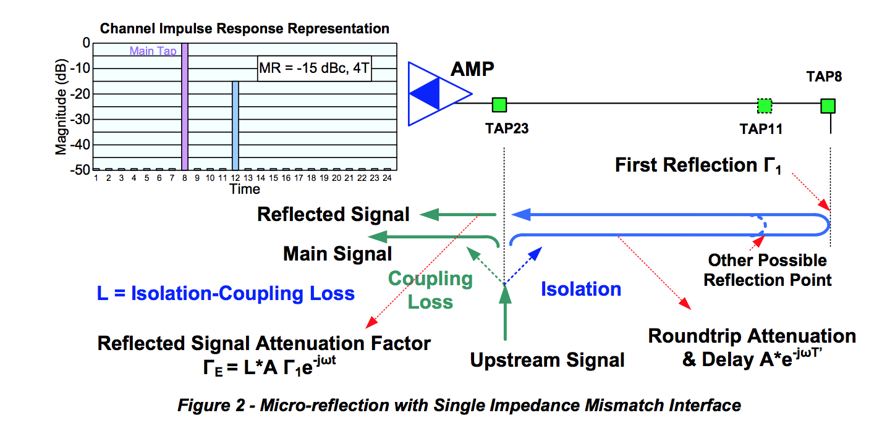

***5.2.1.3 Micro-reflection Example 3***

Figure 3 represents a case that is a superposition of the previous cases described in Micro-reflection Example 1 and Micro-reflection Example 2. A reflective point exists if the amplifier has poor return loss. A fraction of the desired signal is reflected off the output of the amplifier, Γ1, and propagates downstream to the open connection at the end-of-line or an open feeder tap port, Γ2, where it reverses direction back towards the amplifier and rejoins the original signal at the feeder tap location.

If the amplifier and feeder tap are co-located or are very close together, there will little difference in micro-reflection delay characteristic between the previously described Micro-reflection Example 1 and Micro-reflection Example 2. In fact, they may add or cancel each other out.

However, if the amplifier is a pole span or more away from the feeder tap, there may be two different distinct micro-reflections created for the single unterminated feeder tap. These micro-reflections are usually low in magnitude; 30 dB or more lower than the incident signal, but they can be numerous in a single amplifier-to-termination span.

It is conceivable that multiple micro-reflections may emanate from successive multiple passes through HFC components comprising the micro-reflection source. Cases in which only a single micro-reflection exists may be limited to laboratory simulation of the micro-reflection impairment and may not be practically encountered within the HFC network.

The cable industry has favored “capping” unused feeder tap ports rather than terminating the ports. Some operators will defend that position because it is claimed to reduce potential ingress sources. Indeed it is a tradeoff between craft integrity and good impedance matching practices, which causes more stress on the upstream adaptive equalizer.

***5.2.1.4 Micro-Reflection Example 4***

Figure 4 shows a single reflection that travels from the large “X” in the figure toward the source (the tap or some other device beyond the left edge of the figure), which is assumed to have high return loss, resulting in a very low amplitude re-reflection toward the original point of reflection. The interaction of the incident and reflected energy produces standing waves (amplitude ripple). However, the net effect is that the CM sees a flat frequency response on the downstream and the CMTS sees a flat upstream frequency response. Unfortunately, some energy is lost so receive signal levels will be low. (Note: lost RF energy sometimes indicates signal leakage.) As anticipated, this type of impairment is difficult to detect. One method of detecting this problem is via a standing wave measurement in the field, which requires probing the line with a high impedance probe, such as a Trilithic® I-Stop, as illustrated in Figure 4. Note that if a system has an echo tunnel caused by two plant defects, repairing one of the defects will cause the echo tunnel to disappear, but the other defect remains. See Appendix VIII for a discussion of this type of detection.

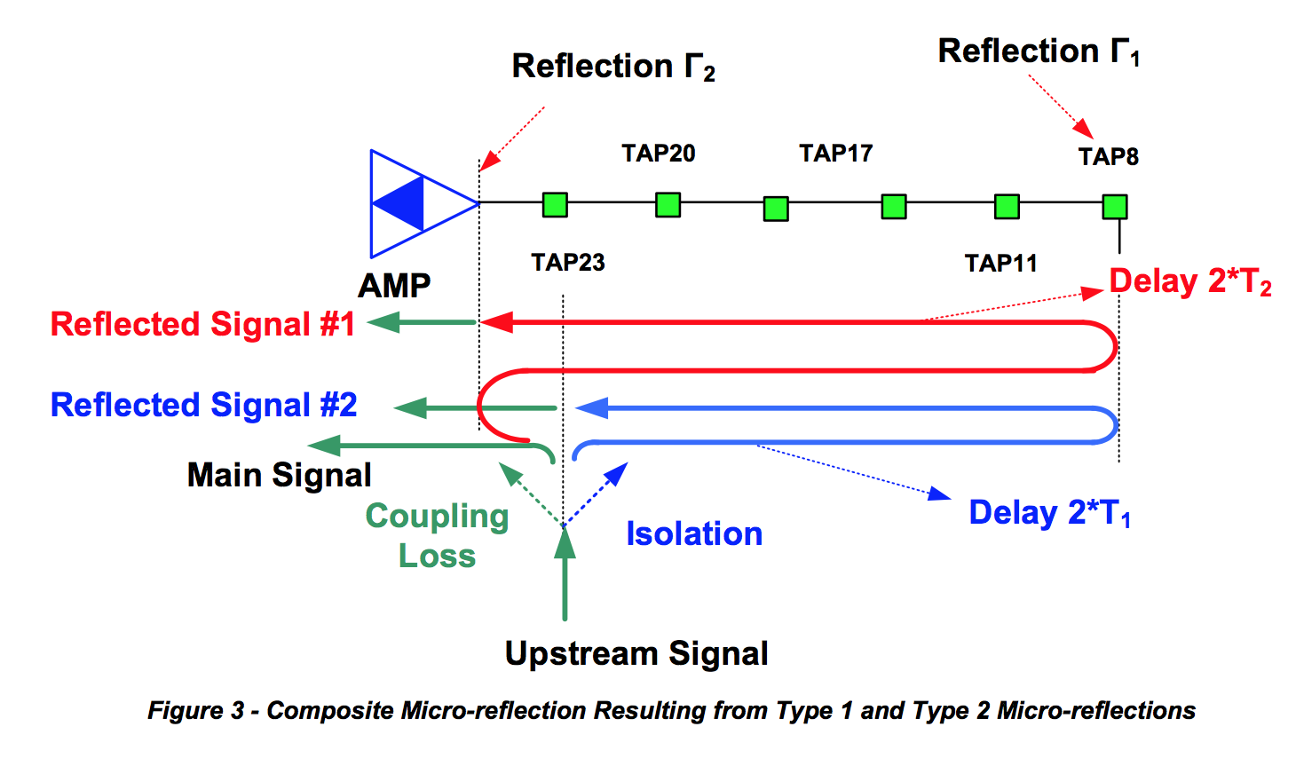

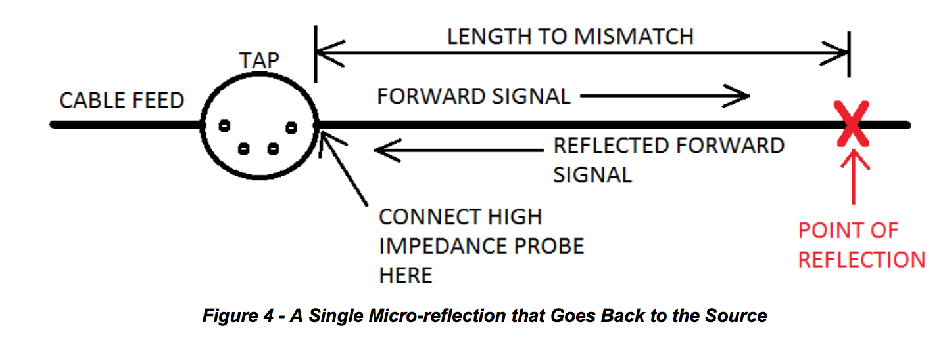

**5.3 Pre-equalization Mechanism Enabled through DOCSIS Ranging**

The upstream pre-equalization mechanism relies on the interactions of the DOCSIS ranging process in order to determine and adjust the CM pre-equalization coefficients. The intent is for the CM to use its

coefficients to predistort the upstream signal such that the predistortion equals the approximate inverse of the upstream path distortion, so that as the predistorted upstream signal travels through the network it is corrected and arrives free of distortion at the upstream receiver at the CMTS.

The pre-equalization coefficients of the CM are the complex coefficients (F1 through F24) of the 24-tap linear transversal filter structure shown in Figure 5.

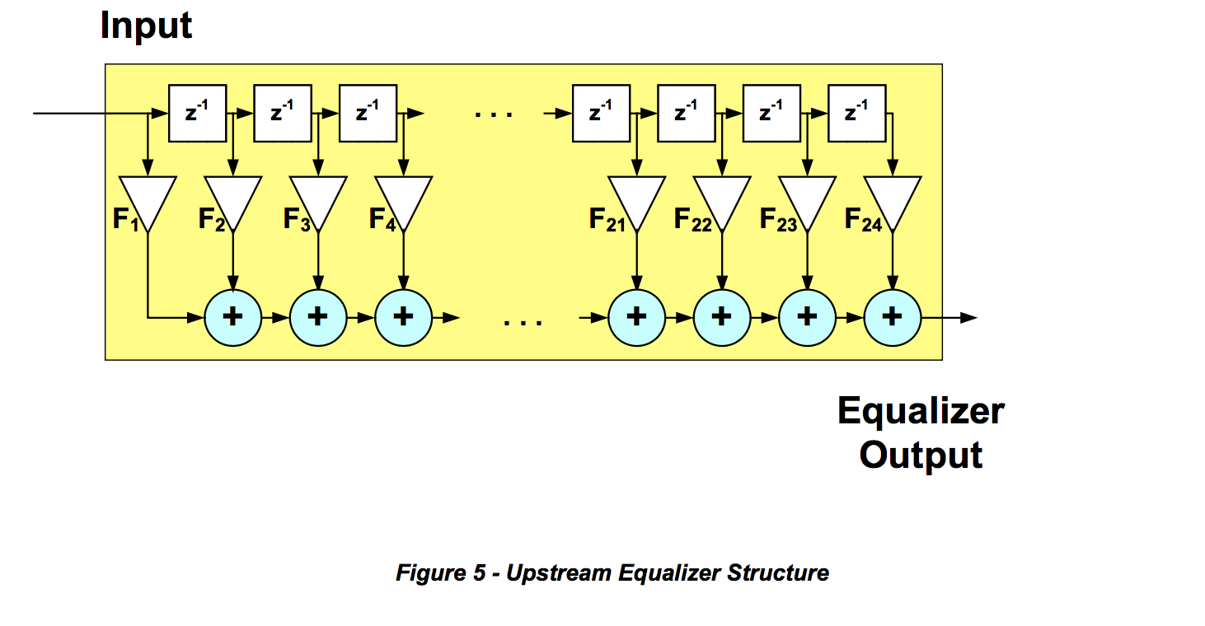

In this structure the blocks with z-1 label represents delay elements, each of which in the DOCSIS 2.0 pre- equalizer is the symbol period T (in DOCSIS 1.1 it can also represent delays equal to T/2 and T/4).

In the ranging process the CM sends a ranging request message (RNG-REQ) to the CMTS. The CMTS may use a known portion of this message, such as the preamble, as well as other known messages to determine the quality of the received signal, as well as to determine the adjustment the CM should make to its pre-equalization coefficients to better compensate the upstream distortion. In response to the RNG- REQ message, the CMTS sends a ranging response (RNG-RSP) message with a set of 24 coefficients and a parameter that indicates whether these coefficients are intended to result in a set or adjust operation by the CM. In the case of a set command, the CM will replace its existing coefficients with the ones sent by the CMTS. In the case of an adjust command, the CM convolves its coefficients with the ones sent by the CMTS to achieve the adjusted coefficients (Figure 6).

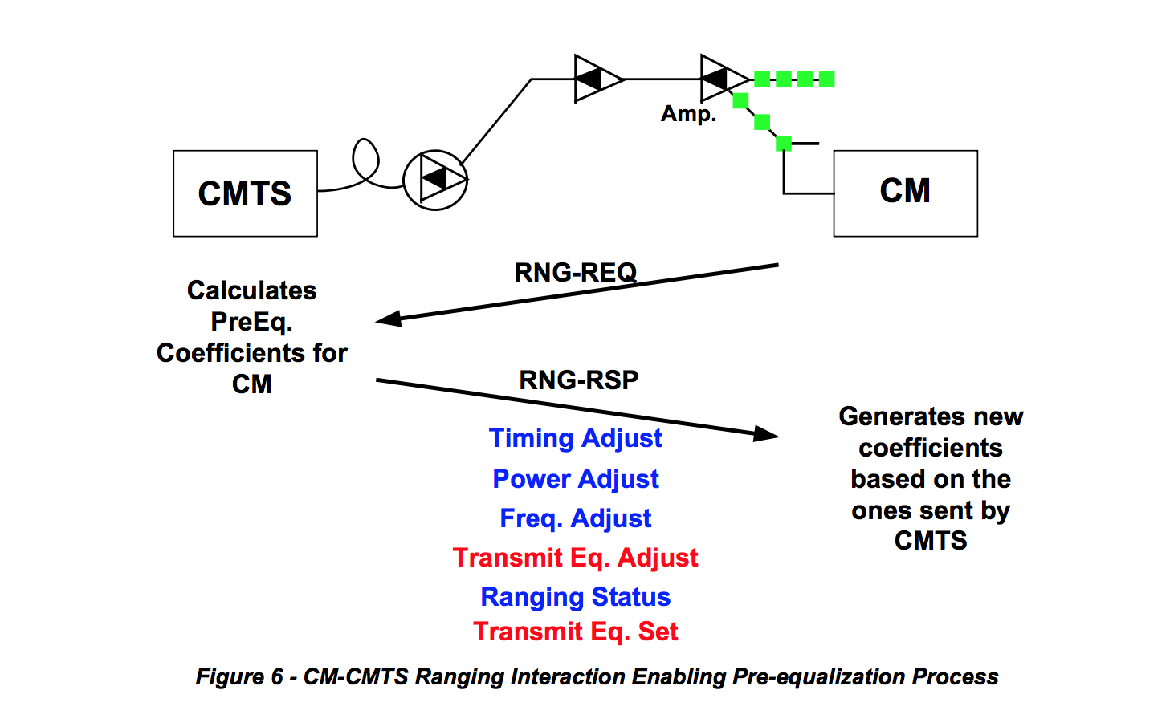

The CMTS may not be completely satisfied with the quality of the signal the CM is sending after the initial try. This is an iterative process which may take a few interactions before the coefficients are stable.

CMTS implementations use for the most part the transmit-equalization-adjust option to convey information. Only after the initial ranging request, one may see a CMTS send a transmit-equalization-set message to make sure that the CM initializes properly. In principle the CMTS could use this message when it needs to reset the coefficients.

A CMTS that is completely satisfied with the values of the pre-equalization coefficients sends an adjust message where all coefficients are zero except for the pre-equalizer’s main tap coefficients, which has maximum or nominal value. This represents a Kronecker delta or impulse function, and any data set convolved with an impulse results in the original data set, which in this case is the CM pre-equalization coefficients, unchanged.

**5.3.1 Pre-equalization Enabling Messages**

As described previously, the two messages that are key in the ranging process are the range response (RNG-RSP) and range request (RNG-REQ) messages. The RNG-RSP message, which is generated by the CMTS in response to a RNG-REQ message, carries timing, frequency, power level, and equalization adjustment information as well as equalization set or load information and ranging status. This information is encoded following what is known as type-length-value (TLV) format. DOCSIS 1.1 pre- equalization coefficients are identified by type 04 and DOCSIS 2.0 or 3.0 by type 09. The RNG-RSP messages that the RNG-REQ messages correspond to are linked by the service ID or SID. SIDs identify upstream service flows. It may be that a CM has several SIDs. In that case a CM will get ranging information through each of the SIDs it has. For example, if a CM has a SID that is used for telephony service and one that is used for data service, there will be two parallel ranging processes within a single CM. In addition to the SID, the RNG-RSP message payload also carries the upstream channel ID. Figure 7 shows the structure of the RNG-RSP message.

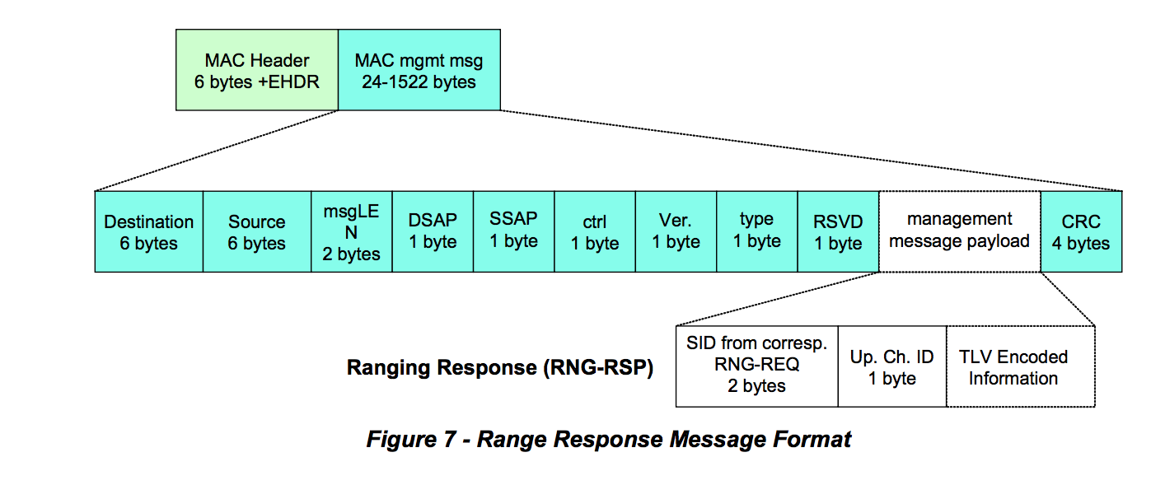

The RNG-REQ message is generated by the CM and sent to the CMTS. The RNG-REQ is used as the reference to determine whether the CM signal needs any adjustment. These adjustments could be in frequency, power level, timing offset, and distortion. Once the CMTS receives the RNG-REQ message it uses a known portion of this message as the reference of what the signal should look like. Typically that known portion of the message is the preamble. If the CM is not finished implementing the changes the CMTS is asking for, the CM includes in the RNG-REQ message a ranging status indicating whether or not the ranging changes are still pending. This is the “pending till complete” field in the RNG-REQ message payload. The RNG-REQ message also carries a downstream channel ID that associates the upstream being used with a downstream channel. Figure 8 shows the structure of the RNG-REQ message.

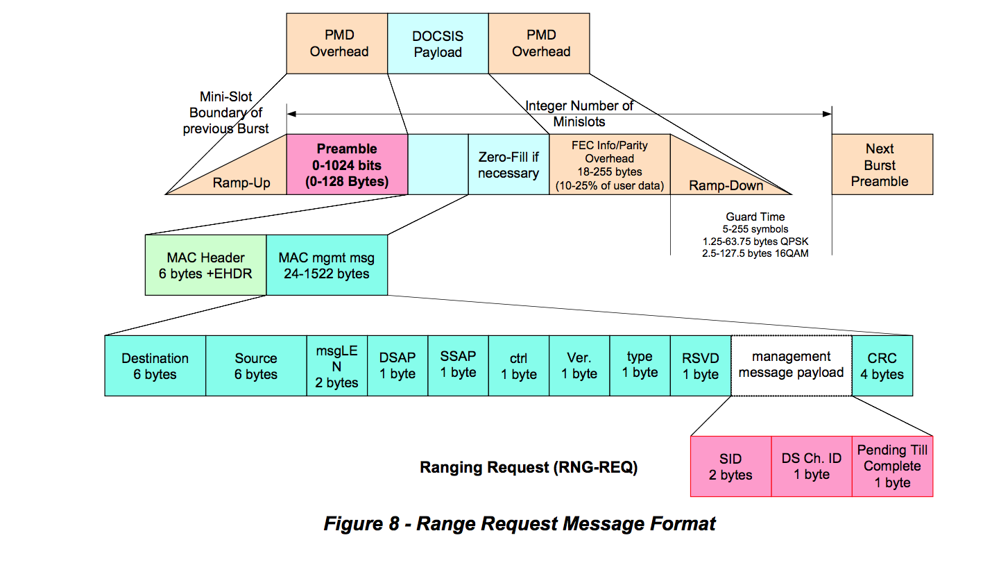

**5.3.2 CM and CMTS Equalization Information**

The pre-equalization coefficients are loaded into the adaptive pre-equalizer in the CM, which is used to compensate for upstream linear distortion(s). Hence the CM pre-equalization data indirectly describes the distortion in the plant for which it compensates. The pre-equalizer response is approximately the inverse or opposite response of the plant. The pre-equalization coefficients provide detailed characteristics of the channel distortion, although the coefficients do not directly indicate the level of micro-reflections. Assuming negligible group delay distortion and a single micro-reflection, a quick estimate of micro- reflection level can sometimes be obtained using the energy in the adaptive equalizer’s non-main taps. In general, an elaborate analysis is required to uniquely resolve micro-reflection level/delay signature characteristics. An upstream channel that exhibits no distortion has all the energy concentrated in the adaptive equalizer main tap while one that exhibits distortion also has energy in taps other than the main tap (Figure 9).

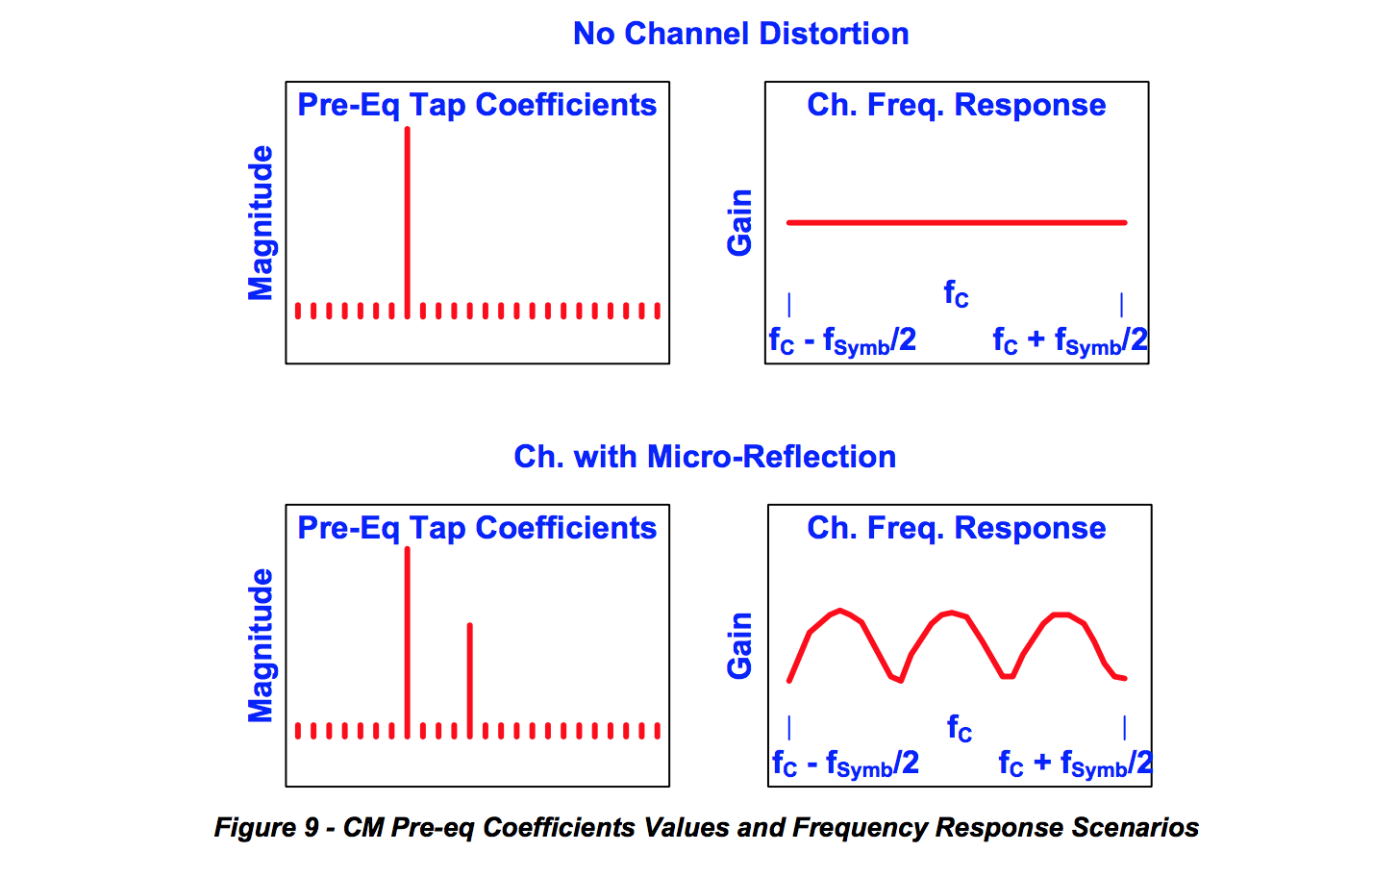

The pre-equalization data which the CMTS continues to send to the CM indicates how successful a CM has been in compensating for the distortion by showing what is left to compensate to achieve ideal reception. Ideally and typically, the CM starts with no compensation and after a few ranging intervals, achieves a steady state where the CM compensates for all the distortion. At that point the CMTS pre-equalization data exhibits a flat response indicating that further compensation is not required (Figure 10).

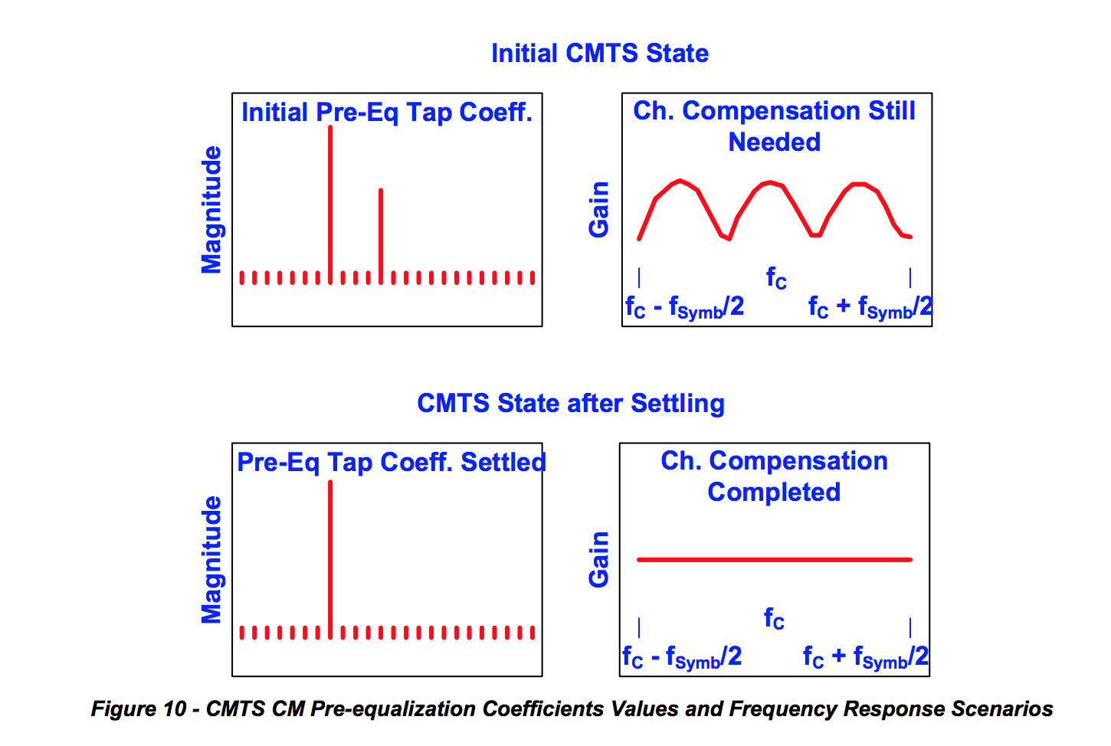

The upstream CM equalization data collected by the CMTS is analyzed to verify that any plant distortion has been compensated. There is the possibility of a distortion being so severe (e.g., a micro-reflection having a very long delay) that the pre-equalization process would not be able to fully compensate for it. These scenarios are rare in current HFC architectures, but if this does occur, one must be aware that an impairment identification process using only CM pre-equalization data will not yield accurate results.

**5.4 Upstream Pre-equalization in DOCSIS 1.0, DOCSIS 1.1 and DOCSIS 2.0**

Upstream pre-equalization in DOCSIS 1.0 was left as optional and the equalization process between CMTS and CM was not defined in sufficient detail. An unexpected result occurred when DOCSIS 1.1 and 2.0 were introduced with a well-defined process. A few 1.0 CMs that implemented pre-equalization exhibited erratic behavior in the presence of downstream RNG-RSP messages that were generated by 1.1 or 2.0 CMTSs. For quite some time operators have not been motivated to turn pre-equalization on, in part because the demand for capacity and spectrum availability have not been significant enough to warrant the use of wider channels, higher order modulations, or frequencies near the edges of the upstream spectrum where linear distortion occurs.

Some 1.0 CMs exhibiting the problem have been successfully upgraded with firmware that corrects this issue. Unfortunately it has not been possible to correct this issue on all affected CMs. To support reliable use of upstream pre-equalization, operators have been replacing 1.0 CMs having known issues.

**5.4.1 DOCSIS 1.1 Pre-equalization Considerations**

The percentage of DOCSIS 1.1 CMs deployed is still significant enough not to take advantage of the pre- equalization compensation. Nevertheless, based on the percentage of 1.1 CM population and the rate at which 1.1 CM versions are decreasing with time, it is important to determine at what point the procedures described in this documentation will be worthwhile to implement.

**5.5 Limitations on Pre-equalization Compensation**

In a scenario of an upstream path that exhibits a micro-reflection, the maximum delay compensation that can be achieved using pre-equalization is limited by the amount of delay that can be generated within the pre-equalization filter structure shown in Figure 5. The maximum delay that can be generated is given by the delay between the adaptive equalizer’s main tap and the last adaptive equalizer tap.

In DOCSIS 2.0 and 3.0, the delay or spacing between each adaptive equalizer tap location is equal to the symbol period, because it always has a parameter of adaptive equalizer taps/symbol equal to 1. Typical implementations in DOCSIS 2.0 and 3.0 have the main equalizer tap in the eighth position out of a 24-tap delay line. Therefore the maximum delay that can be generated in that filter structure is 16T (last tap position – main tap position) where T equals the symbol period.

In DOCSIS 1.1 the delay between different adaptive equalizer tap locations can be a fraction of a symbol period. That is, the number of equalizer taps/symbol parameter is allowed to be 1, 2 or 4, resulting respectively in delay differences between adaptive equalizer tap locations of T, T/2 and T/4. This option has not been implemented in a CMTS. Therefore, in DOCSIS 1.1 CMTS scenarios, the maximum delay that can be generated is equal to 4T (last tap position – main tap position). Table 1 shows the maximum delays that are generated in DOCSIS 1.1 and 2.0 or 3.0 filter structures at different symbol rates using the typical equalizer main tap configurations (position 4 for DOCSIS 1.1 and position 8 for DOCSIS 2.0 and 3.0).

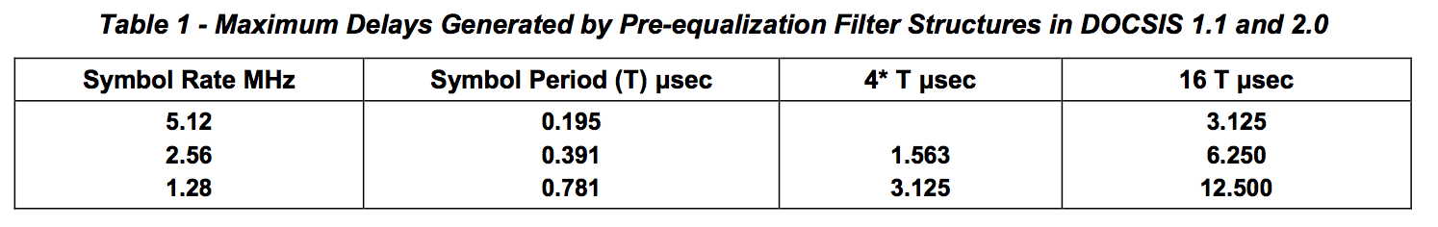

It cannot be assumed that a DOCSIS 2.0 filter structure can fully compensate for a micro-reflection with a delay of 3.125 microseconds. Typically energy in the neighboring equalizer taps help in the fine tuning of that compensation and a micro-reflection that pushes the delay to the limit of the equalizer won’t have longer delay equalizer taps available to help in the representation of the exact value. This is especially true if the echo delay is not a multiple of the symbol period, since the equalizer taps are then not spaced at the exact intervals to efficiently cancel the echo, and more equalizer taps are needed to provide effective cancellation. This will impact more severely higher order modulation scenarios such as 64-QAM where the adjustment is more critical.

In addition, in the case of strong micro-reflections, the equalizer may have a decaying sequence of taps as described in Example 2. For proper cancellation of the echo, taps at 2 or 3 times the echo delay may be needed. This implies that the echo must be 2 or 3 times shorter than the equalizer length.

Here are some examples of a few micro-reflection scenarios in potential HFC plant configurations. The first scenario is a micro-reflection that occurs between an amplifier and a feeder tap that are separated by 75 feet (150 feet round trip distance) and that have a return loss of 6 dB on each reflection interface (interface where impedance mismatch occurred). The feeder cable between these interfaces has a diameter of 0.625” and an attenuation of 1.2 dB/300 feet. This is considered a strong and short micro- reflection. Figure 11 shows the level and delay of the third transit and its subsequent multiple transit echoes.

The second scenario is a micro-reflection that occurs between two amplifiers and there are no feeder taps in between. They are separated by 1200 feet (2400 feet round trip distance) and that have a return loss of 8 dB on each reflection interface (interface where impedance mismatch occurred). The feeder cable between these interfaces has a diameter of 1.000” and an attenuation of 0.8 dB/300 feet. This is considered a strong and long-delay micro-reflection. Figure 11 shows the level and delay of the third transit echo (top large blue square). The fifth transit echo of this micro-reflection is too low in amplitude to be noticeable.

The third scenario is a micro-reflection that occurs between two amplifiers and with feeder taps in between. The amplifiers are separated by 1200 feet (2400 feet round trip distance) and each has a return loss of 8 dB on each reflection interface (interface where impedance mismatch occurred). The aggregate insertion loss (also called through loss) in the feeder taps is equal to 6 dB (12 dB round trip). The feeder cable between the interfaces has a diameter of 1.000” and an attenuation of 0.8 dB/300 feet. This is considered a mild and long-delay micro-reflection. Figure 11 shows the level and delay of the third transit echo. The fifth transit echo of this micro-reflection is too low in amplitude to be noticeable.

Figure 11 also indicates which scenarios can be compensated in the different DOCSIS configurations. The scenarios that lie to the left of the vertical line that corresponds to a given channel width /DOCSIS mode combination can be compensated, while the ones that lie to the right of the line cannot be properly compensated. It is also worth noting that in cases close to the vertical line, higher order modulation may not be possible.

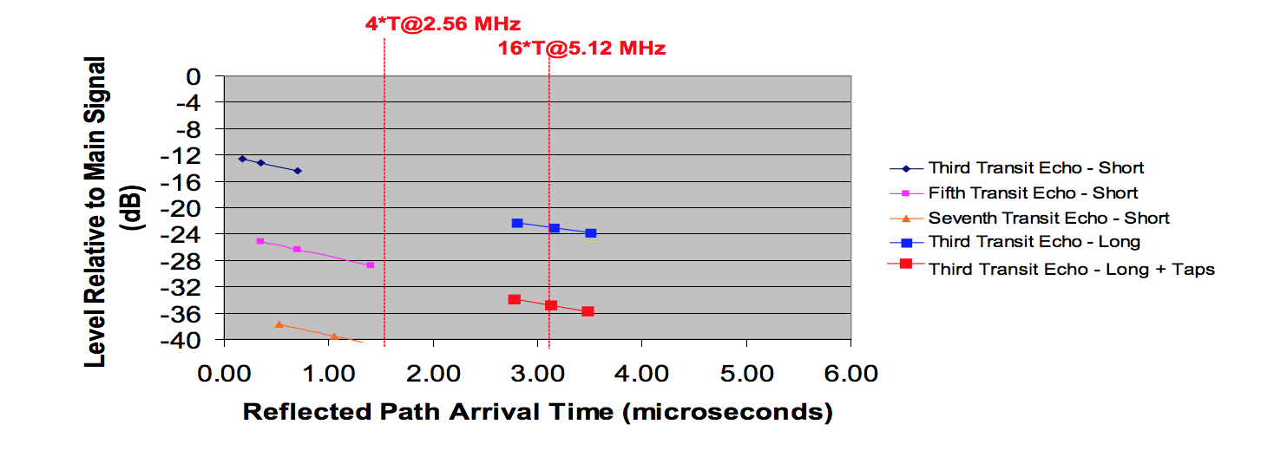

***Figure 11 - Pre-equalization Compensation Capabilities under Short and Long Delay Micro-reflection Scenarios***

The examples just discussed assumed 0.625” cable for the short time delay reflection and 1” cable for the long time delay reflection. The short time delay reflection scenario includes data points at 150’, 300’, and 600’ round trip distances and the long time delay reflection includes data points at 2400’, 2700’, and 3000’.

**5.6 DOCSIS Pre-equalization MIBs**

DOCSIS pre-equalization coefficients indicate different things depending whether the CMTS or the CM is being queried. The information that is available through MIBs relate to what the CMTS and CM keep track of at the time the respective devices are being queried. Through the ranging interaction discussed in Section 5.3.1, the CMTS MIB (docsIfCmtsCmStatusEqualizationData) provides the adjustment necessary to update the CM coefficients and achieve upstream path distortion compensation. The CM MIB (docsIfCmStatusEqualizationData) indicates the current predistortion that is applied to the upstream signals.

The MIB format is as follows:

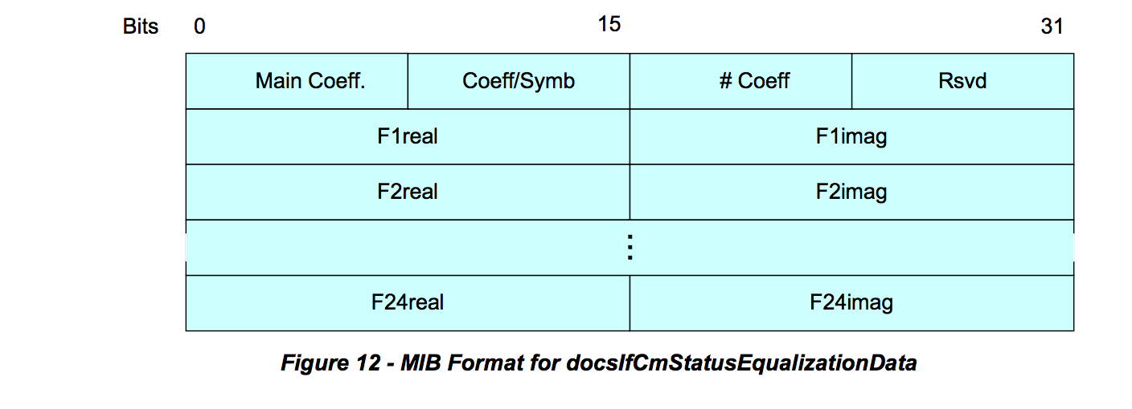

**5.6.1 DOCSIS 2.0 and 3.0 Pre-equalization MIBs**

Pre-equalization data is relevant in CM-CMTS channel combinations. In DOCSIS 2.0 the CM supports a single upstream channel, meaning the CM and CMTS reports a single pre-equalization data value. In DOCSIS 3.0 the pre-equalization data is measured for each of the upstream channels of the CM. To accommodate DOCSIS 3.0, the RFI management requirements were changed and DOCSIS 2.0 and 3.0 have separate MIBs for pre-equalization measurements. An additional per channel pre-equalization data measurement is also available and briefly discussed in this section to avoid confusion on usage of the appropriate information.

***5.6.1.1 Per CM Pre-equalization***

Table 2 presents semantically identical management objects for CM and CMTS for both DOCSIS 2.0 and 3.0.

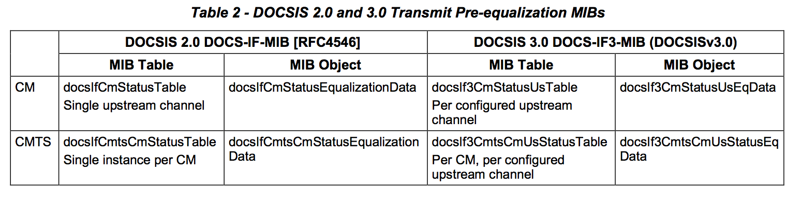

***5.6.1.2 Per Interface Equalization***

For the original RFI MIB requirements there is a per interface pre-equalization data element that is common for DOCSIS 2.0 and 3.0, the docsIfSigQEqualizationData from the docsIfSignalQualityTable.

For the CM, this data provides equalization information of the downstream receiver at the CM. In the downstream direction, the CM does not rely on the CMTS to generate equalization coefficients, but it is solely responsible for this blind equalization process. Variability in downstream equalization coefficients, over time, can be used to detect ingress and interference in the downstream spectrum. The downstream equalization structure is not specified. The implementer has the flexibility to differentiate in the type of equalizer structure and design used. Traditional feed-forward structures or decision feedback structures are implementation examples, although decision feedback structures have likely been used. The current MIBs may not properly described the state of the downstream equalizers implemented. A number of downstream equalization MIB implementations are not reliable. In order to effectively leverage information from the downstream equalizers, it is important to introduce a specification update through the EC process.

For the CMTS this object was intended to report some type of aggregated equalization value for the entire upstream channel. RFI MIB [RFC4546] clarifies the CMTS does not need to report a value other than an empty string.

Note that this equalization data is not relevant to the scope of this document.

**6 METHODOLOGY FOR PNM USING UPSTREAM EQUALIZATION**

**6.1 General Approach and Processes**

The proactive network maintenance methodology that is based on pre-equalization coefficients can be described in terms of a few key general components.

The first general component is the data collection process. It comprises polling all CMs and CMTSs to obtain pre-equalization data from all configured upstream channels. The gathered data is verified for format integrity and is normalized to be useful for comparison. For scalability purposes, the data collection process is conducted using a more frequent polling cycle for the CMs that exhibited apparent distortion above a pre-determined level and a less frequent cycle for all CMs.

The second general process incorporates the initial distortion assessment that is conducted on all CMs that are monitored more frequently. This process uses the non-main tap to total energy (NMTER) ratio to discriminate which CMs should be examined in more detail and which should be left for evaluation in the next coarse monitoring cycle.

The third component in this approach conducts the detail analysis that includes the calibration process and the determination of the distortion signatures from frequency domain and time domain analysis. These signatures include group delay and micro-reflections. In case of multiple different micro-reflections, the signatures are obtained after a discrimination process.

The fourth component takes the distortion signatures and evaluates whether from a static perspective they should be classified as red which implies the need for immediate action, or as yellow which indicates the CM should be monitored more frequently and its distortion data be stored for observation over time. The information describing which CMs have to be examined more frequently is communicated to the data collection process. Green classification indicates that no action is necessary.

The fifth process takes the CM signatures and identifies within a fiber node’s service area which micro- reflections are common to several CMs. The next process identifies by comparing historical data collected in the yellow classified CMs whether intermittent issues or trending issues are of concern and may require action.

The last process is the one that correlates the affected CM or CMs with the outside plant topology and uses that information to determine fault location. Figure 13 shows a diagram of the process just described.

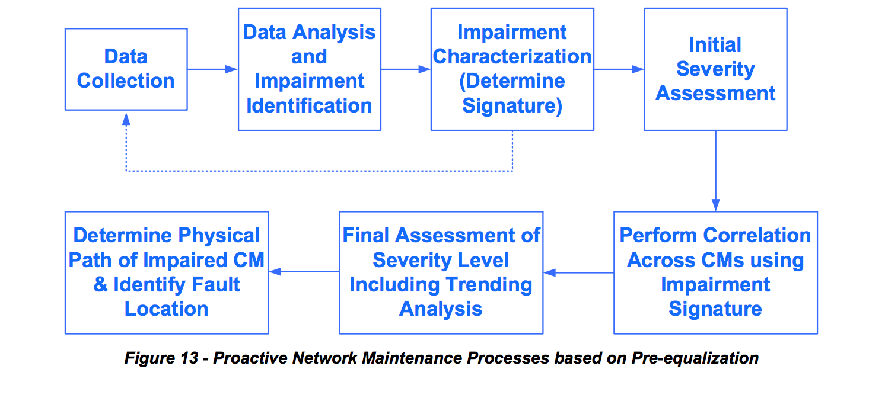

**6.2 Format Verification, Normalization and Guidelines**

The structure of the pre-equalization information has been described in Section 5.6. How the values within this structure are interpreted depends on implementation. The first four byte-long elements in the header are to be interpreted in HEX mode. For example, the number of adaptive equalizer taps value of 18 in HEX is 24 in decimal (Figure 14). The rest of the equalizer structure defined in two byte increments containing the real and imaginary coefficients should be interpreted according to 2’s complement over the entire two bytes or 4 nibbles describing the real or the imaginary coefficients. For example, the 2’s complement of a 2 byte such as the fourth real coefficient is FFFC which in 2’s complement is -4 (red circle).

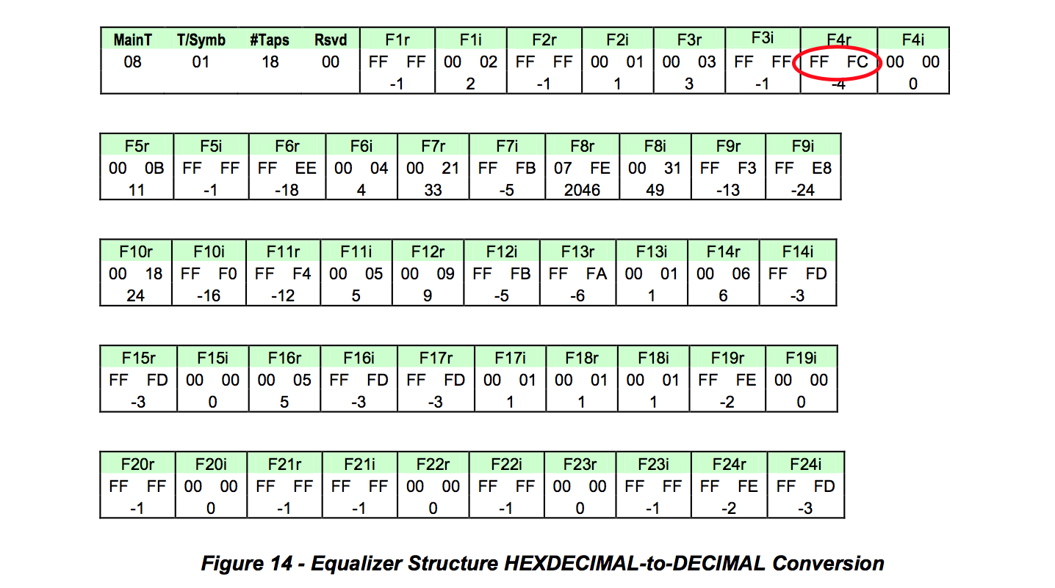

The representation of coefficients often differs among CM vendors. There are variations in maximum amplitude as well as variations in the way the coefficients are interpreted. Table 3 highlights the different interpretations that exist for the most popular CMs deployed.

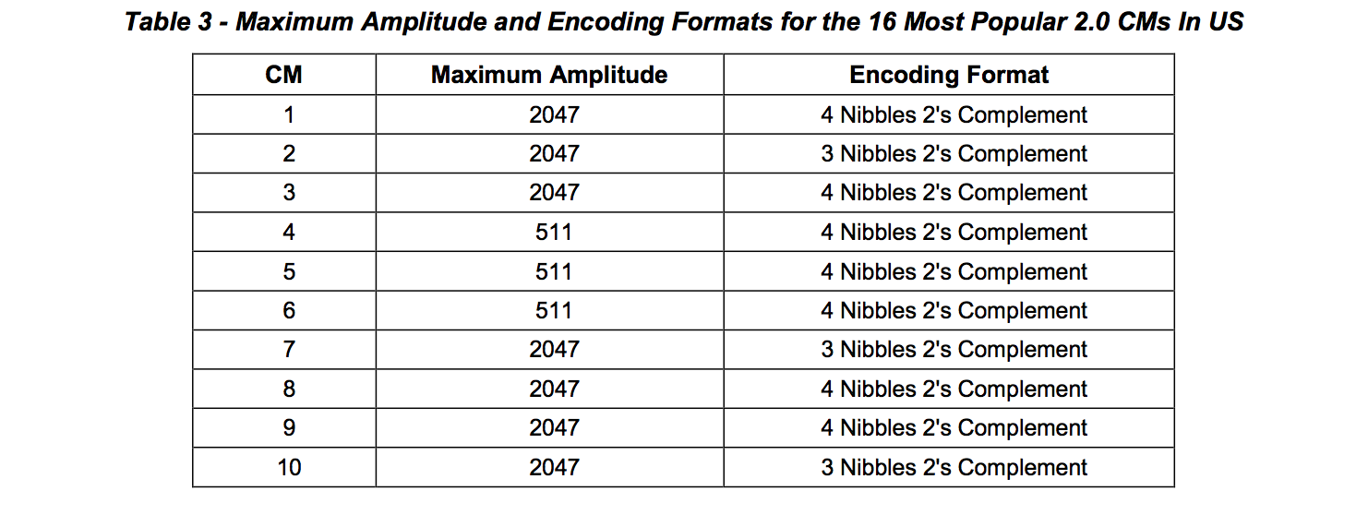

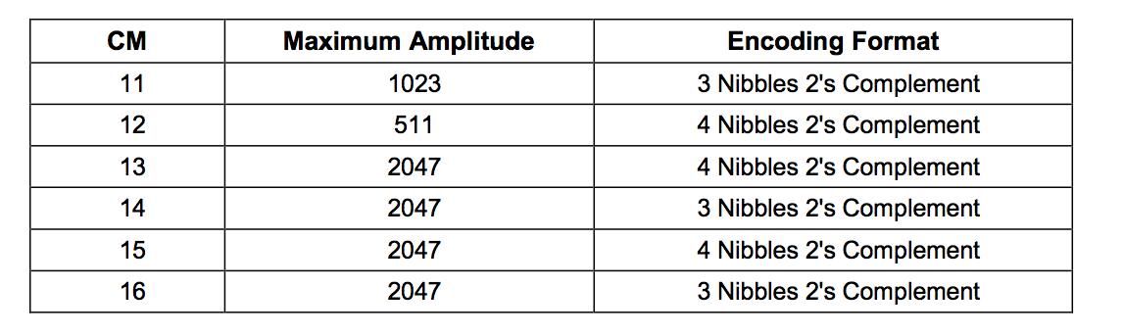

The CM vendors had two interpretations of how to decode the coefficients. One is the four nibble 2’s complement interpretation and the other is the three nibble 2’s complement interpretation. The four nibble 2’s complement interpretation is the one assumed by the spec but there is a significant number of CMs deployed with the three nibble 2’s complement interpretation. Regarding maximum amplitude, CMs have maximum amplitude equal to 2047, 1023 or 511. If the coefficients are normalized, the difference in CMs’ maximum coefficient amplitude turns into a difference in granularity. The difference then becomes one of decoding interpretation of coefficients.

**6.2.1 Four Nibble 2’s Complement Pre-equalization Coefficient Representation**

In this real or imaginary coefficient representation the entire four nibbles (two bytes) are used. This means that if the first bit is 0 the rest of the bits represent a positive integer binary number. If the first bit is 1, it is a negative 2’s complement number. The actual value can be calculated by inverting the bits and adding 1, resulting in the negative of the number. Both positive and negative examples have been included below.

a) 000D = 0000 0000 0000 1101 = 13

b) FFFE = 1111 1111 1111 1110after inverting it and adding 1 → 0000 0000 0000 0001 + 1 = 0000 0000 0000 0010 = 2 → The number is - 2

**6.2.2 Three Nibble 2’s Complement Pre-equalization Coefficient Representation**

In this real or imaginary coefficient representation the last three nibbles out of the two coefficient bytes are used for the calculation. In this interpretation the first nibble is 0 which could erroneously led one to believe that all coefficients are positive. Only after eliminating the first nibble one can tell if a number is positive or negative. This means that if the fifth bit is 0 the rest of the bits represent a positive integer binary number. If the fifth bit is 1, it is a negative 2’s complement number. The actual value can be calculated by inverting the bits of the three nibbles and adding 1. This is the negative of the number in question. Both positive and negative examples have been included below.

a) 000D = 0000 0000 0000 1101 → eliminate the first nibble → 0000 0000 1101 = 13

b) 0FFE = 0000 1111 1111 1110 → eliminate the first nibble → 1111 1111 1110 afterinvertingitandadding1→ 000000000001+1=000000000010 =2→Thenumberis-2

**6.2.3 Universal Decoding**

Since in current implementations the maximum value that a coefficient can take is always less than or equal 2047, the first nibble is never used and can be removed to generate a universal decoder. After removing the first nibble, the decoding process would be identical to the third nibble process.

**6.3 Key Metrics**

The real and imaginary complex coefficients of a DOCSIS 2.0 upstream pre-equalizer defined as: F1R, F1I, F2R, F2I, F3R, F3I, F4R, F4I,. . . F23R, F23I, F24R, F24I, and will be used to define several key metrics that follow.

**6.3.1 Adaptive Equalizer Main Tap Energy**

The adaptive equalizer main tap in DOCSIS 2.0 is typically in tap position eight although some CMTS implementations can have it in as low as the sixth position. In DOCSIS 1.1 the main tap is in the fourth position. The equalizer tap energy is given by the sum of the squares of the real and imaginary components of the coefficient.

The main tap energy (MTE), assuming it in eighth position, is defined as:



**6.3.2 Main Tap Nominal Energy and Main Tap Nominal Amplitude**

The DOCSIS pre-equalization taps exhibit different nominal or maximum amplitudes depending on CM implementations. The maximum of amplitude implementations from CMs are 2047, 1023 or 511. This parameter is defined here as the main tap nominal amplitude (MTNA). The square of the nominal amplitude yields the nominal tap energy.

The main tap nominal energy (MTNE), assuming main tap is in the eighth position, is defined as:

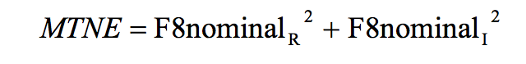

**6.3.3 Pre-Main Tap Energy**

The summation of the energy in all equalizer taps prior to the main tap provides the pre-main tap energy

(PreMTE). The pre-main tap energy assuming a main tap in the eighth position is defined as:



**6.3.4 Post-Main Tap Energy**

The summation of the energy in all equalizer taps after the main tap provides the post-main tap energy (PostMTE).

The post-main tap energy assuming a main tap in the eighth position is defined as:



**6.3.5 Total Tap Energy**

The summation of the energy in all equalizer taps provides the total tap energy (TTE). The total tap energy is defined as:

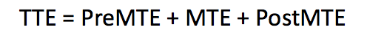

**6.3.6 Main Tap Compression**

Adaptive equalizer main tap compression (MTC) at the CM is a good indicator of the available margin for the continued reliance on the equalization compensation process. An MTC ratio greater than 2 dB may suggest that equalization compensation can no longer be successfully achieved. This metric is given by the ratio of the energy in all taps to the main tap energy.

The main tap compression expressed in dB is defined as:

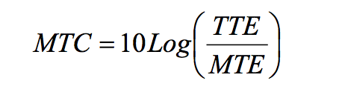

Main tap compression at the CM translates to a less RF power level delivered to the CMTS. An MTC of 2 dB results in the CMTS receiving 2 dB less input power.

Main tap compression at the CMTS is not expected under normal operating conditions. Any level of main tap compression at the CMTS should raise an alarm.

**6.3.7 Main Tap Ratio**

Adaptive equalizer main tap ratio (MTR), the ratio of energy in the main tap to the energy in all other taps combined, is useful distortion metric to determine the distortion level in the upstream path. MTR is approximately the same as non-main tap to total energy ratio (NMTER, see Section 6.3.8), except at extremely high distortion levels. In most cases MTR can be used instead of NMTER.





**6.3.8 Non-Main Tap to Total Energy Ratio (Distortion Metric)**

The adaptive equalizer’s non-main tap to total energy ratio is another useful “distortion metric” to determine the distortion level in the upstream path. This parameter can be used as an initial assessment tool to determine which CMs need to be examined further and more frequently. This distortion metric is given as the ratio of the aggregate energy that exists in all but the main tap to the energy in all of the adaptive equalizer’s taps.

The non-main tap to total energy ratio expressed in dB is defined as:

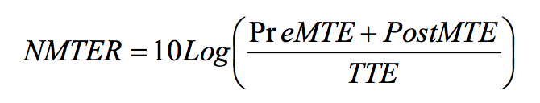

Notice that the main tap energy in the numerator is missing. The non-main tap energy ratio is also a good estimation of the MER assuming that the signal is not impacted by impairments that are not considered linear distortions, such as burst noise and nonlinear impairments.

Non-main tap to total energy ratio at the CMTS is a good indicator of the type of upstream performance the CM signals have based on the amount of linear distortion present. If a 27 dB CNR is assumed for negligible errors with a 64-QAM signal, a NMTER target value of -27 dB can be assumed for comparable performance. If a 30 dB CNR is the threshold where correctable errors are beginning to appear, that would also correspond to a threshold of -30 dB NMTER when correctable errors begin to appear. This CNR to NMTER relationships are useful in determining thresholds from the NMTER values. An operator could assume an immediate action (red) NMTER threshold of -27 dB for 64-QAM operation and a monitor more frequently (yellow) NMTER threshold of -30 dB.

**6.3.9 Pre-Main Tap to Total Energy Ratio**

The adaptive equalizer’s pre-main tap to total energy ratio (PreMTTER) is a useful parameter, along with the adaptive equalizer’s pre-post tap symmetry, to determine the group delay level in the upstream path. This distortion metric is the ratio of the pre-main tap energy to the energy in all taps.

The pre-main tap to total energy ratio expressed in dB is defined as:

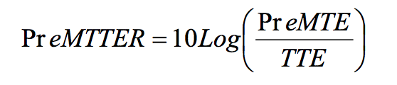

**6.3.10 Post-Main Tap to Total Energy Ratio**

The adaptive equalizer’s post-main tap to total energy ratio (PostMTTER) is a useful parameter to assess micro-reflection impairment contribution. This distortion metric is the ratio of the post-main tap energy to the energy in all taps.

The post-main tap to total energy ratio expressed in dB is defined as:



**6.3.11 Pre-Post Energy Symmetry Ratio**

The pre-post energy symmetry ratio (PPESR), along with pre-main tap to total energy ratio, is a useful parameter to indicate the presence of group delay in the upstream path. This distortion metric is the ratio of the post to pre-main tap energy ratios.

The pre-post energy symmetry ratio expressed in dB is defined as:

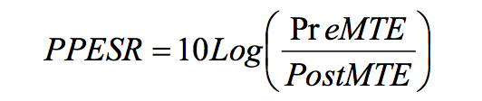

For practical purposes, the pre-post energy symmetry may be approximated using only the two taps adjacent to the main tap, giving the pre-post tap symmetry ratio (PPTSR):

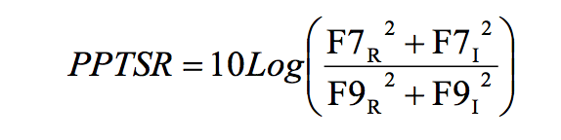

**6.3.12 Group Delay Distortion**

Group delay distortion is a type of linear distortion that is also corrected by the pre-equalization process. Figure 15 shows group delay increase with frequency for increasing number of cascaded actives. This configuration does not include the impact of chokes in the lower portion of the spectrum (typically 5-10 MHz) and it does not assume additional in-line equalizers.

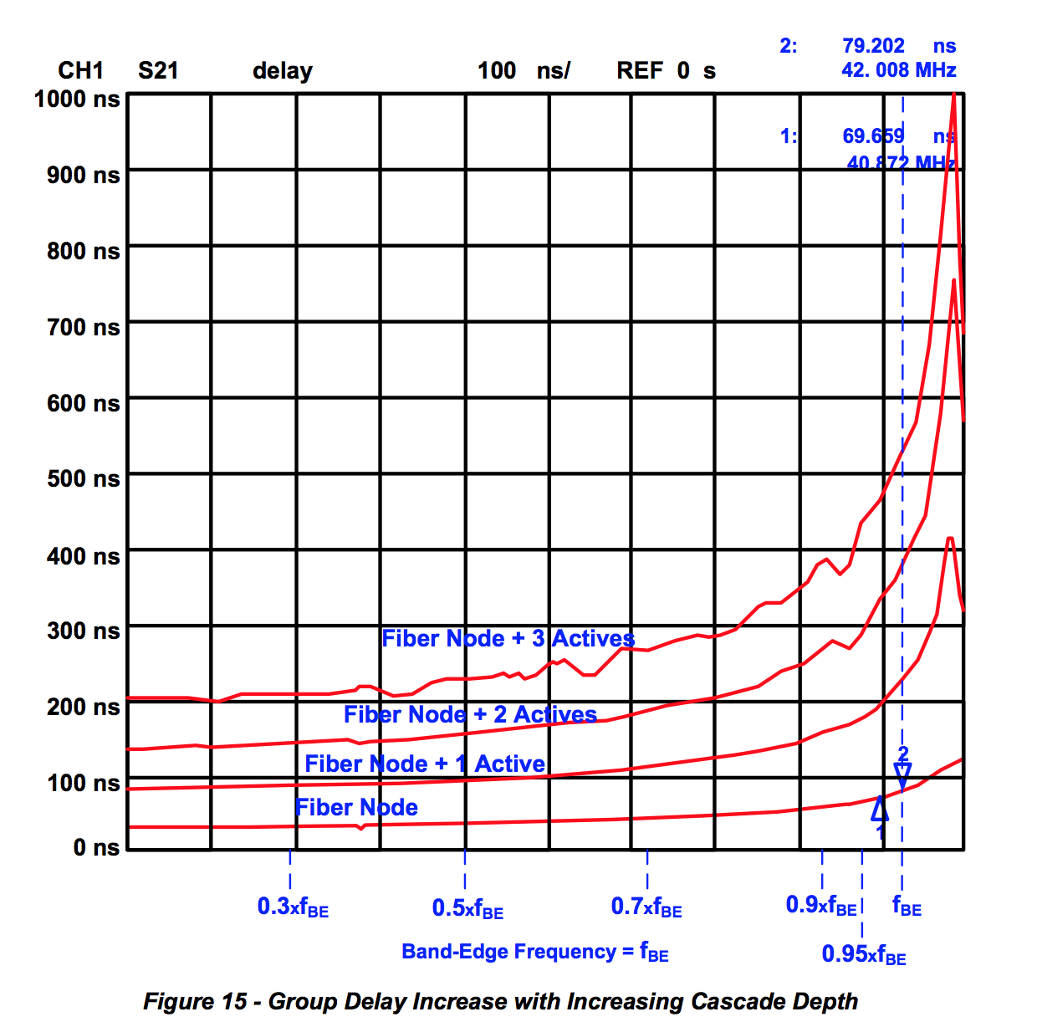

As observed in Figure 15, there is a variation in group delay of up to 300 ns in a channel that is located at the band-edge. The pre-tap equalization coefficient energy increases in the presence of group delay distortion. Additional group delay details are discussed in the tutorial section (Appendix I).

***6.3.12.1 Group Delay Distortion at Band-Edge with No Micro-reflection***

Table 4, Figure 16, and Table 5 relate to the scenario where the DOCSIS channel is at the band-edge and there is no micro-reflection present. Table 4 shows the impact of group delay distortion on tap energy when the upstream channel is at the band-edge and no micro-reflection is present.

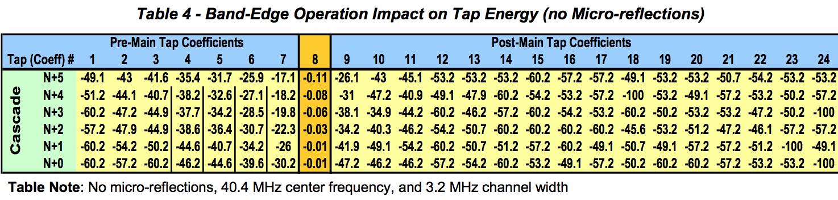

Figure 16 shows how when operating at the band-edge, the pre-main tap energy increases proportionally with increasing cascade depth. This is characteristic of the group delay distortion impact on tap energy. The effect of group delay distortion could be hidden just by looking at cascade depth in a plant topology map. In-line equalizers which may not be obvious in a plant topology diagram may contribute to distortion just as diplexers within amplifiers do. In severe distortion cases, assessment of pre-main tap energy could be used to determine whether certain CMs should be moved to lower distortion channels in the middle of the upstream band.

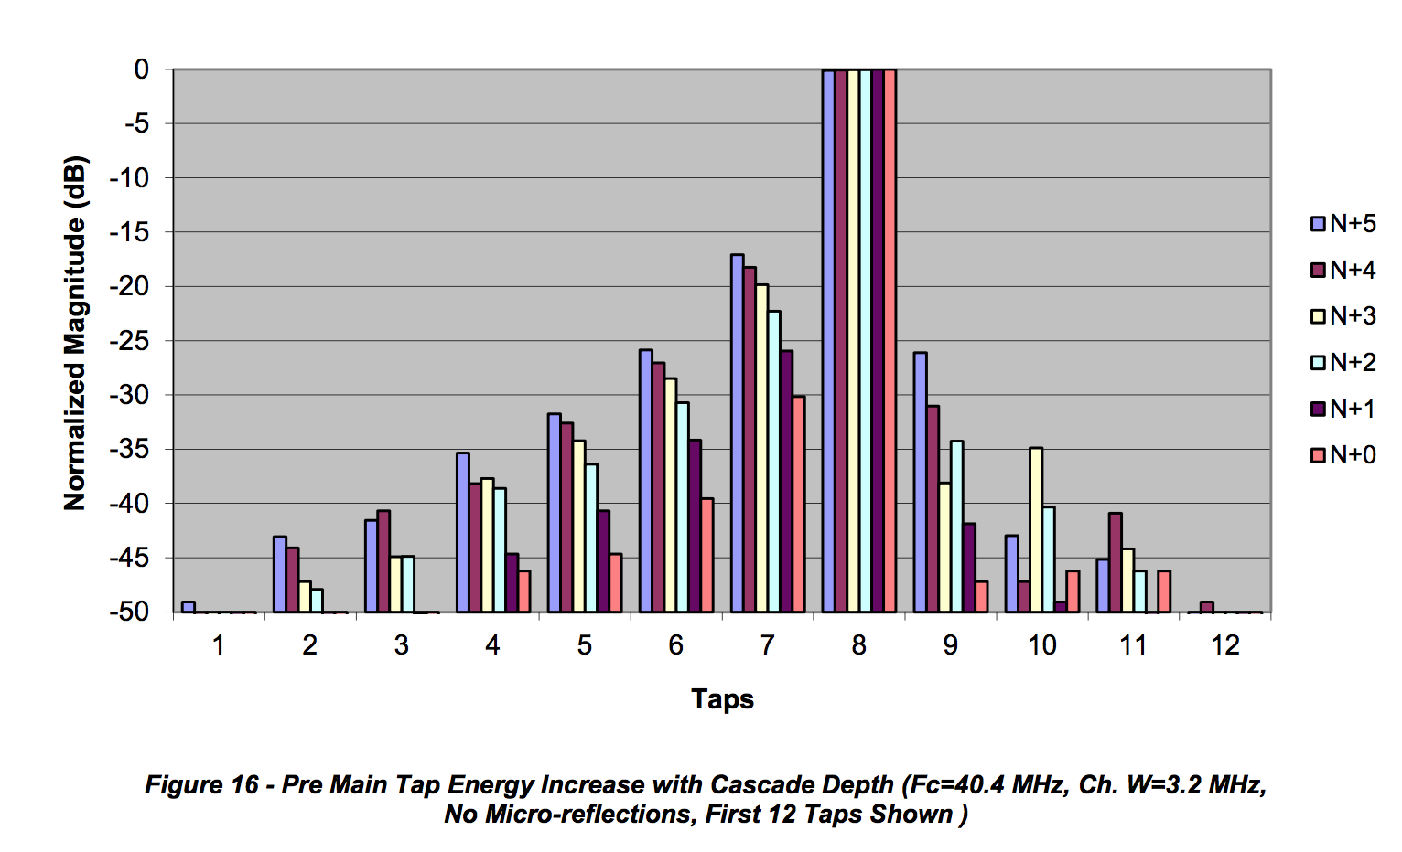

Key metrics worth highlighting in Table 5 are the PreMTTER that increases with cascade depth while the PostMTTER shows low values as no micro-reflections are present. The PPESR show high positive values since in this scenario the dominant impairment is group delay distortion. The low values of MTC are indicative that the pre-equalization compensation is effective.

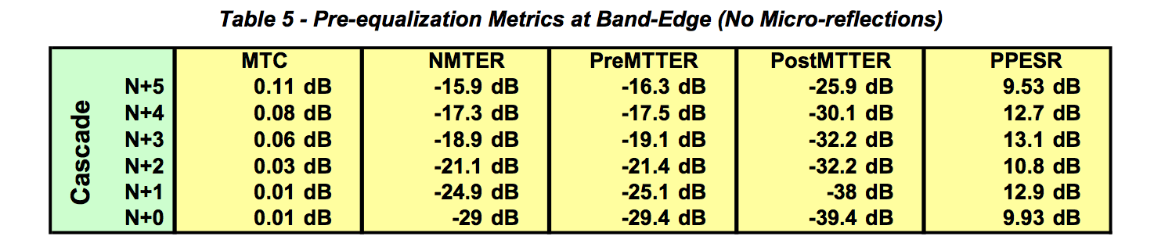

***6.3.12.2 Group Delay Distortion at Band-Edge with 0.5 μs Micro-reflection***

Table 6, Figure 17, and Table 7 relate to the scenario where the DOCSIS channel is at the band-edge but there is also a 0.5 μs micro-reflection present. Table 6 shows the impact of group delay distortion on tap energy.

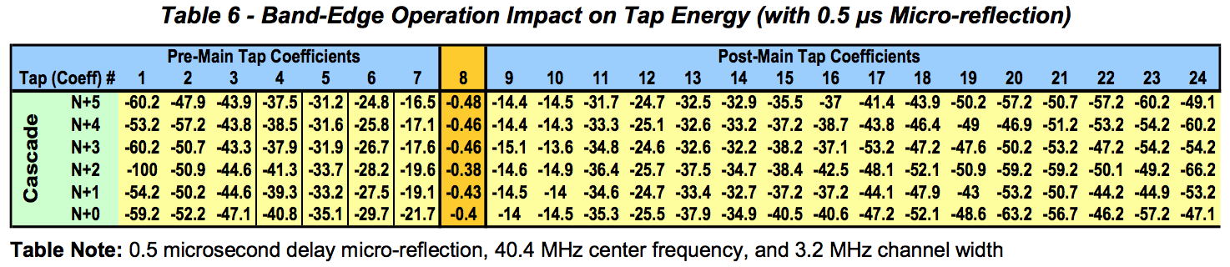

Figure 17 shows how when operating at the band-edge, the pre-main tap energy increases with increasing cascade depth but not as noticeably as the scenario without micro-reflections depicted in Figure 16. This is due to some pre-main tap energy needed to compensate for the micro-reflection which adds to the pre- main tap energy that is caused by group delay distortion. This leaking of energy into the pre-main tap region is more prevalent with shorter micro-reflections that use the taps closer to the main tap for compensation than the longer micro-reflections that use the higher value taps.

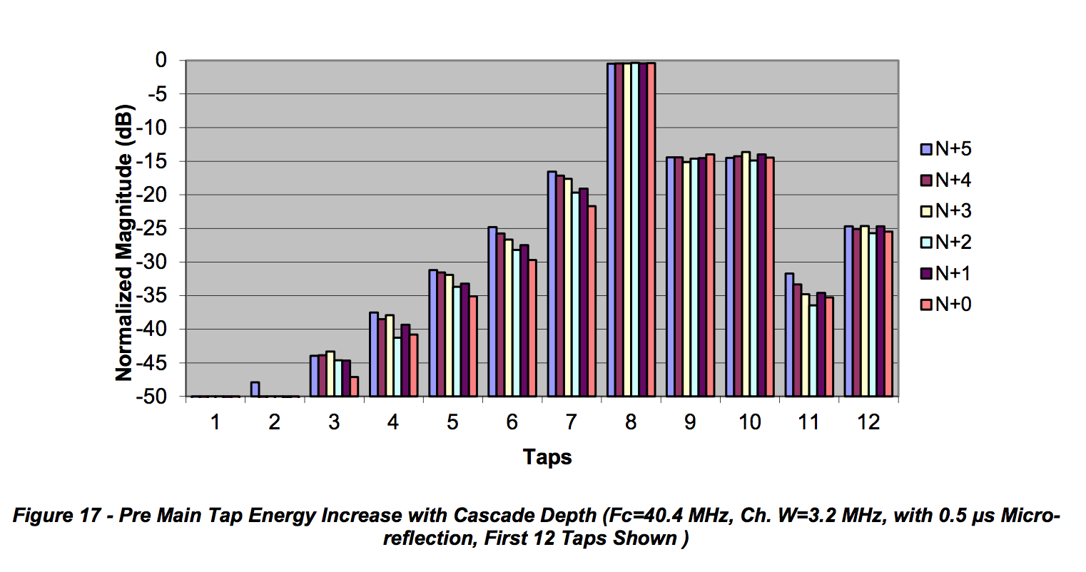Key metrics worth highlighting from Table 7 are the PreMTTER that increases with cascade depth. The PostMTTER shows a high value indicative of the micro-reflection present. The PPESR show negative values since in this scenario the dominant impairment is micro-reflection. The combined group delay distortion and micro-reflection by themselves is properly compensated through the pre-equalization process, although some increase in MTC begins to show.

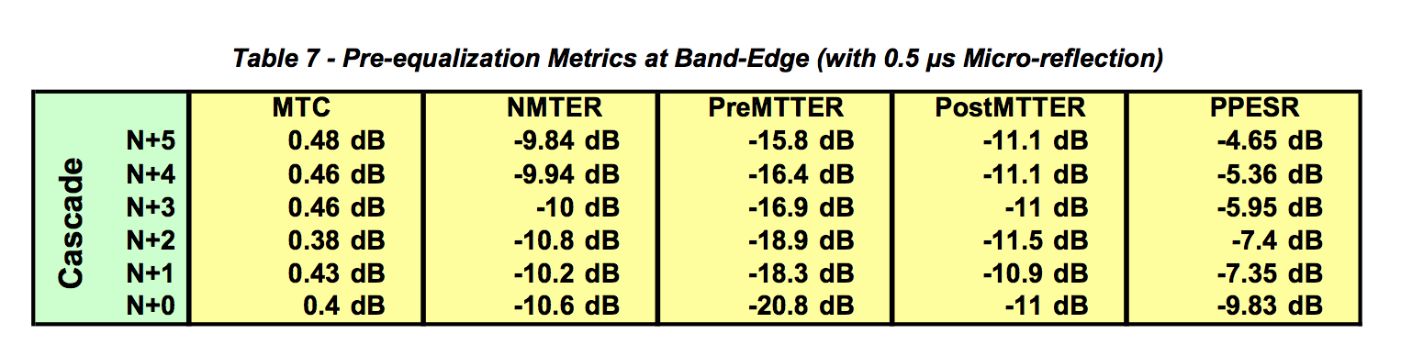

***6.3.12.3 Distortion in Middle of Upstream Band with Micro-reflection***

Table 8, Figure 18, and Table 9 relate to the scenario where the DOCSIS channel is operating in the middle of the upstream band with a 0.5 μs micro-reflection present. Table 8 shows the impact of distortion on tap energy.

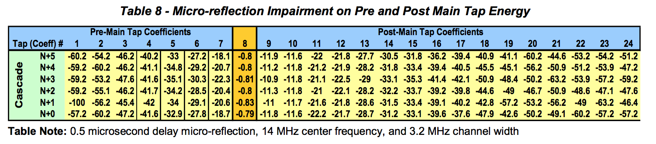

Figure 18 shows how when operating in the middle of the band, there is no increase in pre-main tap energy with increasing cascade depth as the group delay is fairly flat. (See also Figure 15.) Figure 18 shows how post-main tap energy is used in compensating for the micro-reflection. Figure 18 also illustrates how a small amount of pre-main tap energy is used in compensating for the fractional delay 0.5 μs micro- reflection. When the micro-reflection delay doesn’t coincide with a tap delay, neighboring taps are used for compensation. This explains why in Figure 17 the increase of pre-main tap energy with increasing cascade depth is not as noticeable as in the “group delay only” case depicted in Figure 16. The combined effect of group delay distortion and a 0.5 μs micro-reflection of Figure 17 can be approximated to a rough superposition of Figure 16 representing the “group delay only” case and Figure 18 representing the “micro-reflection only” case.

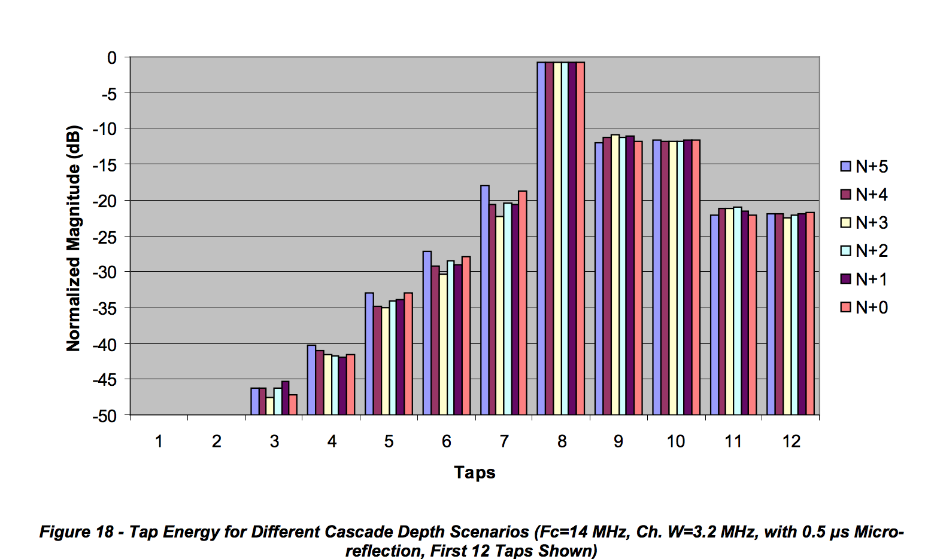

Some key metrics from Table 9 are worth highlighting. The low PreMTTER value is indicative of negligible group delay distortion. The PostMTTER high value is indicative of the strong micro-reflection present. The PPESR show negative values since in this scenario the dominant impairment is the micro-reflection. The MTC value is higher than the previous two scenarios which indicates that the pre-equalizer may be beginning to lose its equalization compensation effectiveness.

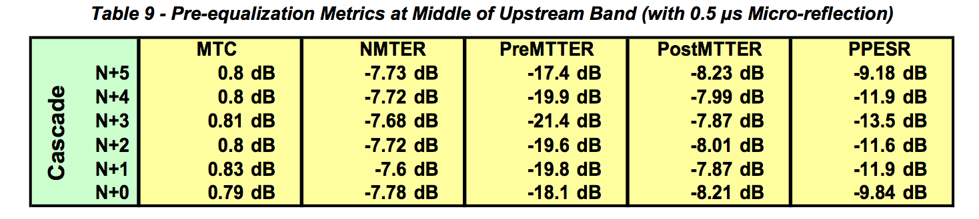

**6.4 DOCSIS Pre-equalization Coefficient Data Collection**

DOCSIS pre-equalization coefficient information is obtained by using simple network management protocol (SNMP). The SNMP management information base (MIB) describes information which is available in a standard manner across all implementations that comply with the DOCSIS MIB definitions.

At a minimum, there are three data elements required to complete the mathematical transformations described in this document. The three values are the DOCSIS equalization coefficients, upstream center channel frequency, and the RF bandwidth of the channel. The three data points are obtained from the cable modem and the CMTS. Having the cable modem coefficients provides a view of the inverted channel

response prior to equalization. The CMTS offers a post-equalization view of the inverted channel response as it is received from the cable modem. This can be helpful when evaluating the performance of the modems’ upstream pre-equalizers. It can also help identify issues where the impairment is changing frequently.

In addition to the three required data elements, there are other metrics which can be used to help identify and localize areas of impairment. These other elements may already be available as a result of pre-existing monitoring systems. One should extend or reuse existing data as opposed to over-polling the modems or CMTS.

**6.4.1 SNMP Implementation and Performance Considerations**

Large SNMP implementations can represent unique challenges when scale is considered. First, assuming DOCSIS 2.0 pre-equalization coefficients and their storage as characters, the minimum over-the-wire network impact is 614 bytes per modem/CMTS pair. This is calculated using the PDU sizes of the minimum required data elements. In this case, both the modem and CMTS coefficients are 299 bytes while the frequency and RF bandwidth together are 16. Assuming binary representation the storage requirements are 100 bytes each (4 bytes header + 96 bytes real and imaginary coefficients data) for CMTS and CM and 4 bytes each for upstream frequency and channel width totaling a minimum of 208 bytes.

Example:

**docsIfCmStatusEqualizationData** (299 bytes character storage, 100 bytes binary storage)

08 01 18 00 00 04 ff fd ff fb ff fa ff fd ff fd 00 07 00 04 ff f8 00 00 00 17 ff ff ff d6 ff e8 07 f7 ff f9 ff 8a ff 94 ff f7 00 28 00 11 ff ec ff f7 00 19 00 06 ff f5 ff fc ff ff 00 0d ff fb 00 01 00 01 00 04 00 04 ff f6 00 07 00 07 ff fb 00 00 00 08 ff ff ff fe 00 00 00 04 ff fc ff ff 00 08 00 00

**docsIfCmtsCmStatusEqualizationData** (299 bytes character storage, 100 bytes binary storage)

08 01 18 00 FF C8 FF F0 FF F8 FF E8 FF C0 00 20 FF F8 00 38 FF C8 FF D8 00 18 00 18 00 38 FF F0 3F 20 00 00 00 08 00 40 FF D8 FF E8 00 38 FF D0 FF D8 FF B8 00 08 FF D8 00 40 00 40 FF E8 00 00 00 00 FF C0 00 48 00 20 00 20 00 58 00 10 FF F0 00 00 FF E8 FF F0 FF D8 00 50 00 00 FF D8 FF F0 00 18 FF E8

**UpstreamFrequency** (8 bytes character storage, 4 bytes binary storage) 29300000 **UpstreamWidth** (8 bytes character storage, 4 bytes binary storage) 6400000

A payload of 614 bytes with a million devices translates to nearly 600 megabytes. At 5 million devices, a single poll represents almost 3 gigabytes. This traffic would be distributed between both the CMTS and the cable modems. Careful consideration should be made regarding the impact on routers, firewalls, traffic monitors, the CMTS, and other network elements.

In large implementations, heavily threaded/distributed SNMP processing will be required to accommodate the large number of requests. Assuming 250 milliseconds round trip query latency, 1 million devices would require 70 hours of CPU time if executed serially. Given that most of the CPU time is spent in wait state, a horizontally scaled execution can be very effective. Specifically, “horizontal scale” can be achieved by adding additional CPUs or polling nodes. When this same load is distributed across 1000 threads of process, that time is reduced to sub five minutes.

If the network topology is well known at the time of polling, a geographically sensitive polling approach might be considered. Also, market specific maintenance windows may be among the factors to consider in polling cycle timing.

**6.4.2 Data Collection Strategy**

Initially, three polling rates are discussed to accommodate different levels of analysis. First, a low-rate cycle should be used to acquire a daily baseline of data used for coarse grained analysis. This coarse grained analysis will provide several metrics calculated from the raw coefficient data prior to Fourier transformation. Analysis of the coarse metric will narrow the scope of devices which qualify for medium- rate polling. This secondary polling cycle will be used to drive further equalization analysis which includes a Fourier transformation to the frequency domain. The intent of the medium-rate polling is to insulate the data processing layer from unnecessarily processing modems that are currently operating within acceptable thresholds. Finally, the high-rate poll cycle will be used to provide low latency visibility to a small subset of devices. Given the expense associated with polling, storage and analysis, this stage should be reserved for only the most critical or otherwise material-interest devices.

***6.4.2.1 Low Rate (once daily, rotating across eight-hour time-shifts, adjustable)***

Modem based pre-equalization coefficient data should be collected once per day. It’s possible that certain plant problems might be specific to the time of day. These scenarios might include weather patterns, watering systems and other time-based anomalies. Assuming an eight-hour window to complete polling (including accommodation for maintenance), a three shift pattern should work well. This could be achieved by a single daily poll with a time offset of 32 hours. Likewise, the modem population could be divided by three and the load distributed throughout the day. In the latter approach, it would be important to rotate the three modem populations to correctly achieve the desired result (Table 10 and Table 11).

CMTS based equalization coefficient data should be collected as close in time to the modems as possible. Understanding that the SNMP process for gathering data from the CMTS will be decoupled from the modems is important. The most efficient way to obtain this data from the CMTS would be a bulk walk (SNMP) of the docsIfCmtsCmStatusEqualizationData table. This will return a large swath of data, while the modem collection threads are completely independent and non-synchronized with the CMTS process.

Using the main tap compression and non-main tap to total energy ratio formulas (see Key Metrics, Section 6.3), modems of interest are identified and promoted to the medium-rate polling cycle. These will remain under medium-rate scrutiny until the correct threshold is met for some predetermined time. Initially, 48 hours is recommended.

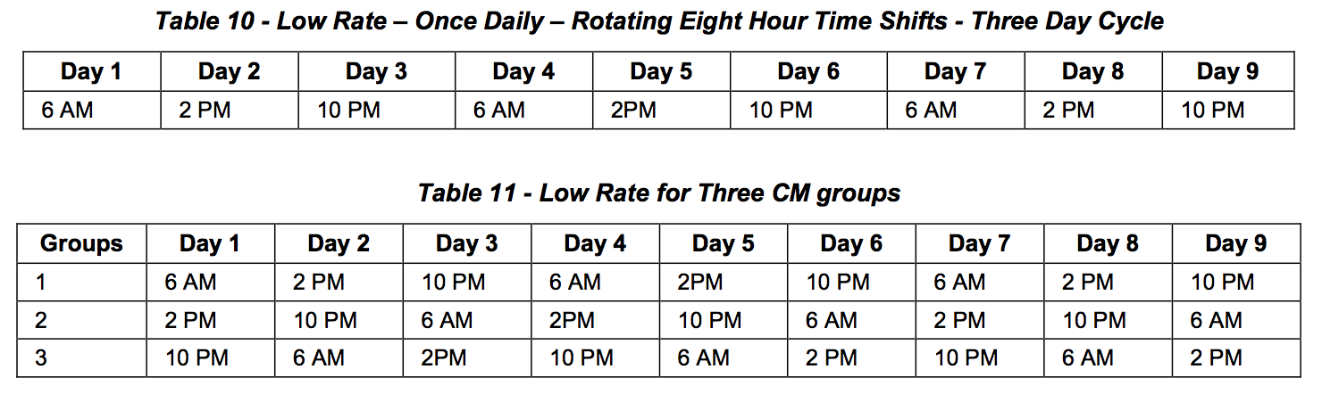

***6.4.2.2 Medium – Rate (every four hours, adjustable)***

The secondary level of analysis will require greater resources to gather, store, and analyze, so sizing should be done based on preliminary results of the initial low-rate poll. This poll will handle the subset devices of interest. Devices may be promoted/demoted across low, medium and high rate polling as described in the analysis section of this document. Table 12 and Table 13 show medium rate polling examples.

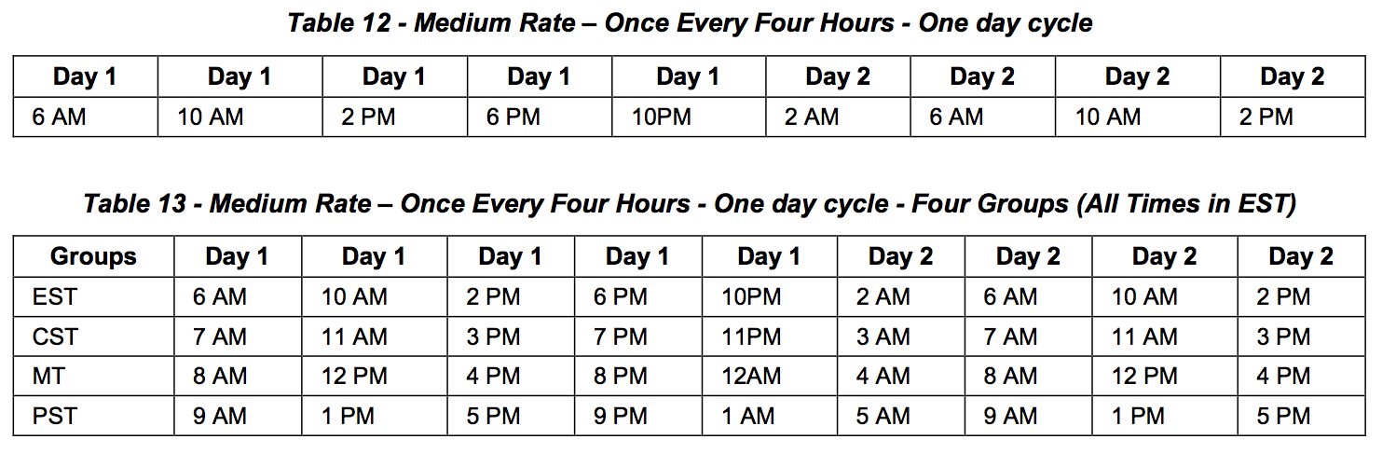

High – Rate (ten minute, adjustable)

Only devices of the highest interest will be candidates for high-rate polling. This will most often be the result of manual intervention to facilitate real-time troubleshooting or field analysis. In general, there will be limits placed on high-rate entries which automatically expire in a designated period of time

**6.5 Calibration Mechanisms 6.5.1 CMTS-CM Short Reference Plant**

Improved accuracy may be achieved by subtracting the contributions of the CMTS and cable modem(s) from the end-to-end channel response, leaving just the channel response signature of the cable network. Determining the channel response distortion contributions of these two components can be done using a short reference plant–sometimes called a six foot plant–which isolates the CMTS and cable modem(s) from the cable network. Adaptive pre-equalization coefficients can then be used to characterize the response signature of the combined devices, much the same as is done to characterize end-to-end pre- equalization signatures in an operating cable network. Once the CMTS and modem response signatures are known, they can be subtracted from operational field measurement results. It is recommended that this characterization be performed for each make/model CMTS and cable modem combination in use.

The short reference plant illustrated in Figure 19 has been measured with a vector network analyzer, and verified to provide optimum performance using the parts listed in Table 14. Choose a diplex filter that has a frequency split well above the normal operating upper frequency limit of the return path. This will reduce the group delay contribution of the diplex filter. For example, a 5-42 MHz DOCSIS return should use at least the 65/85 MHz split diplex filter in the short reference plant.

Interconnecting cables should be as short as practicable, and where it is possible to eliminate cables altogether, one should use appropriate male-male or female-female F-type splices. In any case, avoid exceeding the maximum cable lengths shown in Figure 19.

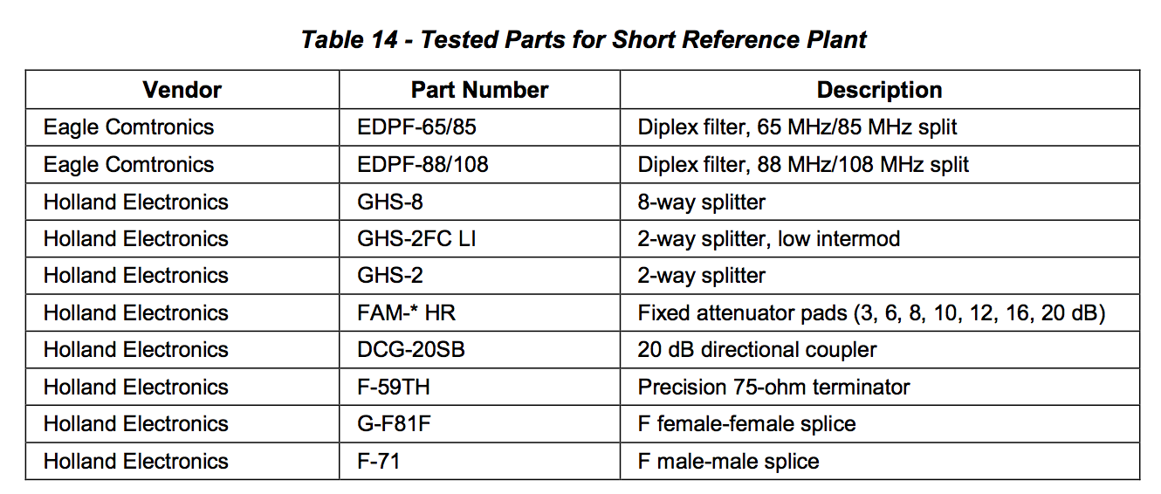

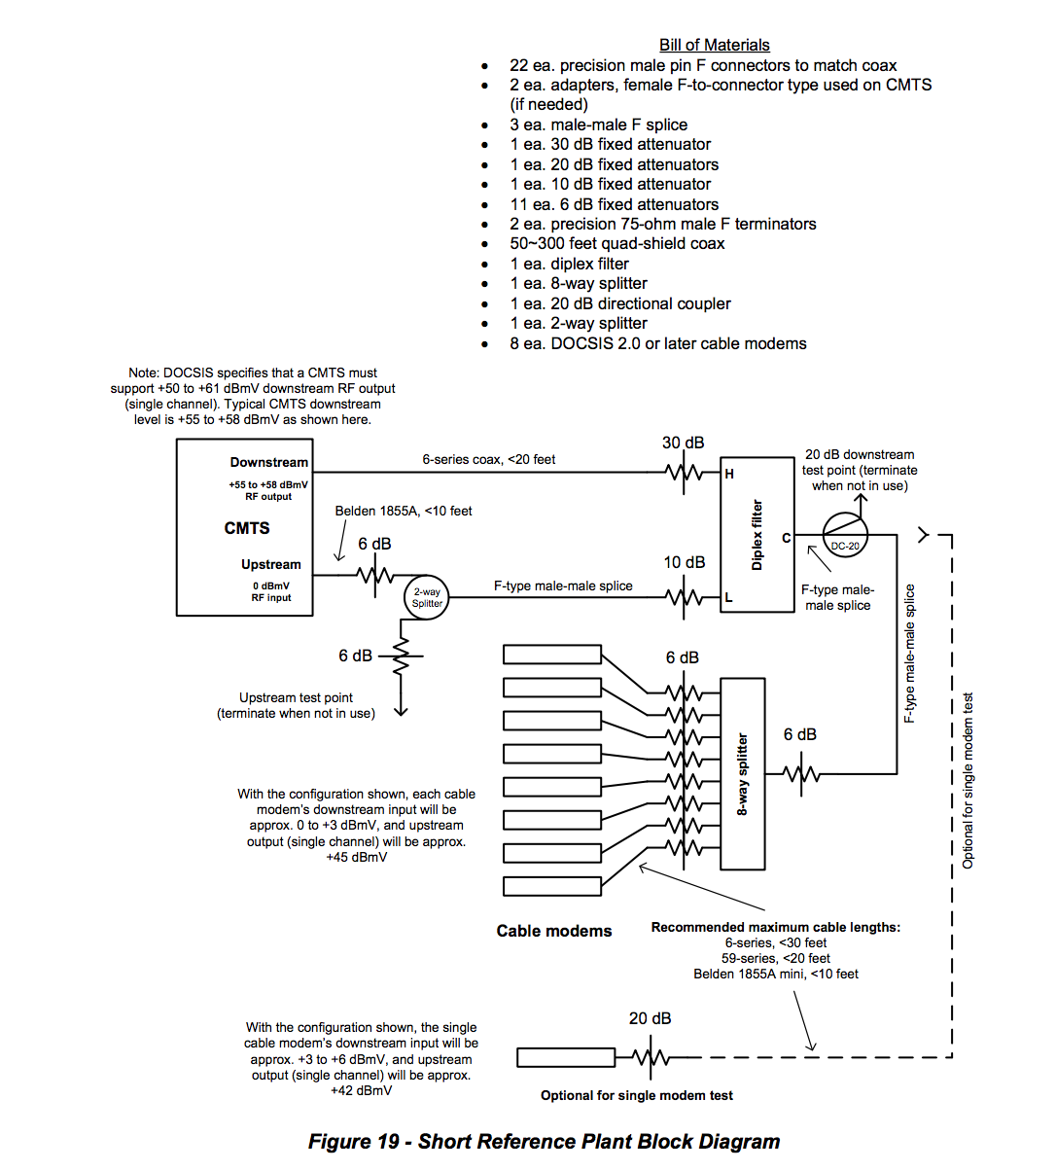

**6.5.2 Pre-equalization Calibration Approach**

The pre-equalization process between CMTS and CM compensates not only for the distortion that occurs in the plant, but also for any existing distortion that exists in the upstream path following the transmit equalizer within the CM up to the baseband receiver inside the CMTS. This includes filters, modulators, and amplifiers in the CM, the home network, combining network at the hub or headend as well as the front-end components in the CMTS (Figure 20).

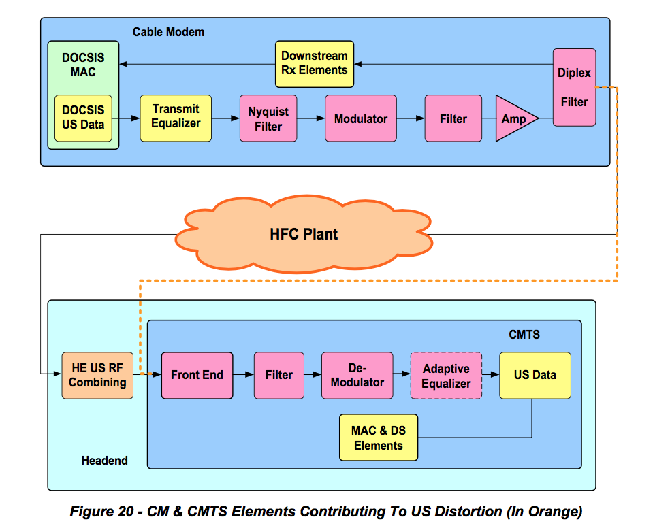

If there was a-priori knowledge of the distortion contributed by the CM and CMTS, it could be calibrated out in order to have a more accurate representation of the distortion in the field.

Generating a database with all the possible CM and CMTS model pairs is feasible given that there are a limited number of CM and CMTS implementations. A known short plant setup consisting of a CMTS-CM pair and a few fully characterized components enables determining almost exclusively the contribution of the CM and CMTS internal distortion. Section 6.5.1 describes an example of a known short plant where the internal characteristics of the CMTS and CM can be measured. The CMTS-CM internal distortion is obtained by gathering the pre-equalization coefficients of the CM after allowing a few maintenance intervals to elapse to achieve convergence of the coefficients.

Assuming that the real and imaginary values of the 24 CM pre-equalization coefficients for a particular CMTS-CM model pair measured on a short calibrated plant are given by:



For every ith real and imaginary coefficient, the resulting complex number is obtained,

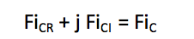

Resulting in the following complex coefficients



Similarly, assuming that the real and imaginary values of the 24 CM pre-equalization coefficients obtained in the field, matching the CMTS-CM model pair being analyzed, are given by:



The resulting complex coefficients are



Given 24 complex coefficients and assuming that the equalizer’s main tap is located at tap position number 8, a 32 element fast Fourier transform can be used to translate from the time domain into the frequency domain. Tap 8 would coincide with FFT input element 16 to preserve the relative position of the response in frequency.

The mapping of coefficients to FFT input parameters follows:



The mapping for the coefficients obtained using the short plant measurement results in the following:



After calculating the 32 point FFT the following frequency response values are obtained:



For calibration, the magnitude of the field coefficients are divided by the magnitude of the short plant coefficients and the phase of the short plant coefficients are subtracted from the phase of the field coefficients.

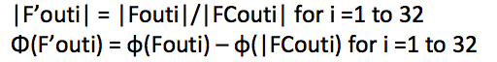

From the calculated magnitude and phase values, the corrected F’out frequency response values are obtained



Additional granularity in the frequency response representation can be obtained by inserting zeroes to a larger size FFT such as a 64, 128 or 256 FFT.

An example of the calibration process is illustrated next.

Figure 21 shows the distortion of a CMTS/CM pair in a short calibrated plant versus the same CMTS/CM pair measured in the field. The pre-equalization coefficients obtained from the CM MIBs are shown in Table 15.

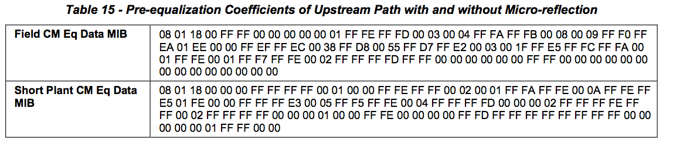

The first four bytes 08 01 18 00 provide the main tap position “08”, the number of taps per symbol “01”, the number of taps “18” (hex number for 24) and a reserved byte. The rest of the information are the real and imaginary coefficient data (2 bytes each) for the 24 taps.

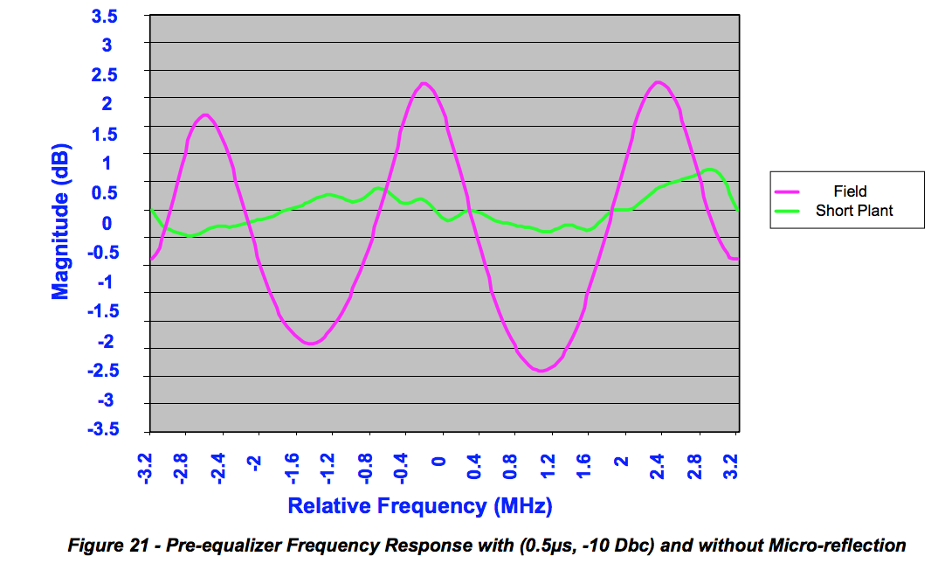

The distortion in the short plant scenario is predominantly impacted by the CMTS receiver and CM transmitter. Therefore, to calibrate out the impact of the CMTS and CM, the frequency response of the short plant (micro-reflection off) is subtracted from the frequency response of the micro-reflection on scenario. This calibrated response is shown in blue in Figure 22.

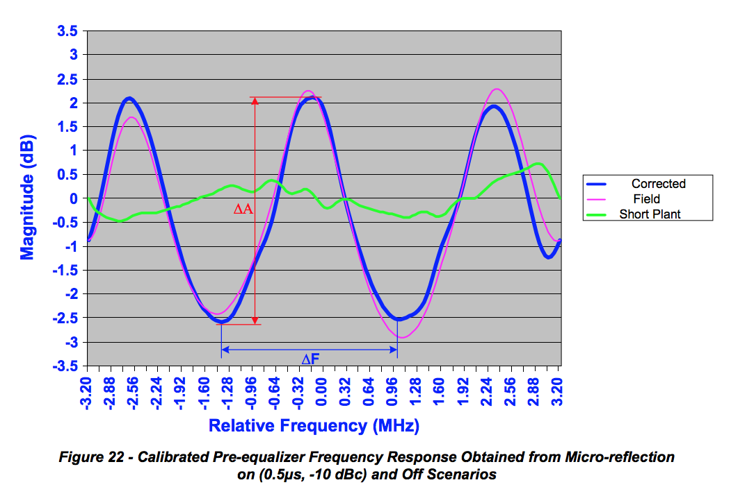

Averaging ΔF and ΔA values is no longer necessary since the calibrated response is fairly even across the frequency range under observation.

**6.6 Fault Localization**

The process of fault detection and localization relies on monitoring the network for general plant-wide or neighborhood-localized problems as well as for specific end devices. In this process it is assumed that there is detailed knowledge of the node service area’s topology. It is also assumed that distortion data (pre-equalizer coefficients and other applicable information) has been collected from the CMs and analyzed to determine the distortion signatures of the affected CM(s). Next, a process is described by which, through correlation of topology with distortion signatures, the location of faults can be determined.

In the example highlighted in Figure 23 is a group of CMs, identified in red, that exhibit the same unique distortion. The CMs in green are CMs that don’t share that specific distortion.

It is assumed that to obtain the distortion signatures, an analysis and classification process of the impairments has already taken place.

If only information from one CM were available, the problem area could only be isolated to somewhere along the path between the CM and the fiber node (dashed line). The more interesting process is when the relationships of CMs that share specific impairments (as well as those that do not) to upstream paths are examined.

In order to estimate the impairment location, the common path shared by the end devices showing the specific impairment is found. This path containing the impairment is further constrained by excluding the path that is shared with the end devices that operate properly.

Knowledge of the micro-reflection signature also helps localize the problem. For example, in Figure 23 a triple transit reflection signature with delay matching the distance between known devices on the plant, such as distance between taps, length of drops, or distance between amplifiers, can point to the likely cause or narrow down the possible set of causes of the problem.

After analysis and path manipulation of the end devices showing impairments such as micro-reflections, a potential location of the problem is determined. These areas are shown in purple on Figure 23. This mechanism maps the devices that have the same unique micro-reflection attribute and pinpoints the portion of the network that exhibits the impairment.

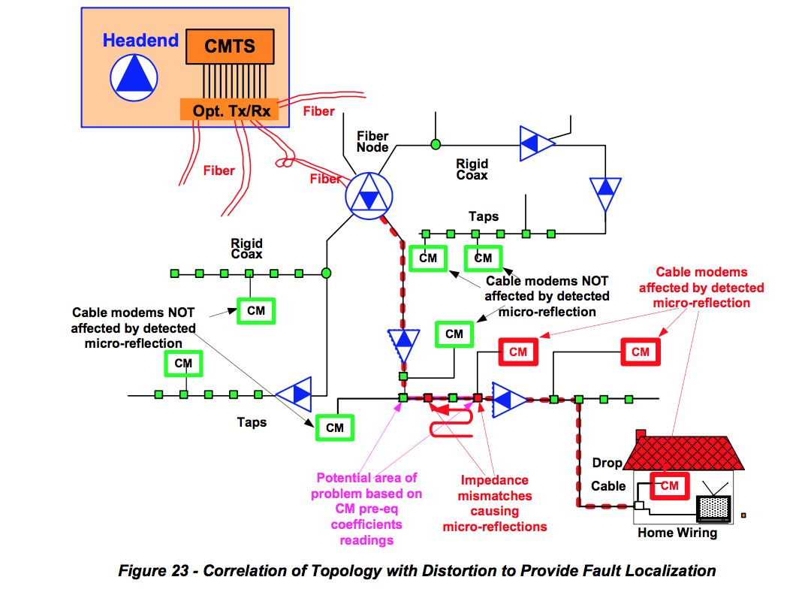

**6.6.1 Fault Localization Examples**

This section details basic examples of fault location based on micro-reflection signatures. Data from a 6.4 MHz DOCSIS channel on a single fiber node was used. A few limitations of the data set are worth noting. First, the node was selected not for the diversity of problem scenarios but for the availability of the digital maps. Therefore, the micro-reflections found were not significant, and in most cases the scenarios detected corresponded issues either near a line termination or impedance mismatches inside or near-the home. Second, there was a relative low number of CMs in the 6.4 MHz channel in this node which lead to few scenarios for evaluations as well as few “monitoring probes/CMs” for accurate determination of the impairment location. High penetration of CMs narrows the potential problem area where the leading edge of the micro-reflection can be located.

**6.6.2 Determining Micro-reflection Signatures**

A micro-reflection signature consists of a pair of characterizing elements, the relative level of the reflected signal compared to the main signal and its delay. The level provides an indication of the severity of the micro-reflection (see Section 6.7.4 for Severity Analysis Strategy for Intermittent Issues considerations). The delay represents the extra distance traversed by the reflected signal or echo and is represented in microseconds (see Section 5.2.1 for definitions of micro-reflections types).

Figure 24 shows the frequency response of several CMs sampled from a fiber node. For clarity, only a few CMs are included in the figure. However, in the field, if encompassing an entire fiber node, the technician will have to pay close attention to the chart to distinguish and extract the common micro-reflections (labeled as A and B in Figure 24 and Figure 25) from all the micro-reflections present. Nonetheless, the intention of this section is to explore systematic mechanisms where human intervention can be minimized as a first pass at extracting the most relevant cases for analysis and troubleshooting. In summary, the micro-reflection signature which provides a two-dimensional characterization from which the selection of common frequency responses as noted in Figure 25 is feasible.

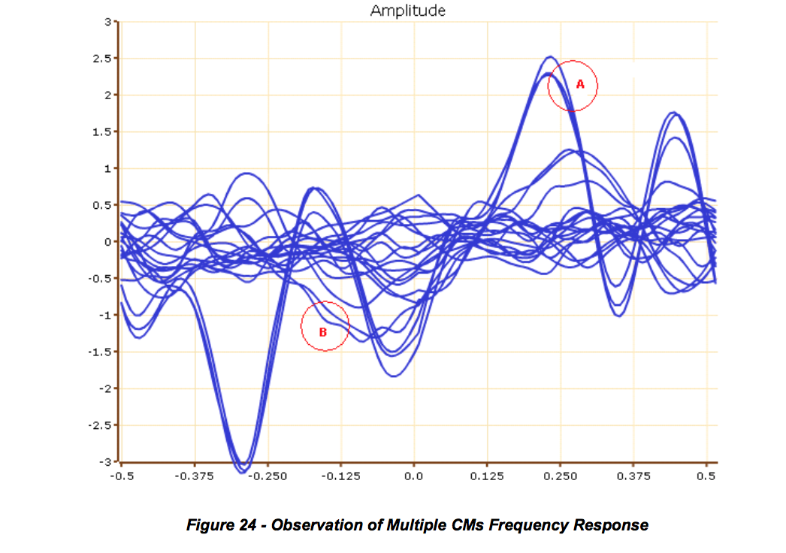

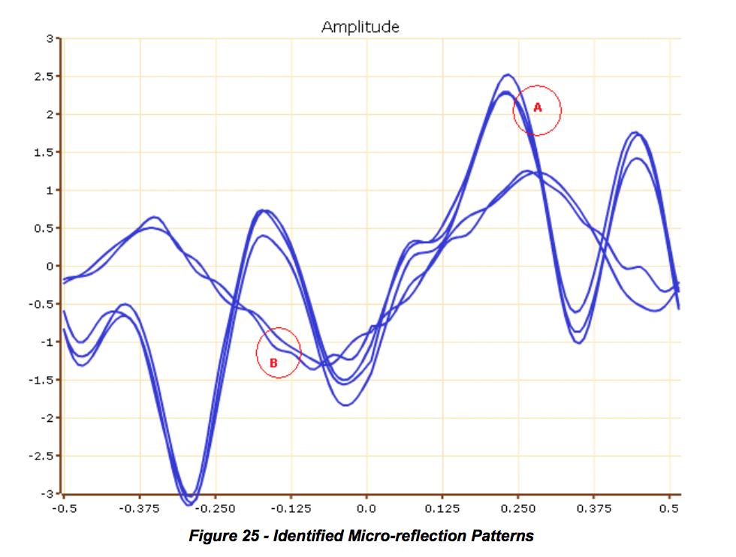

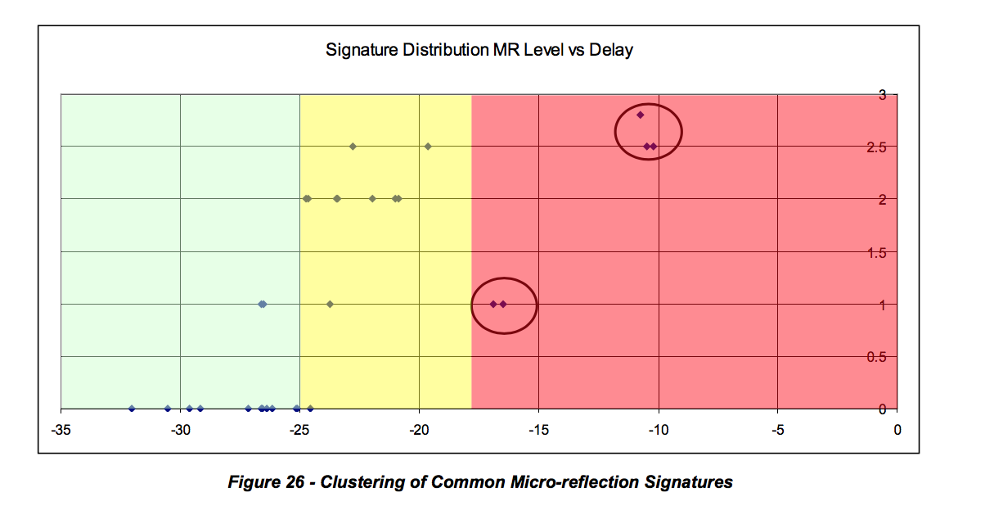

As seen in Figure 25, the amplitude ripple of the frequency response is sufficient to determine group the CMs with same micro-reflection. Some amplitude variability margin must be allowed. Note that in a few cases, the same ripple magnitude range could correspond to different micro-reflections. In such cases the estimation of echo delay can provide an unambiguous answer. For typical fiber node sizes the probability of uniqueness of a micro-reflection is very high. In rare exceptions, the micro-reflection signature pair will not be sufficient to determine the CM clusters (e.g., a sub-T echo delay). In such cases, only the topology resolution will provide final resolution of such conditions. Figure 26 shows the way that common signatures of CMs are correlated. The delay is an approximation of the estimated maximum delay and it is expressed as 2T where T is the inverse of the symbol period. That means the distance between the two reflectors is calculated based on half the delay. Delay below the "no action required" threshold is not relevant.

**6.6.3 Determining Micro-reflection Boundaries Edges**

For the relevant micro-reflections cases A and B, the next steps consist of performing the localization within the HFC plant topology.

By considering the upstream direction and other CMs in the path that do not present the same signature, the trailing edges of the micro-reflection is determined as discussed at the beginning of this section.

Figure 27shows micro-reflection case A. This micro-reflection can be considered as a composite of type 1 and 2. CM1 and CM2 are close to the Tap reflecting the signal and CM 3 has an additional transit for the echo relative to the distance to the reflecting tap. Hence the echo from CM3 (2.8T) is longer than CM1 and CM2.

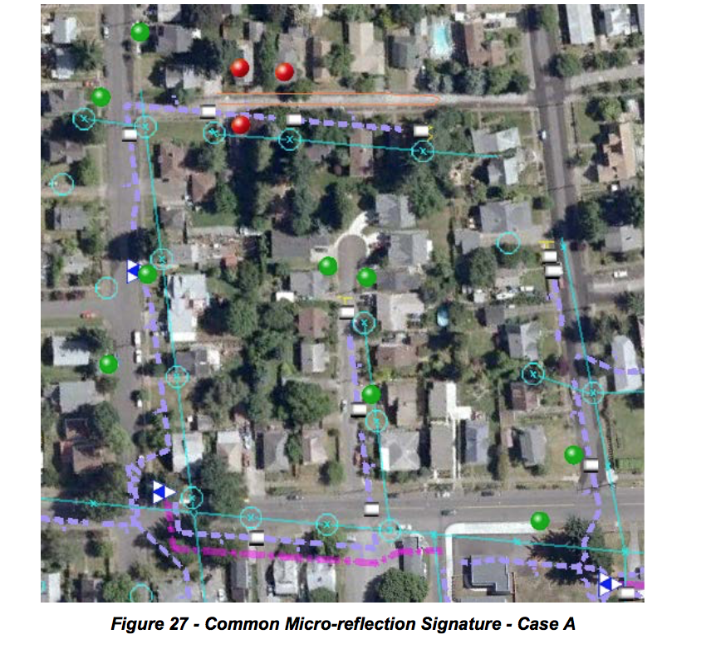

Figure 28 shows the case of a single sub-T echo. The two signatures come from the same household, H1, and note the neighbor CMs: CM4, 5, 6, and 7 do not register the same micro-reflection signature as the CMs in observation.

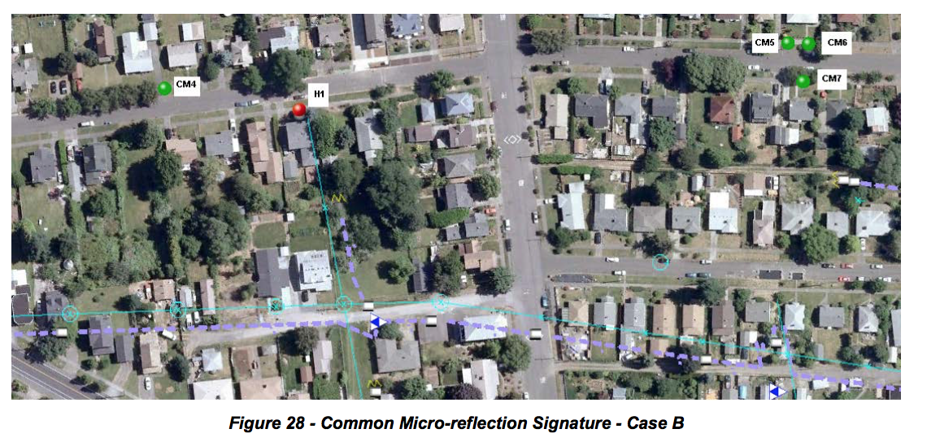

Note that limited data could lead to non-optimal location of the micro-reflection. For example, fewer CMs reporting pre-equalization data or few customers in the fiber node branch will reduce the possibility to accurately estimating the location of the micro-reflection.

**6.6.4 Parabolic Interpolation**

In most cases the actual time delay of an echo does not land directly on the delay of a tap in the pre- equalizer. Rather, the echo may occur at a delay that lies somewhere between two taps. The purpose of the parabolic interpolation algorithm is to improve the resolution of time delay estimation to a fraction of a pre-equalizer tap.

Figure 29 below shows an example test case. Pre-equalizer taps 9, 10, and 11 have magnitudes 35 dB, 40 dB and 29 dB, respectively. We are not concerned about other taps since the algorithm uses only a 3-point interpolator, so the surrounding taps are plotted as zeros.

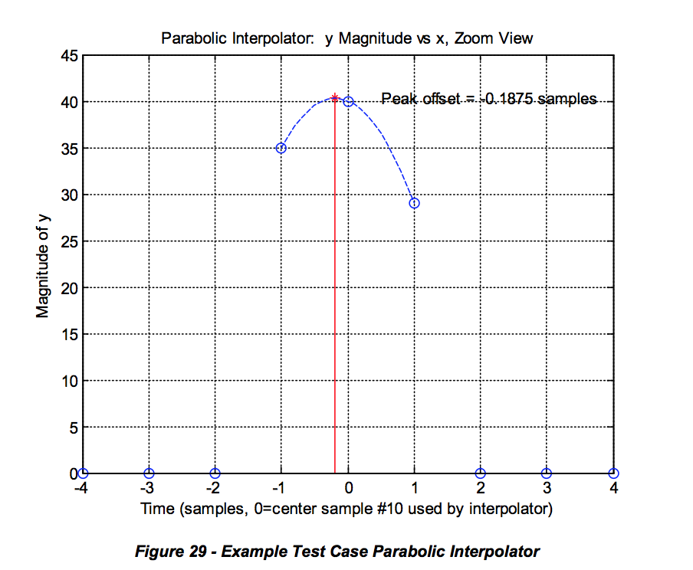

The algorithm inputs are the 3 taps around the (local) peak: (x0,y0), (x1,y1), (x2,y2), where the middle sample (x1,y1) is the local peak of interest. The x value is the pre-equalizer tap number (typically in the range from 1-24) and the y value is the tap magnitude in dB. It has been found empirically that using the dB values gives good results; it is not necessary to convert from dB values to power ratios. Hence for our example we have the following inputs to the algorithm:

x0 = 9

y0 = 35

x1 = 10

y1 = 40

x2 = 11

y2 = 29

The algorithm fits a parabola, shown in the figure as a dotted blue line, to the 3 taps. We assume the equation for the parabola is y = a*x^2 + b*x + c.

The following code solves for the location of the peak of this parabola:

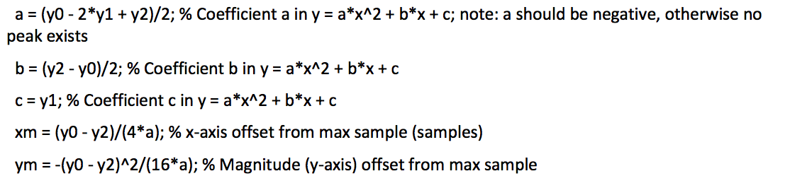

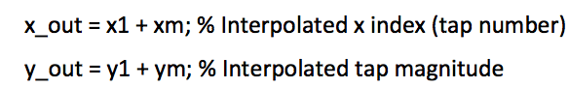

The output is (x_out,y_out). The x_out value generally lies between integer tap numbers, giving fine time location information. The y_out value may also be used if fine magnitude accuracy is desired. In our example we have the following outputs:

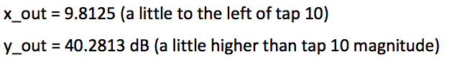

**6.7 Severity Assessment**

The goal of any operator’s service department is to be invisible to its customers’ experience. Too often leaders have reviewed post mortem reports only to discover the failure was a slow degradation caused by water migration and corrosion. In other words, there was an opportunity to resolve the impairment before the customer had to alert the cable company to the failure with a trouble call. This issue points squarely at the operator’s preventive maintenance program or lack thereof. A plant inspection program such as system sweep is a great idea but operators rarely have enough resources available to inspect, locate and make repairs before a customer notices the failure. Tracking the length of time it has been since an area has been inspected is fine but it doesn’t solve the resource problem. Operators are left with sweeping areas/nodes that are showing an increase in the number of trouble calls or outages. This method is reactive, not proactive.

Planning an effective preventive maintenance program is based on historical practices. When an operator uses statistics such as MER (SNR), FEC, T1-T4 timeouts, receive level and transmit power, which are all important variables to track over time, data is being used that would be better served in an active maintenance program. That being said, if the *MER* and *FEC* are bad then the customer has already been influenced in a negative way. If the modem is timing out on a range request or response, then the customer is being affected. If the levels are fluctuating outside the expected range of the design, then customers usually feel the pain. It turns out that adaptive pre-equalization resolves a lot of plant impairments. Of course, there is a limit to what can be compensated for using adaptive equalizers and for how long. This is especially true when consideration is given to the fact that whatever is already broken will continue to derade. The power of PNM lies in the ability to be alerted to failure before MER and FEC and other statistics begin to ring the alarm bells. If an operator is able to solve the problem within the window that pre-equalization is saving the day, then trouble calls and outages are being prevented and the customer’s experience is being preserved.

One of the first things an operator will need to determine is the MTR threshold for what is good and bad. A good starting point would be to review the original recommendations from CableLabs’ first document on PNM. The following recommendations were included in that document: Thresholds will determine which modems are green (no action required), yellow (high monitoring frequency) and red (immediate action required). That information can then be used for CMTS health. If the thresholds show most of the modems in red, then that means that everything must be inspected. On the other hand, if the thresholds are not reviewed regularly and updated, the operator could be missing opportunities to improve. A few of the variables which the operator should consider when selecting threshold include amplifier cascade, node size and bandwidth utilization.

MTR severity should still be graded into three categories: immediate action required (Red), high monitoring frequency (Yellow), and no action required (Green).

From the original PNM document, the three severity assessment metrics that are used for a single CM are defined as follows:

The first severity metric is a static classification conducted solely based on the relative level of the MTR.

A second severity metric results from a trending analysis that is conducted so that a network operator can identify an impairment degrading at a rate that will result in immediate action in the near future (e.g., one week). This method requires time stamping of the measurements gathered so that a history of the impairment is obtained. Typically 3 dB of level change is worth attention.

A third severity metric is generated from a historical comparison of the MTR levels of the high frequency monitored CMs. This third metric measures intermittent fluctuations that would be considered significant, but which did not rise to the immediate action level. The measurements should be conducted over multiple days. The comparison of the measurements is done at the same time of the day. Again, 3 dB of level change should ring alarm bells.

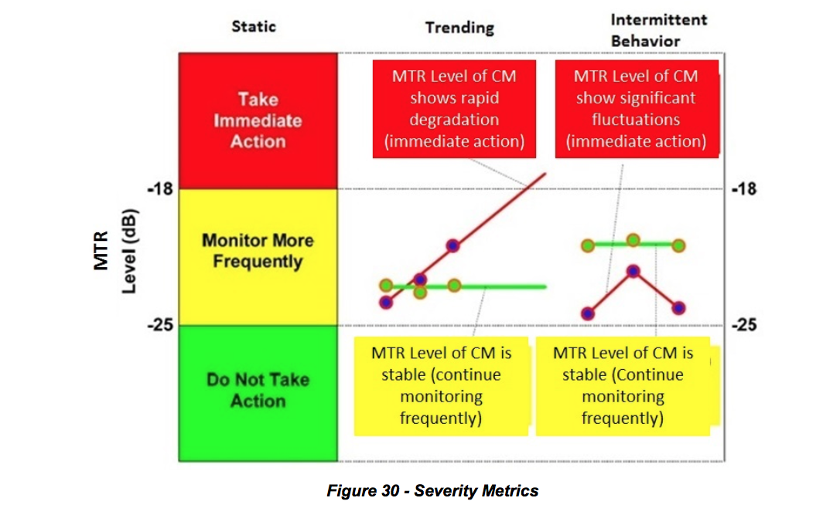

It is noteworthy to point out that this same approach can be applied to other levels like *micro-reflection* or *group delay*. *Micro-reflection* levels can be calculated by using the same formula for MTR while utilizing the equalizer tap values that compensate for micro-reflections *Post-MTR* (usually taps 9 through 24). *Group delay* level is typically calculated using taps 1 through 7.

Operators that are new to the PNM process may want to use the following metrics as a starting point for the first year or two. Explaining to a team of technicians that 50% or better of their network is suddenly bad will not inspire them to fully grasp a new idea. The metric in Table 16 will also ensure that the most vulnerable parts of the network will receive attention first.

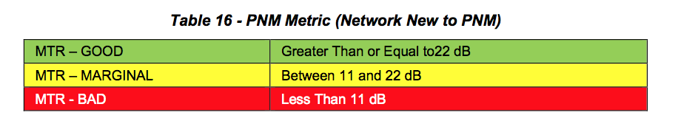

Systems that have short amplifier cascades may want to stick with the original recommendation from CableLabs which is represented in Table 17. Amplifier cascades that are fewer than four and have a well- established PNM team for support would fall into this category. Plant Health index, which will be explained later, that falls in the neighborhood of five would be well served by this metric because there is room to improve.

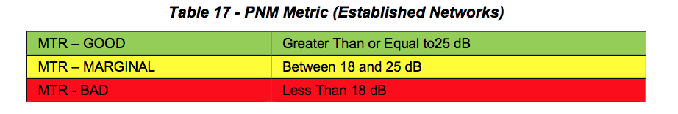

Another point that operators should consider is when a modem starts using a more robust modulation type such as *16-QAM* because of high noise, it is a clear sign that something is broken and needs attention. However, if the metric doesn’t change in pace with the less demanding modulation type, a problem could be concealed.

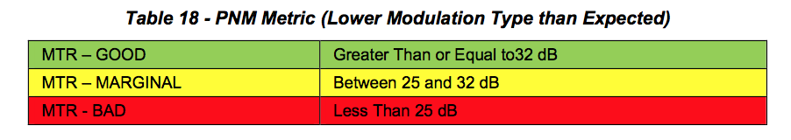

It is valuable to know that a modem is compensating for impairments, but if that was the limit of what could be ascertained, then it is unlikely PNM would be a successful tool. The power of PNM is the comparison to and correlation with other modems to identify clusters or groups that may be affected by the same impairment. It is like turning all of the modems into mini-sweep meters then comparing the response of those meters to identify problems. An operator should keep track of the total number of groups and focus on reducing the number over time.

CMTS or Plant Health is calculated by using the formulas on the next page. This is an excellent way to take large numbers of modems’ MTR values and place them on a scale from 1 to 10, with 10 being perfect. Since the desire is to identify which node or upstream interface needs attention, a *Health Index* by node doesn’t work well because it lacks clarity with so few modems. It is better to flush out upstreams using an average level of MTR, micro-reflection or group delay. The formulas are fairly simple in that they compare the number of troubled modems or the total number of registered modems on the CMTS. Only 50% of the marginal/yellow modems are used in the formula since they are not as damning as the critical/red modems. There are two basic spins on the *Health Formula* which varies by the denominator. If a modem is unable to produce an accurate MTR value, such as a legacy modem that doesn’t utilize pre-equalization, then that modem should be excluded as shown in Formula 1. On the other hand, if a significant number of green modems stop communicating because of something outside the control of the operator, like commercial power, than an operator could use Formula 2. Keep in mind the larger the total number of modems that are being used in the formula, the better the index will be. A well-operating system typically lives around the index of 7, but what is more important is for an operator to have room to improve.

Customers care little about a cable operator’s measuring tools when it comes to their ability to enjoy the service being provided.

CMTS/Plant Health Formula 1:



CMTS/Plant Health Formula 2:



The use of the trending or intermittent approach could be difficult since it requires time stamping pre- equalization records and deploys an effective filtering process that produces usable data without getting drowned by information over- load. A good example would be the CableLabs-authored SCTE/ISBE Cable- Tec Expo 2015 operational practice2. The authors were able to show the ability to flush out noisy drops, which is traditionally a painstaking activity, through the use of monitoring intermittent MTR activity. Considering intermittent activity could be a tough sell if the plate is already more than full with just trying to diminish the static opportunities. However, every operator would benefit by building, early in their PNM tool development, a methodology to time stamp and store data points. That data would provide huge dividends as the outside plant performance improves. It is also worth pointing out that tracking other metrics, which are easily recorded and available, such as modems transmit or received power, could aid in the initial identification of trouble-prone areas which could benefit from some PNM support.

Using the pre-equalization mechanism defined in DOCSIS is efficient, resulting in no performance degradation even in the presence of strong micro-reflections. Pre-equalization may help decrease the urgency for plant repair, but it should not be used to circumvent required plant maintenance. The purpose of proactive network maintenance is to listen to important network health metrics and take action before service is impacted.

Micro-reflection severity can be graded into three categories: immediate action required (Red), high monitoring frequency (Yellow), and no action required (Green).

The three severity assessment metrics that are considered for a single CM are defined as follows:

The first severity metric is a static classification conducted solely based on the relative level of the micro- reflection amplitude.

A second severity metric results from a trending analysis that is conducted so that network operators can identify an impairment degrading at a rate that will result in immediate action in the near future (e.g., one week). This method requires time stamping of the measurements gathered so that a history of the impairment is obtained.

A third severity metric is generated from historical comparison of the micro-reflection levels of the high- frequency monitored CMs. This third metric measures intermittent fluctuations that would be considered significant, but which did not rise to the immediate action level. The measurements should be conducted over multiple days. The comparison of the measurements is done at the same time of the day.

Refer back to Figure 29 for an illustration of the severity assessment metrics.

As seen from Figure 29, a single micro-reflection level of -18 dBc results in an amplitude ripple of 2.2 dB and a -25 dBc micro-reflection results in an amplitude ripple of 1 dB. See Micro-reflection Calculator in Appendix IV for more information on converting ripple to relative micro-reflection levels.

**6.7.1 Initial CM Selection for Analysis**

It is assumed that the monitoring strategy combines a standard measurement interval (MIntSTD) to monitor all CMs in the network with a frequent measurement interval (MIntFREQ) for CMs that are deemed of interest for further analysis. This initial assessment of which CMs need to be examined further and more frequently can be done using the distortion metric MTR.

This distortion metric, expressed in dB, can quickly indicate which CMs have to go through detailed signature analysis. These CMs of interest will also be placed in the “monitor more frequently pool” to gather performance history and detect signature trending and intermittent behavior.

Consider a scenario in which the threshold value of the distortion metric is -25 dBc, as shown in 6.3. This means that any CM that exhibits a MTR > -25 dB will undergo detailed coefficient analysis through which one or more micro-reflection signatures will be determined. It is assumed for the analysis that follows that the CM pre-equalization coefficients have already been analyzed and manipulated, and distinct micro- reflection amplitude and delay signatures have been obtained.

**6.7.2 Severity Analysis Strategy for Static or Single Data Point Scenario**

In a static environment where no change of pre-equalization data is assumed, or when there is only one data point and not able to determine change, a simple set of fixed thresholds can be used to determine severity categories.

For example, a total distortion energy amplitude of -25 dBc or lower may fall into the category of “No Action Required,” while -18 dBc or greater may be considered in the category of “Immediate Action Required.” Two thresholds determine the three categories. In Figure 29, the values below -25 dBc belong to the “No Action Required” category or green severity. The values above -18 dBc belong to “Immediate Action Required” category or red severity. The values between -18 dBc and -25 dBc belong to the category “High Monitoring Frequency” Category or yellow severity.

As additional data points are collected, time dependent analysis can be conducted which is described in the next section. Since time dependent analysis is conducted for CMs that are already in the yellow category from a static perspective, the time dependent severity classifications only have to define a red classification criteria.

**6.7.3 Severity Analysis Strategy for Trending**

If, for example, an analysis resulted in a single micro-reflection with a signature of -22.2 dBc in amplitude and 0.5 μs delay, it would fall into the yellow severity or “monitor more frequently” category. At the same time, a second CM showing an initial signature of -19.2 dBc in amplitude and 1 μs delay also falls into the yellow severity or “monitor more frequently” category.

Assuming that the standard measurement interval (MIntSTD) is once a day and the frequent measurement interval (MIntFREQ) is every four hours, the data from these two CMs’ micro-reflection amplitudes tracked in time is detailed in Table 19. The micro-reflection time delay is not used for comparison here and is not shown. It is expected though that the changes in delay will be negligible.

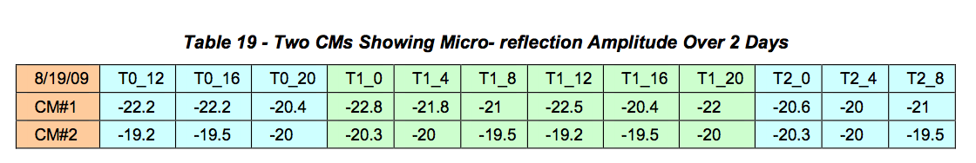

The time measurement reference parameter Tn_m is coded as follows; the first number (n) indicates the number of days after the initial measurement date, while the second number (m) corresponds to the approximate time of day when measurement was taken. This means that measurement T0_16 was taken at 4:00 p.m. on the same day as the initial stored measurement, and measurement T2_12 was taken two days after the first measurement and at 12:00 p.m.

Figure 31 plots Table 19’s micro-reflection amplitude versus time, indicating that in less than three days, CM#1 will be going from yellow to red according to the static criteria while CM#2 stays in the yellow region. These trends should be conducted using data points measured at the same time of the day so that approximately equal temperature data points are obtained.

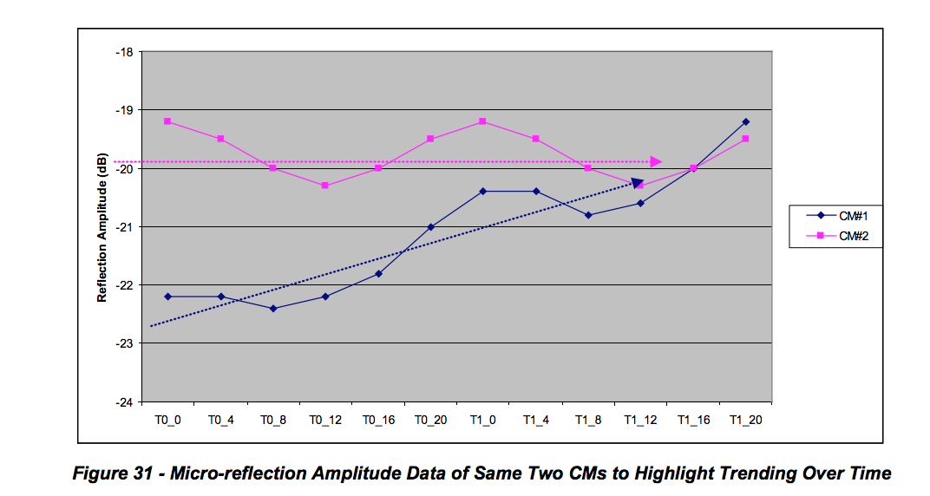

If CM#1 shows a delta of 1.8 dB between T0_0 (-22.2 dBc) and T1_0 (-20.4 dBc), at that rate of change it will reach -18 dBc in less than three days with respect to T1_0. The estimated level at T2_0 is -18.6 dBc and T3_0 would be -16.8 dBc, crossing into the red region.

If delta amplitude per day is D, the last amplitude measured was MRLast and if MRLast + 3 * D > Trending Red Threshold then it is classified as red for the trending criteria.

3D is a variable subject to operator adjustment and is intended as a recommendation.

In addition, another indicator of urgency is determined by the number of days that the operator has until the micro-reflection amplitude reaches the red region.

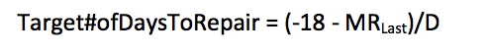

**6.7.4 Severity Analysis Strategy for Intermittent Issues**

Another time-related behavior of adaptive equalizer coefficients operators may observe is the rapid change of micro-reflection amplitude. This intermittent behavior may be hiding a problem that is on the verge of causing service interruption and should be addressed promptly.

Table 20 shows two CMs that are monitored more frequently as they initially were categorized in the yellow category but one of the CMs shows a behavior that cannot be explained with daily temperature variations.

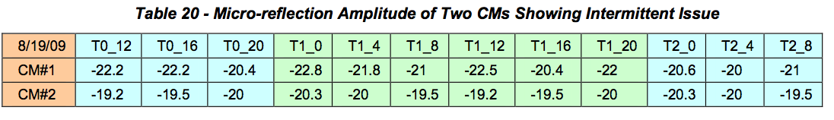

Figure 32 plots Table 20’s micro-reflection amplitude versus time showing CM#1 with significant micro- reflection amplitude swings. Both CMs remained in the yellow region under the static severity criteria but CM#1 shows drastic changes in micro-reflection amplitude which could be a loose connector or something likely to break in the very near future.

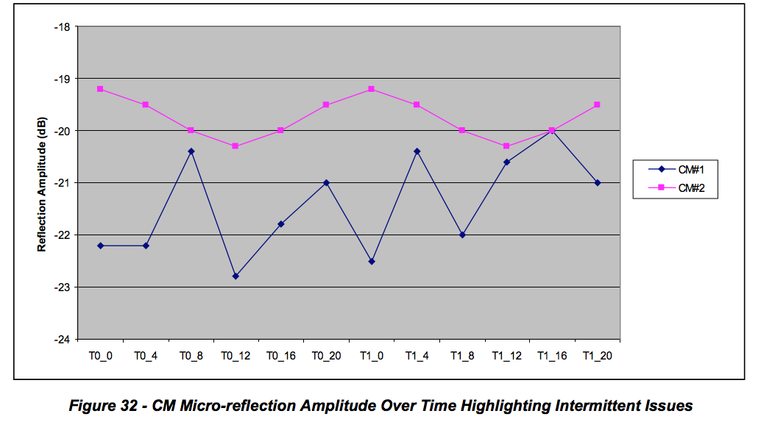

CM#2 shows gradual amplitude swings that could be attributed to daily temperature variations. CM#1 shows significant variations in micro-reflection amplitudes. A metric that could define the red classification criteria for intermittent behavior is proposed as follows.

Intermittent Red Threshold = Avg 4 hour ∆ Ref. Amp / (Static Red Threshold – Avg. Refl. Amp.) > 0.25 where the average four hour delta of the reflection amplitude represents the average swing in dB over the four hour interval which corresponds the monitoring granularity in time of the devices that were deemed to need high-frequency monitoring and historical data tracking. The average reflection amplitude is measured up to a fixed number of days (for instance, four days). If this metric approaches 1 it indicates that the reflection amplitude is varying with swings that approach the static threshold level. If this metric is smaller than 0.1, for example, one can say that the reflection amplitude swings occur at a safe margin below the static threshold.

The scenarios just discussed dealt with the quantification of the degree of impairment of a single CM. It is assumed that a cable operator may add weighting factors to indicate urgency in addressing these issues after the previous information is correlated with the number of CMs affected by a particular impairment. The analysis used to determine fault location can also be used to determine how many users will be impacted.

**6.7.5 Grouping Similar Responses (Signature Matching)**

In many instances a single plant impairment will simultaneously affect multiple cable modems. The affected modems will exhibit the same or similar frequency response signatures. The following section describes how to identify and group those responses, a process called signature matching. This technique facilitates easier troubleshooting and repair of the problem. When locations of modems affected by a common problem are overlaid on an outside plant map, identification of where the common problem exists is simplified. Figure 33 shows an example of five groups of modems affected by five different plant problems. The colored location markers on the left represent individual cable modems, with each color corresponding to a group of modems affected by a common plant impairment. The frequency response signatures on the right in the figure are color-matched to their corresponding groups of modems. In other words, the red modems are all affected by one particular plant problem common to those modems; the purple modems are affected by a different plant problem, and so forth.

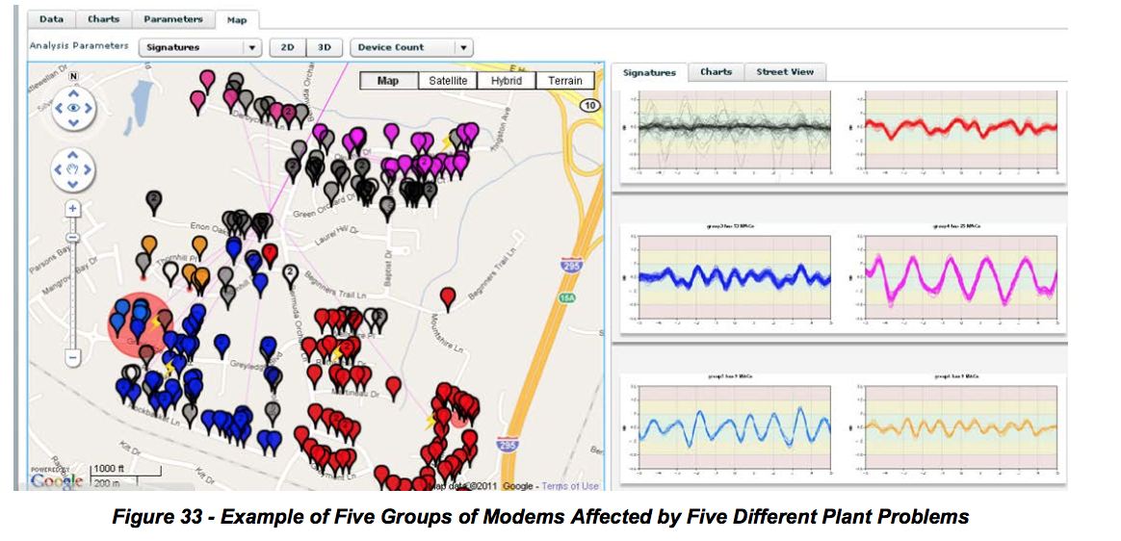

**6.7.6 Upstream Equalizer Response Matching Procedure**

It is important to determine a number of cable modems in a node that are using a same common echo solution to discover a location of a plant impairment that caused a common solution. If an echo is created in hardline plant, it will likely affect more than one home. If an echo is created inside a home or on a home’s drop, it will probably affect just the one home.

However it is possible for two modems both to share a common impairment, but one or the other can also have unique impairments. For example, an impedance mismatch inside a home could create a non-shared impairment. Fortunately, most unique echo tunnels are less than 50 meters, which affect only taps 9 and 10.

When working on a trouble call, a technician wants to know if an upstream linear distortion impairment problem one customer is experiencing is shared by multiple subscribers. Localizing the impairment will determine where the repair truck should go and whether an installer or line technician is required to fix the plant fault.

The equalization coefficient data may be extracted from a database, or alternatively the data may be obtained real-time by polling.

Digital signal processing is performed by processing one CM’s equalizer data with another CM’s equalizer data. Two methods are discussed. A first method uses complex frequency domain division of coefficients, where a resulting flat frequency response means a perfect match. A second method is simpler complex time-domain coefficient subtraction, followed by a restoration of the main tap.

***6.7.6.1 Process:***

Determine all the MAC addresses connected to a node. This can be done by connectivity records, or by examining the MAC addresses that are connected to an upstream interface.

For each MAC address, obtain CM coefficient data and eliminate invalid responses. This results in a reduced node list, with all CMs having valid coefficient data. It is now desirable to reduce the number of match computations, because the number of match computations is proportional to the number of CMs squared. (The number match calculation for a typical node’s population, while not negligible, can be done in several seconds with modern computers.)

CMs must also belong to the same logical channel, including the same center frequency and same bandwidth. Optionally, eliminate CMs that have unimpaired responses. That is, if the main tap to all other tap energy (MTR) is below some threshold, such as 25dB, there is no serious echo. This results in a node list with all CMs having echoes needing to be matched, if possible. (Note that if a very low match threshold is used, CMs coming out of the same factory or of the same design will match.)

Going round-robin fashion, process each CM’s coefficients with each of the other CMs’ coefficients and compute a single match value for each match pair. If a match value is above some threshold (such as 18dB), indicating the two unit match, a match result of 1 is set. Otherwise a match result of 0 is set. Match results may be stored in a square matrix. If a node’s list of CMs needing to be processed is 100 CMs, 10,000 comparisons will need to be computed, resulting in 10,000 match values. See Table 21 for an example 20 x 20 matrix created with a match threshold of 18 dB. Because every unit matches perfectly with itself, a diagonal line of 1s is obtained. Note in Table 21 for an example 20 x 20 matrix created with a match threshold of 18 dB. Because every unit that units 0 and 1 match, units 3 and 9 match, and units 11 and 17 match. More on matching processes later.

Convert the matrix into a symmetrical triangular matrix by forcing all matching pairs to agree. For example, if unit 11 matches with unit 17, unit 17 is forced to match with unit 11.

From the matrix form groups of CMs with matching coefficients, and plot them on a GIS map. One group-forming strategy is to remove CMs from the pool once they are in a group. Another strategy is to incorporate GIS data to prevent a mismatch. That is, a distant CM probably found its way into a group accidentally.

Create work tickets for line technicians for each matching group.

Create work tickets for service technicians (or installers) with single homes having unmatched bad responses.

***6.7.6.2 Frequency Domain Division Method to Determine If Two CMs’ Responses Match***

One method that can be employed to see if two units have matching responses is to just “look at” or “eyeball” a plot of the complex coefficients in either in the time domain or in the frequency domain. This is complicated by the coefficients being complex with both real and imaginary components, so a two- dimensional plot can be hard to interpret. So despite the human eye being a versatile instrument, it is difficult for the human eye to establish a single number that quantifies a difference between two similar- looking responses. Other less-effective methods that could be used are to numerically measure the ripple of the responses, or use the frequencies of peaks and troughs in the responses.

A simpler method is to perform a de-convolution with a frequency domain (FD) division of one unit’s FD coefficients with the other unit’s FD coefficients. If two responses are exactly the same, a resulting quotient frequency response will be unity at all frequencies, with a flat phase response at zero degrees. This method is essentially a calibration process, with the denominator unit being used as a reference value. De-convolution is a standard Matlab function, and is most efficiently performed in the FD.

**Example:**

Assume the 24 coefficients from the MIB (time values) are zero-padded out to 32 and converted with a FFT, giving 32 frequency domain points.

Figure 34 is a plot of a set of coefficients for cable modem A with about a 14 dB T-spaced echo. The main tap on the plot has been barrel-rotated (circular) from index 8 to 0. The main tap has a value of approximately 1.0, but the vertical scale has been compressed to 0.2 to enhance the values of the taps on a linear scale. The ratio of the energy in the main tap to all other taps combined is 14.09 dB for modem A.

The corresponding “correction” frequency response is shown is Figure 35. Note that the frequency response of the physical channel will be approximately a frequency domain inverse of the response shown in Figure 35.

Figure 36 and Figure 37 are the corresponding frequency responses of Figure 34 and Figure 36 look alike in the time domain, and responses of Figure 35 and Figure 37 look alike in the frequency domain. The ratio of the energy in the main tap to all other taps combined is 15.3 dB for modem B.

Figure 38 is a quotient frequency set obtained by dividing each coefficient in Figure 35 by a same- frequency coefficient in Figure 37. Thus, if a frequency domain coefficient in Figure 35 is .55 at an angle of 130 degrees, and the corresponding same-frequency coefficient in Figure 37 is 0.57 at 120 degrees, a resulting coefficient in Figure 38 is 0.9065 (.55/.57) at an angle of 10 (130-120) degrees. If the coefficients in CM A and CM B were identical, Figure 38 would have a response of 1.0 at zero degrees at all frequencies.

At this point, a 32-point IFFT is employed to find an impulse response (time domain) associated with the frequency-domain quotient response associated with Figure 38, and a resulting time plot is shown in Figure 39 If the two responses are absolutely identical, the impulse response would be 1.0 real and 0.0 imag at index 0 and 0.0 real and 0.0 imag (MTR) at every other time index. The units are matched if the ratio of energy in the main tap to the energy in all other taps is below some threshold, such as 25 dB. (In general, it is good to make the threshold level adjustable.)

Experience has shown that some CMs that are experiencing a common hard-line echo may also be experiencing a unique in-home echo. The presence of an in-home echo may cause the matching process to fail for this house. This problem can be mathematically remedied by zeroing-out the “close-in” taps on either side of the main tap, thereby eliminating the energy of the house echo. This method only works well when the hard-line echo is of a relatively long duration.

In digital signal processing, equivalent processing can be done in either the time domain or frequency domain. Time domain convolution is functionally equivalent to frequency domain multiplication.

Matching code is available in the CableLabs’ member-accessible code repository.

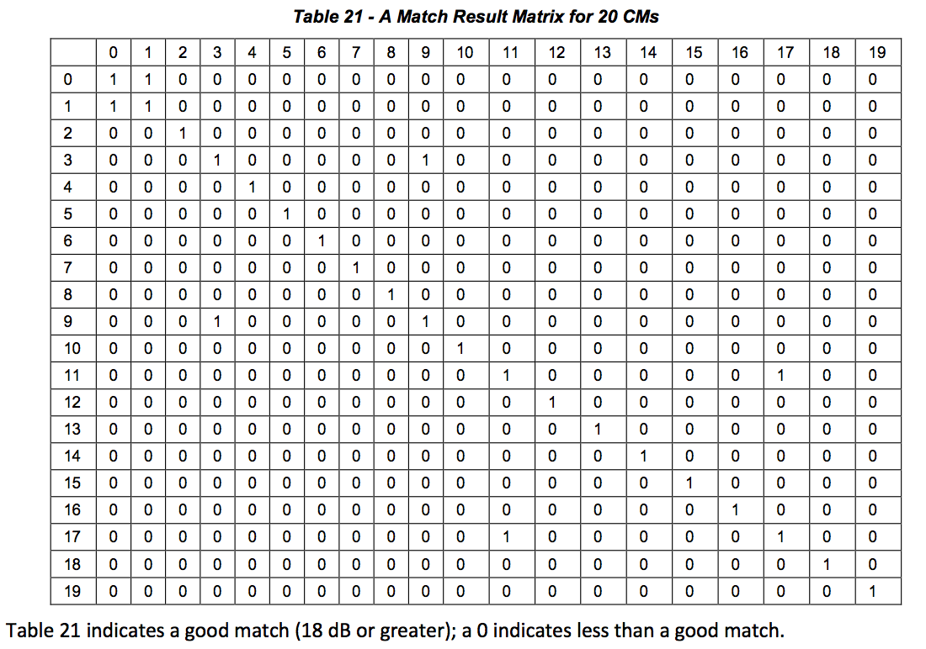

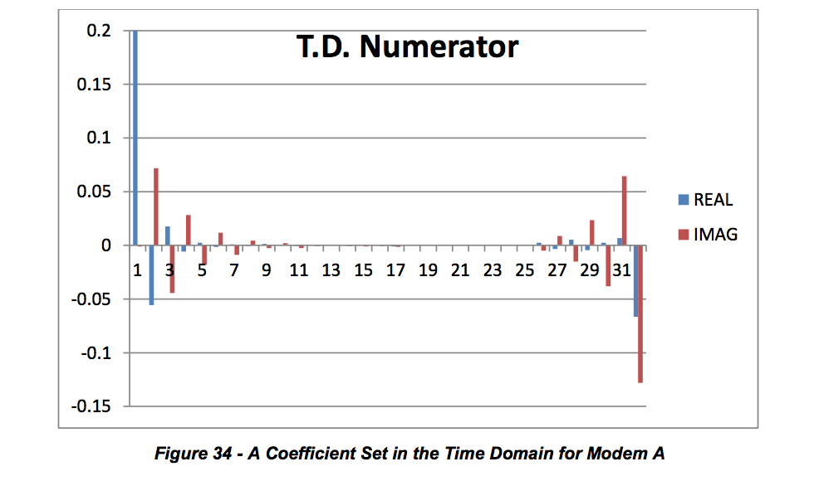

Main tap is 1.0, but vertical axis is clipped at 0.2 to enhance other taps on linear vertical scale. MTR = 15.3 dB

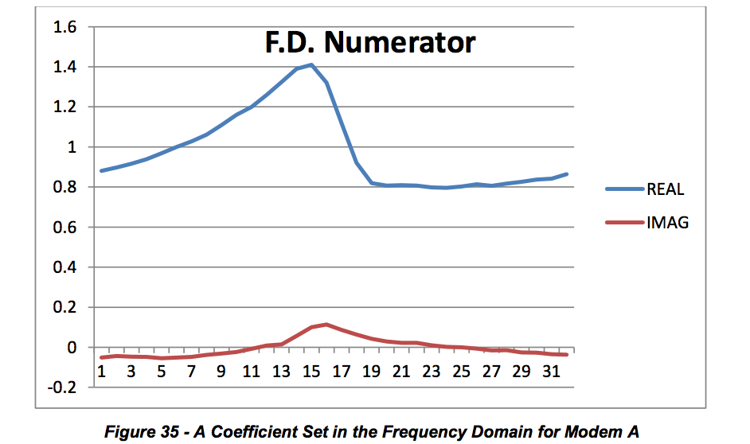

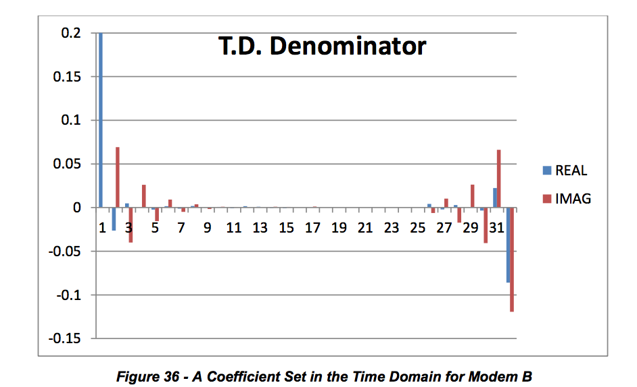

Main tap is 1.0, but vertical axis is clipped at 0.2 to enhance other taps on linear vertical scale. MTR = 14.09 dB

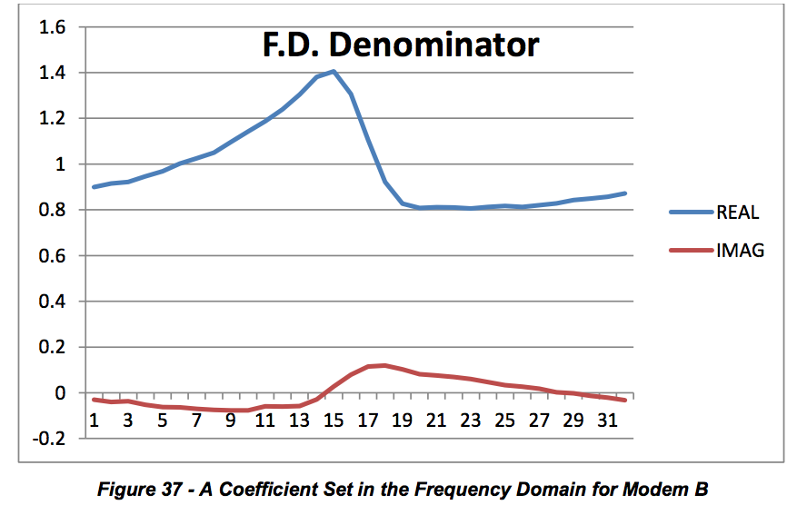

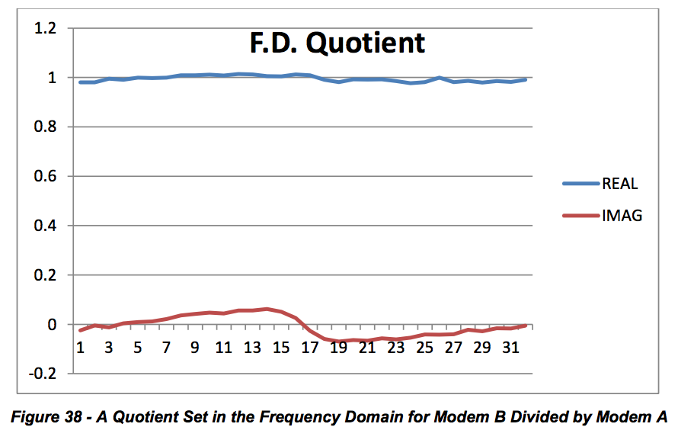

**NOTE:** Because CM A and CM B are experiencing the same echo, the quotient set is relatively flat.

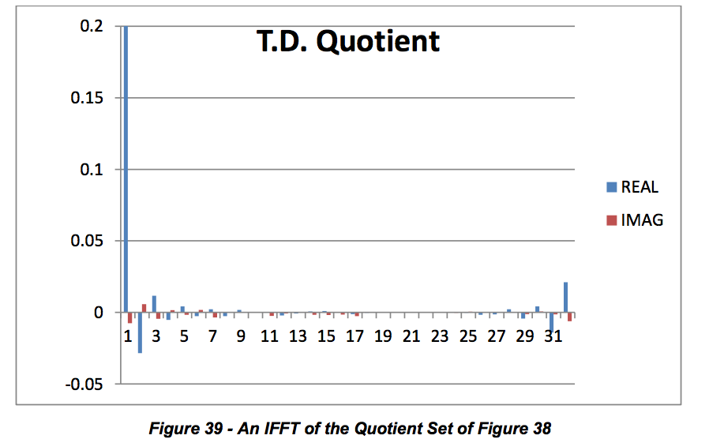

Main tap is 1.0, but vertical axis is clipped at 0.2 to enhance other taps on linear vertical scale. MTR = 27.3 dB, so the match is excellent and both modems are seeing the same echo.

***6.7.6.3 Method 2: Time Domain Subtraction Method to Determine If Two CMs’ Responses Match***

This method is conceptually simpler than the frequency domain division method, but produces similar results.

Take the 24 time domain coefficients from two CMs and normalizing the responses by scaling. For example, if the main tap target is 2048, divide all complex coefficients by 2048 to make a unity (approximately) main tap.

Then perform a complex subtraction of each time domain coefficient. Make one response the subtrahend and the other response the minuend. This will normally cancel the main tap, which must be restored.

Restore the main tap. There are a number of approaches to restore the main tap. A first method is simply to make it 1.0 real and 0.0 imaginary. Another is to use the main tap of the subtrahend or the main tap of the minuend. Another method is to use a conservation of energy approach, and subtract a sum of all other taps energy from unity. This yields a residual energy, and the main tap is the square root of the residual energy, which should be a value just under 1.0.

Compute the MTR of the difference with a restored main tap.

**Use Case Examples for Adaptive Equalizer Coefficients**

The following four listed states describe the condition of the plant and the performance of the measurement devices for different scenarios operators may encounter in the field.

State 1. Adaptive equalizer tool is working properly and plant is within acceptable limits. State 2. Adaptive equalizer tool is working properly, and plant exhibits severe linear distortion.

Plant is stable

Plant is unstable (intermittent or trending) State 3. Adaptive equalizer tool is working properly, but CMTS/CM is reacting badly

Transmission characteristics in channel have resulted in no solution for CM coefficients (e.g., a deep suck-out or echo is too long or too severe)

Upstream impulsive noise is causing wrong or unstable adaption.

CM needs to be replaced State 4. Adaptive equalizer tool is not working correctly because of equipment design or configuration.

CMs are giving wrong MIB data, but working properly. CMs are giving wrong/no MIB data and not working properly. Wrong configuration of CMs or CMTS.

The CMTS is not configured for adaptive pre-equalization in the upstream

CM includes DOCSIS capable devices STBs and MTAs

Distortion red = static or trending or intermittent

**6.8.1 Use Cases**

The following use cases describe how tools are used. Examples are provided in the following subsections.

***6.8.1.1 Use Case 1: In or Near Home Problem Identification***

**Description**

Support User detects possible service problem by monitoring (proactive) or trouble call (reactive). Analysis tool is used to interrogate the customer’s modem and CMTS for performance information. The performance data is analyzed for radio-frequency reflections to determine approximate problem location. Location information is used to instruct Support User or dispatch a repair technician to resolve the problem.

**Level:** User Goal **Primary Actor**

Maintenance User or Support User

**Supporting Actors**

Customer, Repair Technician, Dispatch Personnel, Customer Modem, CMTS

**Stakeholders and Interests**

Customer – may be unaware of service trouble in proactive scenario. Plant Maintenance – non-critical repair may be scheduled during routine maintenance. Billing Personnel – billing system accounts may need to be reconciled.

**Pre-Conditions**

Support User must have specific knowledge of a possible service problem. Customer’s modem must be online. CMTS and customer modem must both support Adaptive Equalization. Analysis tool must be available to the Support User.

User must have sufficient access and knowledge of using the tool and interpreting the data.

Impairments to the customer’s signal must be such that the modem can still respond correctly.

**Post Conditions**

Success end condition

Reactively, the problem was identified and repaired to the satisfaction of the customer. Proactively, the problem was identified and repaired before the customer perceived a problem. Customer’s modem and entire node show improved performance.

Failure end condition

Modem fails to demonstrate any actionable performance metrics. No remediation of problem, customer may experience recurrence or deterioration of service.

**Trigger**

Proactive alert identifies possible service affecting problem OR reactive alert, customer calls with trouble.

**Main Success Scenario**

1. Customer calls with service trouble.

Support User initiates analysis tool, providing customer identification.

Customer identification is used to obtain the modem MAC address and CMTS for the customer.

MAC address is used to query both the modem and CMTS for performance information.

Reference SD-PNM200 for software sequence (Appendix VI).

Performance data is analyzed to obtain reflection information if available, used for distance  calculations.

Support User is presented with customer’s service address and an estimate of problem distance  from home.

Support User evaluates distance information to determine “in or near home” problem, escalates  to Dispatch Personnel.

Dispatch Personnel evaluates trouble call information and approves a repair call.

Repair Technician is provided with analysis and dispatched to the customer premise.

Repair Technician locates trouble and resolves issue.

**Extensions**

4a. in Step 4, the customer information is not located. • Trouble is escalated to billing department for account reconciliation.

4b. in Step 4, the modem or CMTS do not support equalization analysis. • Trouble resolution reverts to conventional process.

5a. in Step 5, analysis data shows no trouble present.

• Customer account is noted for future reference 2. Proactive monitoring is escalated to a higher rate

5b. in Step 5, customer has multiple devices at premises.

1. All devices are analyzed for similar distortion characteristics 1a. multiple devices share distortion - common fault is noted in analysis 1b. Single device demonstrates distortion - scope of analysis is narrowed to “in home”

5c. in Step 5, adjacent homes may also be analyzed

1. All devices within a specified radius are analyzed for similar distortion characteristics 1a. multiple customer devices share distortion - common fault is likely to be at or above the tap. 1b. single customer devices demonstrate distortion - fault is more likely to between the tap and something in the customer’s home.

**Variations**

1a. in Step 1, proactive monitoring may provide use case trigger. 1b. in Step 1, automations such as an interactive telephone system may provide use case trigger. 2a. in Step 2, the Support User role may be implemented as an automated telephone system. 3a. in Step 3, the customer identification may be any one of MAC, telephone number or account number.

**Frequency**

Use case is executed per each trouble call, day of install or subject to the frequency of proactive monitoring.

**Assumptions**

Users of the system must have basic knowledge of troubleshooting cable service problems. Users must have required access and training of the analysis tools. **Special Requirements**All systems must support authentication and encryption pursuant to corporate security standards. **Issues**

Distance calculations are preliminary, subject to market specific conditions and trial findings.

Distance estimates actually describe the distance between two impedance mismatches  (reflectors). In the case of in or near home, the assumption is made that one of the reflections is within the subscriber’s home. This may not always be the case however the majority of the time, this holds correct. There will be some cases where an outside plant issue may be incorrectly characterized as “in or near home” problem.

**To do**

Validate use case in arid climates with less water ingress and corrosion.

Track distance estimates with actual problems found to identify opportunities of improvement in

the distance calculations.

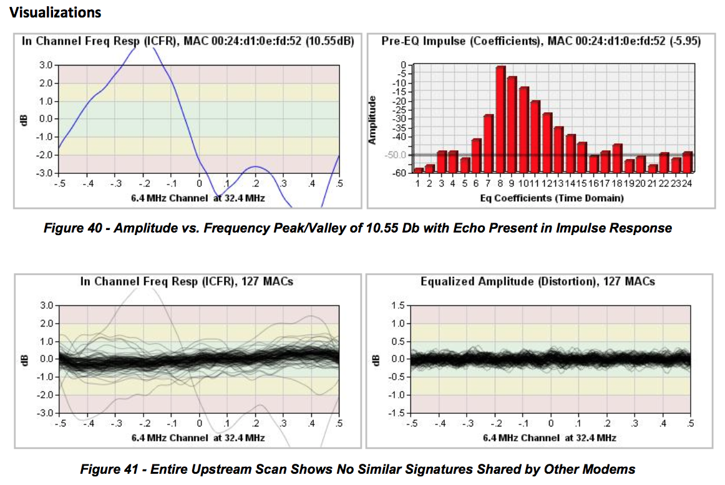

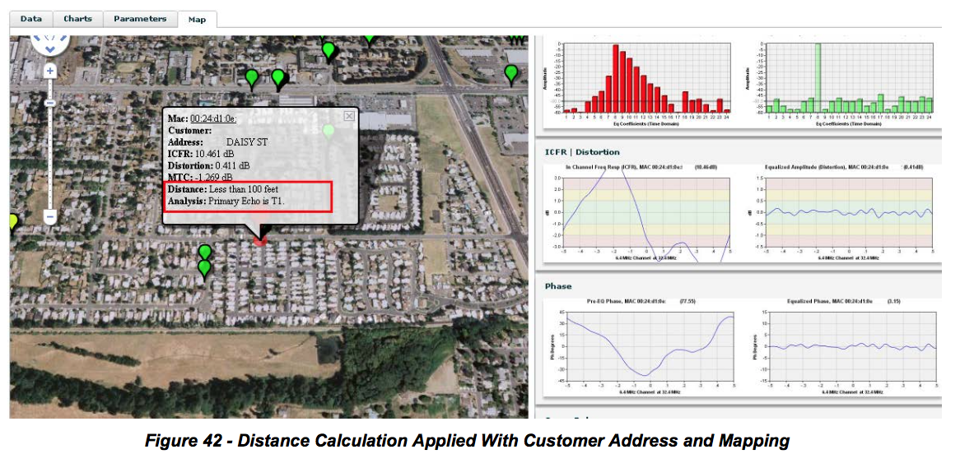

**6.8.2 Use Case: Upstream Ingress or Noise Detection**

**Description**

Support User detects possible service problem by monitoring (proactive) or trouble call (reactive). Analysis tool is used to interrogate the customer’s modem and CMTS for performance information. The performance data is analyzed for additive influence in the modem transmission.

**Level:** User Goal **Primary Actor**

Maintenance User or Support User

**Supporting Actors**

Customer, Repair Technician, Dispatch Personnel, Customer Modem, CMTS

**Stakeholders and Interests**

Customer – may be unaware of service trouble in proactive scenario. Plant Maintenance – non-critical repair may be scheduled during routine maintenance. Billing Personnel – billing system accounts may need to be reconciled.

**Pre-Conditions**

Support User must have specific knowledge of a possible service problem. CMTS and customer modem must both support Adaptive Equalization. Analysis tool must be available to the Support User. Support User must have sufficient access and knowledge of using the tool and interpreting the data.

**Post Conditions**

Success end condition

Reactively, the problem was identified and repaired to the satisfaction of the customer. Proactively, the problem was identified and repaired before the customer perceived a problem. Customer’s modem and entire node show improved performance.

Failure end condition

Intermittent ingress such as impulse may no longer be present. Modem fails to demonstrate any actionable performance metrics. No remediation of problem, customer may experience recurrence or deterioration of service.

**Trigger**

Proactive alert identifies possible service affecting problem OR reactive alert, customer calls with trouble.

**Main Success Scenario**

Customer calls with service trouble.

Support User initiates analysis tool, providing customer identification.

Customer identification is used to obtain the modem MAC address and CMTS for the customer.

MAC address is used to query both the modem and CMTS for performance information.  • Reference SD-PNM200 for software sequence. (Appendix VI)

Performance data is analyzed to obtain the distortion present at the CMTS after equalization.

Support User evaluates performance of all modems on the same node.

Support User determines that only the single customer demonstrates a noisy response.

Customer is asked to tighten connectors and remove extra cable or splitters.

Support User rescans device for performance information and perceives that the problem has been resolved.

Extensions 4a. in Step 4, the customer information is not located.

2. Trouble is escalated to billing department for account reconciliation. 4b. in Step 4, the modem or CMTS do not support equalization analysis.

2. Trouble resolution reverts to conventional process. 5a. in Step 5, analysis data shows no trouble present.

Customer account is noted for future reference

Proactive monitoring is escalated to a higher rate

6a. in Step 6, modems on same node may also be analyzed

2. All devices sharing the common upstream interface are analyzed 1a. multiple customer devices share ingress – one or more points of ingress need to be resolved.

a. Trouble is escalated to Dispatch for maintenance scheduling 1b. single customer device demonstrates noisy response – likely impedance problem caused by

loose, damaged or corroded connectors or cable.

**Variations**

1a. in Step 1, proactive monitoring may provide use case trigger. 1b. in Step 1, automations such as an interactive telephone system may provide use case trigger. 2a. in Step 2, the Support User role may be implemented as an automated telephone system. 3a. in Step 3, the customer identification may be any one of MAC, telephone number or account number. **Frequency**

Use case is executed per each trouble call, day of install or subject to the frequency of proactive monitoring.

**Assumptions**

Users of the system must have basic knowledge of troubleshooting cable service problems. Users must have required access and training of the analysis tools. **Special Requirements**All systems must support authentication and encryption pursuant to corporate security standards. **Issues**

3. Magnitude of equalized response ripples from the CMTS need to be correlated to concrete BER / MER values. Pending lab work.

**To do**

3. Better correlate the perception of “noise” with unstable equalizer operation. This is reproducible with corrosion.

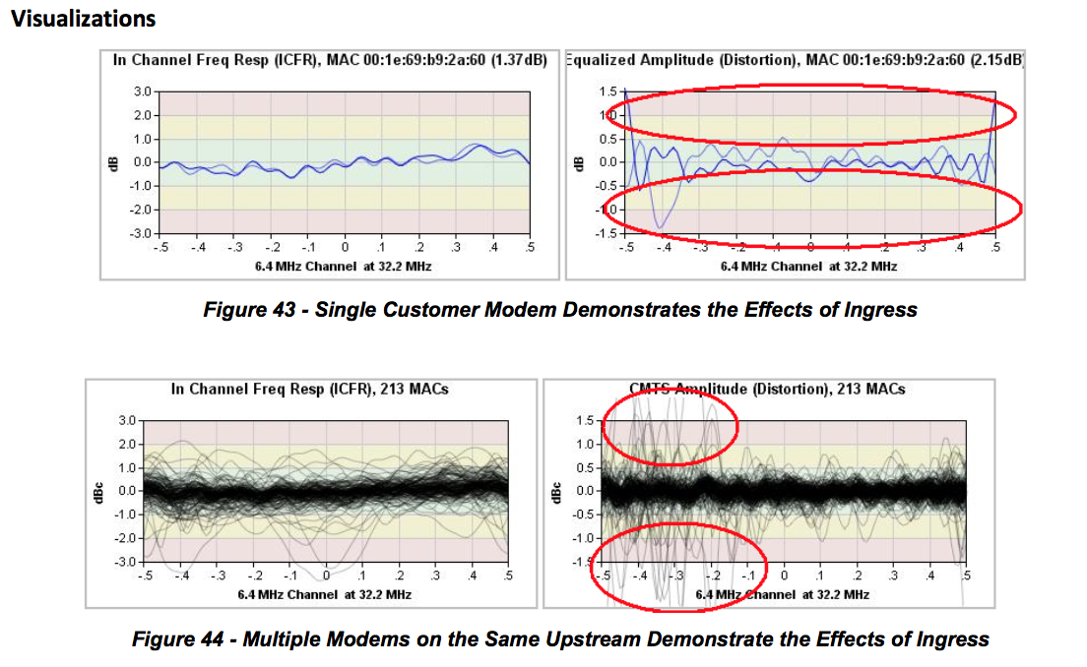

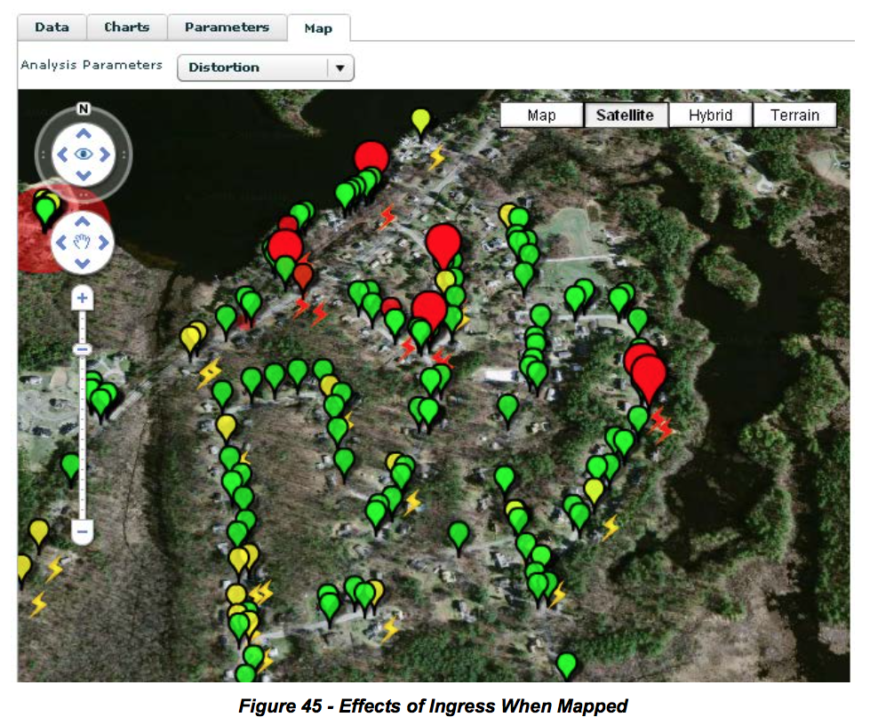

**6.8.3 Use Cases 3-11**

***Figure 45 - Effects of Ingress When Mapped***

Plant technician trying to solve a frequency response problem with the upstream or augment system upstream sweeping. State 2.  Actors: Technician, NOC  External Event: Distortion red, other indicators yellow/green or plant sweep shows problem/anomaly  Proactive/High distortion detected Group of CMs Expected Outcome: Distortion removed

Tech Supervisor: To deploy technicians. Verify technicians got the upstream frequency response issues resolved. State 2 becoming State 1.  Actors: Tech Supervisor, Technician External Event: Close out trouble ticket Reactive and Proactive

Group of CMs

Expected Outcome: Resolved Issue (non-main adaptive equalizer tap or coefficient energy reduced)

CMTS having issues due to equalization. Unable to compensate for channel. Micro-reflection too long or no inverse solution, e.g., notch in channel. Upstream burst noise interfering with the correct ranging of CMs’ coefficients. State 3.  Actors: Technician, NOC, CSR, HE Tech External Event: Distortion red, other indicators yellow or red Reactive/High distortion detected Group of CMs Expected Outcome: Fix cause of impairment

QA for accessing a node health score. Goes along with upstream MER (on a per CMTS port or per CM basis). States 1 and 2.  Actors: Technician, NOC (QA) External Event: Periodic scan and alarms - Distortion red, other indicators red/yellow/green Reactive and Proactive/High distortion detected Group of CMs Expected Outcome: Distortion removed

Identification or location of faults. Combine location technique with GPS data or plant connectivity data. Accurate micro-reflection time delay is important. Condition 2. (Subset)

Qualifying an upstream for a wider channel RF bandwidth or higher order modulation. Qualification can also be done to verify a service level agreement (SLA). States 1 and 2.  Actors: Initially NOC, then technicians External Event: Distortion red, other indicators yellow/green Use higher order modulation and wide bandwidth channel as reference Generally Proactive/High distortion detected Group of CMs Expected Outcome: Node qualified

9 CSR quick check. See if something abnormal is going on, and if the neighbors have the same problem. All Conditions

Actors: CSR, Technician External Event: Customer complaint Reactive/High distortion detected 1 device possible others Expected Outcome: Trouble ticket or no distortion problem, service call avoided

Trend and Intermittent Issues Tracking. State 1 becoming State 2 Actors: NOC  External Event: Distortion turning red within predetermined period, significant delta distortion within short time period, other indicators yellow/green  Proactive/Change in distortion detected Group of CMs Expected Outcome: Problem identified and located, trouble ticket generated

Resolving flapping problems and unstable equalization solutions. State 3 or State 4. Actors: NOC  External Event: CMTS not compensating or improperly compensating for distortion, high uncorrectable FEC statistics, high impulse noise scenario  Reactive/CMTS change in distortion detected Group of CMs (if distortion generated), all CMs in node (if impulse generated) Expected Outcome: Problem identified, located and resolved

**6.9 Post-equalization**

As its name indicates, post-equalization is the process of distortion compensation after the signal has been received. In the cable environment, post-equalization has been used mostly in the downstream direction where a CPE device always receives a continuous signal coming from one location, usually the headend. That fixed location signal source simplified downstream distortion compensation implementation using adaptive equalization at the receiver. In the upstream direction the upstream signals come from multiple sources. Transmission is bursty and one burst may have suffered a different distortion from the next because the upstream paths traversed may be different. A post-equalization approach would require the receiver to compensate for distortion on a per burst basis. Early in DOCSIS, it was deemed that a post- equalization approach would be a significant processing burden on the CMTS, which led to the implementation of the upstream pre-equalization approach covered in this document. Processing capabilities improvements have enabled the implementation of per burst equalization which is now common in CMTSs. The advantages and disadvantages of pre- versus post-equalization are discussed next.

**6.9.1 Advantages of Pre-equalization**

Reliable diagnostic transmission analysis is enabled by the regular complex coefficient updates the CMTS equalizer provides to individual cable modems when adaptive pre-equalization is enabled. The repeated convolution of coefficients effectively generates a time averaged response of the upstream channel, which leads to the following advantages:

Reasonably stable per modem equalized MER as reported by either the CMTS or SNMP Polling

Ability to view all of the linear transmission path characteristics unique to the individual cable modem due to the complex coefficient impulse response reported via SNMP MIB query. From the SNMP MIB query one can also compute the effective unequalized MER in addition to amplitude and group delay characteristics, as well as enable analysis of micro-reflection conditions for any given cable modem.

Superior equalized MER capability compared to that provided by post-equalization when the channel is at the upper edge of the return path spectrum. The superiority is also a function of the depth of the return path amplifier cascade

Another advantage of pre-equalization over post-equalization is that throughput is somewhat higher when pre-equalization is used because there is no need to equalize the data transmission burst. This is related to the difference in the length of the data burst preamble.

Pre-equalization is beneficial to virtually all DOCSIS 2.0 and DOCSIS 3.0 services. In some cases there would appear to be some instability or inconsistency in the metrics being reported when using pre-equalization. Some causes for such behavior are discussed next.

**6.9.2 Disadvantages of Pre-equalization**

Pre-equalization disadvantages are worth mentioning although they can be considered minor compared to the advantages.

**Memory**

Operation of pre-equalization has memory associated with the function, and that memory lives in the convolution of the equalizer updates in the cable modem. As stated previously there are many benefits to having this function exist in the cable modem, but there are a few deficiencies as well.

For example, if there is suddenly a major impulse noise event or a change in ingress characteristics during a station maintenance transmission, when the CMTS is assessing the equalized impulse response update to send back to any given modem, there is the possibility that the station maintenance will be corrupted. That would cause the CMTS equalized impulse update to become corrupted, and the corrupted update would be transmitted to the cable modem. The cable modem will convolve the corrupted update, so now that particular cable modem’s equalized impulse response will no longer be valid for a period of time.

One weakness of pre-equalization is that the CMTS must be assumed to be responsible as the final arbiter as to which equalized updates are sent and which updates are potentially corrupted, and compensate for those differences in one manner or another. There are indeed many options available to the CMTS to deal with equalizer corruptions, but that topic is beyond the scope of this document.

**CM TX Level Increased**

One unfortunate but direct consequence of the transmit pre-equalization process occurs when there is significant amplitude roll-off present on a given channel such as at the very end of the cascade, and on the highest available carrier frequency. A primary function of pre-equalization is to eliminate the post equalization noise enhancement that occurs when raising the signal power over a specific portion of the spectrum and thereby raising the flat noise floor of the receiver right along with it.

Equalizer noise enhancement elimination is the single biggest improvement that pre-equalization provides over post-equalization, especially when operating near the upper band edge. Transmit pre-equalization eliminates post-equalization noise enhancement by hitting the receiver with an ideally flat spectrum. This happens even as the equalization process compensates for other impairments such as group delay distortion.

The very act of updating the cable modem to increase the transmit power in the heavily attenuated or rolloff portion of the spectrum at the expense of lowering the power in the less attenuated portion of the spectrum eventually ends up with a perfectly flat response at the input to the CMTS receiver. The final amount the cable modem may be instructed to increase the transmit level over the original non pre- equalized transmit signal power is a function of how much amplitude roll off exists on the channel.

If there is sufficient headroom for the cable modem to increase its upstream transmit level, then there is no penalty for the significantly improved performance. If the cable modem does not have sufficient margin to increase its transmit level to the correct amount then the CMTS will only allow as much low input signal level to exist as was defined in the CMTS’s operating configuration.

**6.9.3 Advantages of Post-equalization**

The following summarizes some of the benefits of post-equalization.

**No Memory**

Since post-equalization operation starts off every new data burst from scratch, there are no pre-stored conditions required. As such, there is no memory condition to become corrupted from any given error condition.

In other words, while any given post-equalized burst can be corrupted, all that is lost during that corruption period is that particular burst, and not, say, multiple bursts until a station maintenance can correct the corrupted update from the CMTS.

Because the post-equalization process possesses no memory in the operation, one might argue that the post-equalization mode of operation is potentially more stable, or the simplicity of the post-equalization process results in a more stable performance loop over all. This is particularly true in the below 20 MHz frequency range where both ingress and impulse noise are common.

**Lower Cable Modem Transmit Levels**

At the upper end of the return path spectrum there is generally no mechanism that will result in the post- equalization process requesting more cable modem transmit level, at least as a result of the equalization process itself. This is because the post-equalization process requires absolutely no cooperation on behalf of the cable modem. That is, there is no pre-equalization function being convolved in the cable modem for post-equalization to work.

A reasonably strong case can be argued for using post-equalization only when in TDMA or A-TDMA mode below 30 MHz, and definitely below 20 MHz.

**6.9.4 Disadvantages of Post-equalization**

The following summarizes several disadvantages of post-equalization.

Lower throughput than pre-equalization operation due to longer data preamble – the throughput loss is mostly a small amount compared to FEC correction capabilities variations, but nonetheless it is measurable.

Poorer equalized MER performance compared to pre-equalization because of the convergence time required, versus a data preamble length most operators would be willing to suffer with to attain better equalized MER performance per burst. Also, given the possibility of multiple impairments being present during any given data burst, there can be a significant variation regarding the equalized MER estimate from burst to burst.

Vastly poorer micro-reflection analysis capabilities in part because of convergence time and in part because of any impairment present during the data burst.

Equalizer noise enhancement phenomena are unavoidable at the diplex filter band-edge, and the phenomena become increasingly worse as the amplifier cascade increases. In other words, in an N + 1 or perhaps even up to an N + 3 cascade depth, the equalizer noise enhancement penalty is perhaps a minor point that could be forgotten. However, as the cascade depth increases to N + 6 or higher, the

equalizer noise enhancement penalty becomes more significant to the point that the post-equalization mode of operation total available or usable bandwidth on a given return path becomes much less than when using pre-equalization.

• Generally speaking, much poorer estimate for both amplitude roll-off and group delay distortion when attempting to extract the information from a single equalized data burst for any given cable modem.

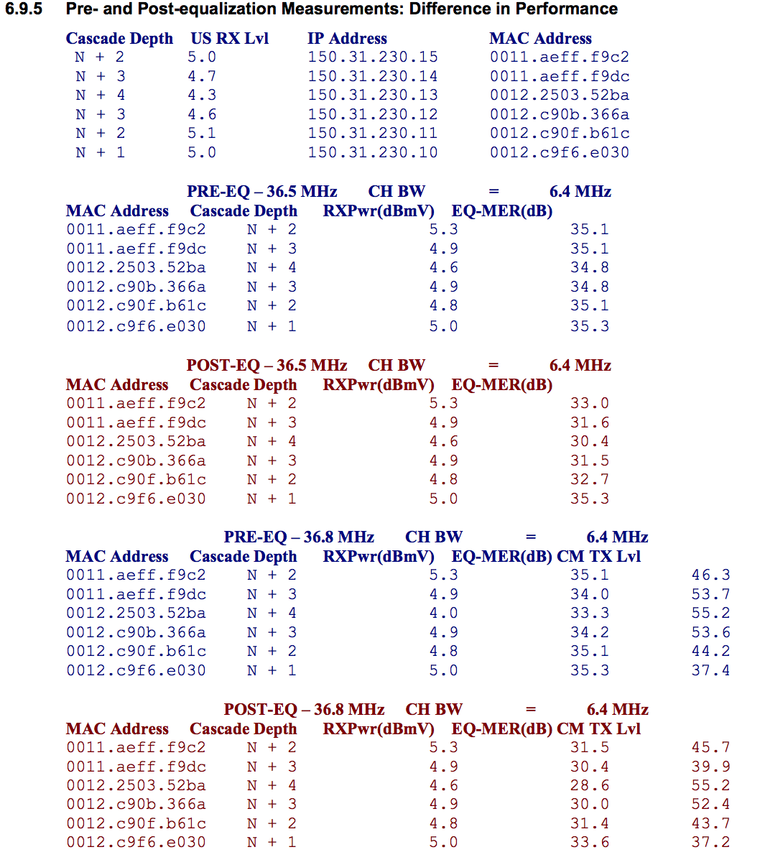

**7 PNM USING FULL BAND CAPTURE**

**7.1 Technical Description of Process**

This section focuses on downstream FBC.

Spectrum analyzers are specialized instruments that provide a graphical display of amplitude versus frequency. Figure 46 shows a typical spectrum analyzer display.

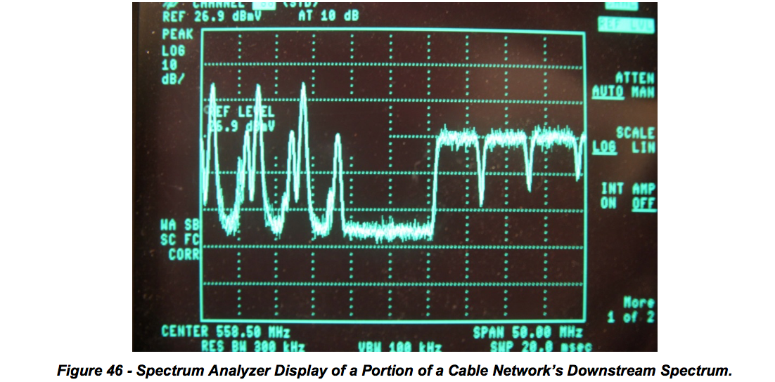

Spectrum analyzers have been used by cable operators for decades for routine maintenance and troubleshooting. However, spectrum analyzers are expensive instruments, so they have not typically been widely available to field personnel. Technicians could only imagine having a spectrum analyzer in every home.

FBC is a relatively new concept that takes advantage of low-cost discrete Fourier transform (DFT) and fast Fourier transform (FFT) technology to support spectrum analyzer-like functionality in customer premises equipment such as cable modems.

Integrated spectrum analyzer-like functionality is supported by the latest Broadcom and MaxLinear CPE silicon. The CPE’s spectrum data can be accessed remotely using simple network management protocol (SNMP) or similar, allowing a cable operator to see where ingress or other impairments might be problematic. Figure 47 shows an example of FBC, in which FM and LTE ingress are visible.

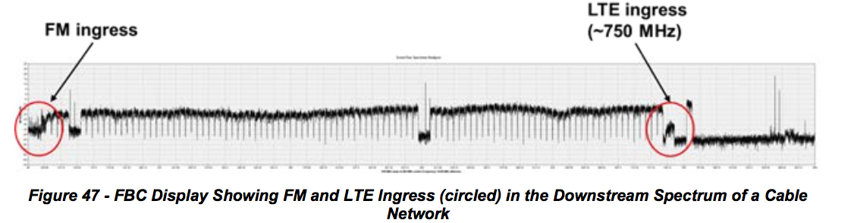

**7.1.1 What Does FBC Do For Operators?**

FBC can be used to remotely troubleshoot a variety of headend, outside plant, and subscriber drop problems. Since the spectrum analyzer-like functionality is integrated in the cable modem or other device, it’s much like having a spectrum analyzer in every home that has FBC-equipped CPE. Figure 48 shows examples of impairments that can be identified using FBC.

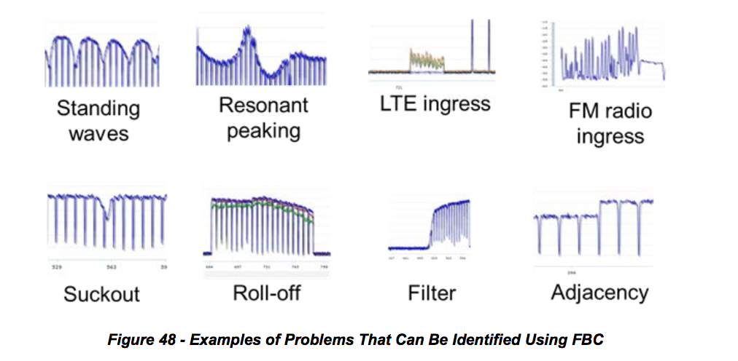

Problems can be identified by evaluating the RF spectrum *without rolling a truck*. If a sufficient number of FBC-equipped devices are available in subscribers’ homes, it may be possible to determine the approximate location of the source of a given impairment. A technician can be dispatched directly to the suspected problem area, simplifying troubleshooting and saving time.

**7.1.2 How FBC Works**

As mentioned previously, a spectrum analyzer is a device which measures the frequency content of an input signal. Fortunately, this is precisely what DFT does. Multiplying by the DFT matrix measures the correlation of the input signal with each row in the DFT matrix, and each row is a sine/cosine of a particular frequency. Thus, each output bin represents the power of the input signal at that frequency.

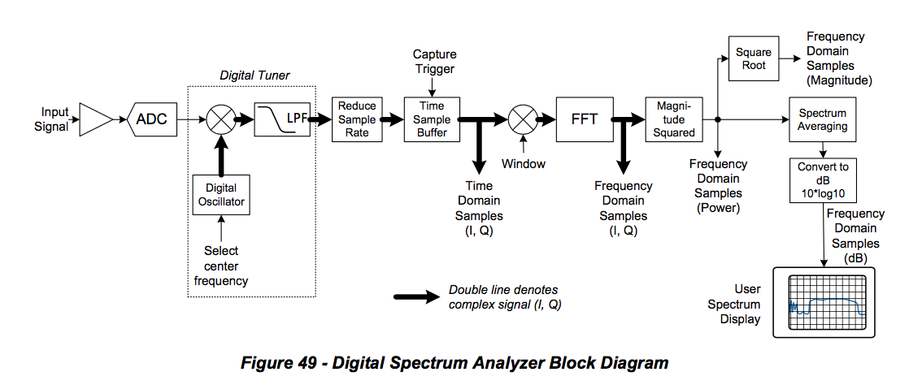

Figure 49 shows a block diagram of a digital spectrum analyzer which may reside in a cable modem or CMTS. The input signal enters at the left of the diagram; this signal is the full upstream or downstream band of the cable plant. An analog front end amplifies the signal and provides RF gain control. A high- speed analog-to-digital converter (ADC), typically 2.5 giga-samples per second (Gsps) or higher, provides digital samples of the signal. A digital tuner, consisting of a digital oscillator and lowpass filter, selects the desired analysis band around a specified center frequency. The signal from the selected band is applied to the FFT, which multiplies the signal by the DFT matrix. Each bin of the FFT output comprises a complex value consisting of two numbers, real (I) and imaginary (Q), giving the correlation of the input signal with the particular frequency corresponding to a single row of the DFT matrix. Typically a spectrum analyzer is only concerned with the magnitude, not the phase, of the FFT output. So, the power (magnitude-squared) of each bin is computed, that is, I2 + Q2 for each bin. If spectrum smoothing is to be applied, the previously-described process is repeated with a fresh set of data from the same band, and the power values from several captures are averaged at each bin location. The smoothed bins are converted to decibels by taking 10*log10 of each bin power value. These decibel values, one for each frequency bin, are displayed as the spectrum of the input signal.

Note that if the entire band is able to be processed as a single analysis band, the tuner shown in Figure 49 is not necessary. However, if the band is being analyzed in segments, then the tuner is used to step through a sequence of analysis segments of the band, and the individual spectrum segments are spliced together to produce the overall wideband spectrum.

**7.2 Field examples and screen shots**

This section includes several examples of FBC screen shots as “seen” at the cable modem. The horizontal axis in each figure is frequency in MHz, and the vertical axis is in dB. Images are courtesy of Comcast.

**7.2.1 Ingress**

Technicians can look at a captured spectrum display for indications of the presence of downstream ingress (and in some cases, direct pickup). If a sufficient number of FBC capable devices are available, it may be possible to roughly isolate the area of plant where the ingress is entering the network. Figure 50 shows an example of visible ingress in the FM band (left edge of figure) as well as in the LTE band (near the right end of the figure).

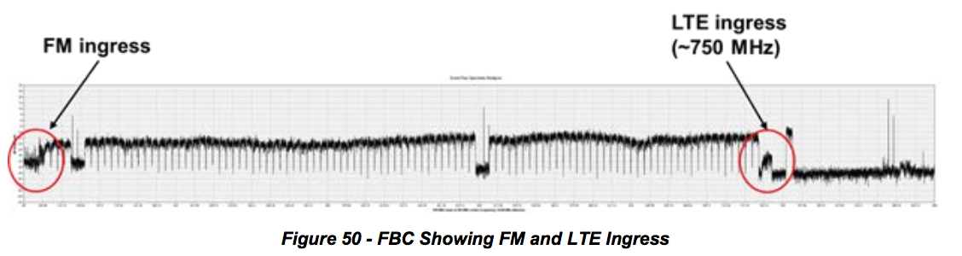

**7.2.2 Multiple problems**

Figure 51 shows a FBC from one modem, in which multiple downstream impairments can be seen

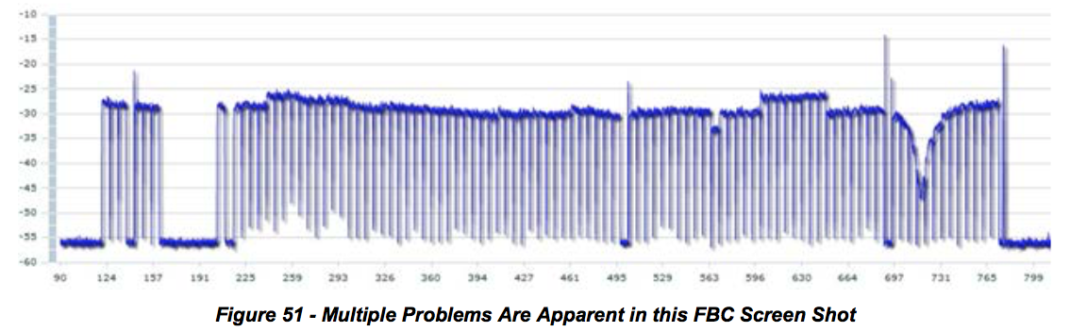

The most serious problem is the suckout (notch) visible between 697 MHz and 731 MHz. The suckout, which is about 18 dB deep, affects a half dozen QAM channels. Another problem evident in the display is called adjacency, where a group of eight channels in the roughly 600 MHz to 650 MHz range are several dB higher than other channels in that part of the spectrum, likely caused by incorrect narrowcast injection levels. A third problem is a QAM channel near 563 MHz that is a few dB lower than the adjacent channels. A fourth problem also is level-related, in the vicinity of 250 MHz.

**7.2.3 Displaying Multiple Modems**

It is possible to simultaneously display an overlay of spectrum data from multiple cable modems – say, modems in the same neighborhood. Figure 52 illustrates this.

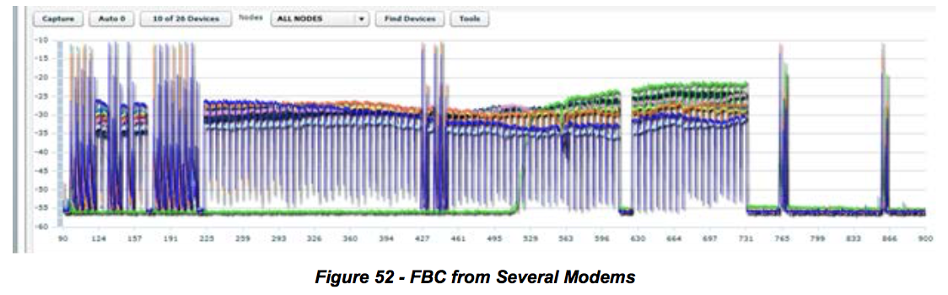

Standing waves, also known as amplitude ripple, are caused by impedance mismatches in the RF signal path. Standing waves are usually easy to see in a FBC display. Figure 53 shows several examples of standing waves. Of particular interest is the combination of two standing waves in the lower right screen shot.

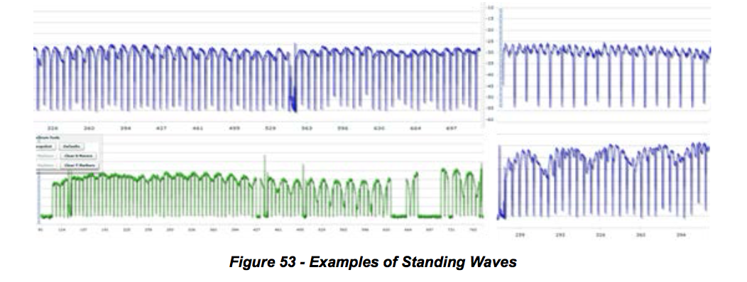

**7.2.4 Presence of filters**

Figure 54 includes two examples where filters are present in subscriber drops. The upper trace in the figure shows the effects of a bandstop filter (an adjacency problem is visible at two locations in the

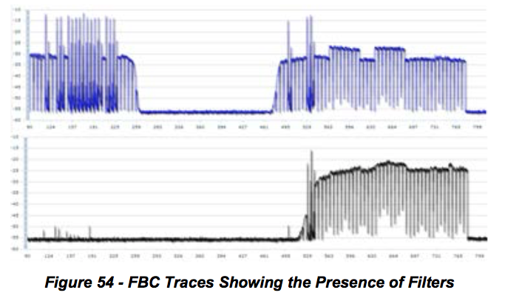

**7.2.5 Rolloff**

Rolloff is a non-flat loss of signal level-versus-frequency at or near the lower or upper end of the RF spectrum. When rolloff occurs at the upper end of the downstream spectrum, the cause can be active device misalignment, active or passive device damage, presence of older cable or equipment in the network designed for a lower upper frequency limit than the network’s existing operating frequency range, and so on. Figure 55 shows examples of rolloff at the upper end of the downstream spectrum.

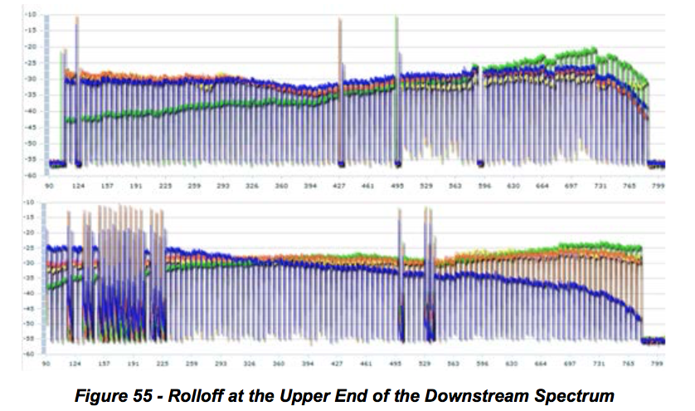

**7.2.6 Tilt**

***Figure 55 - Rolloff at the Upper End of the Downstream Spectrum***

Tilt describes the condition where signal levels vary from low to high in a more or less linear manner as frequency increases (positive tilt), or from high to low in a linear manner as frequency increases (negative tilt). Depending on the location in the plant, tilt may be desirable – for example, at the output of an amplifier. Ideally the frequency response at the input to CPE should be flat, but in some cases the response may be tilted excessively for a variety of reasons. Figure 56 shows examples of negative and positive tilt.

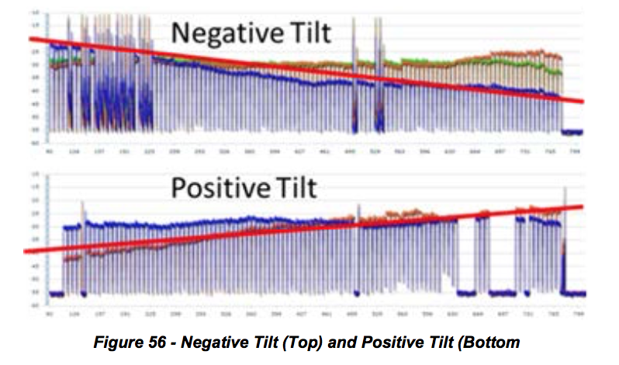

**7.2.7 Resonant Peaking**

Resonant peaking affects a relatively narrow frequency range, typically no more than a handful of channels. The peaking can exist anywhere in the spectrum, and typically occurs in an active or passive device. Vibration and temperature changes may affect the nature of the peak: The response peak can be intermittent, change in level and/or shape, and move around in frequency. Examples of causes include defective components, cold solder joints, loose modules (or module covers), loose or missing screws, and so forth. Figure 57 highlights examples of resonant peaking.

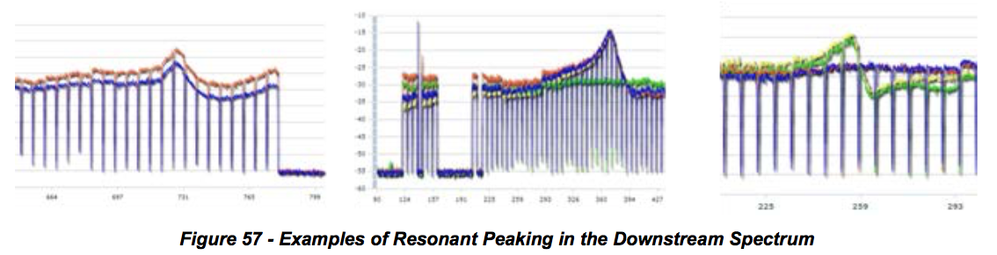

**7.2.8 Making It Work**

***7.2.8.1 How to Capture Data from Devices Equipped with FBC Functionality***

*7.2.8.1.1 Design Considerations*

Capturing spectrum information requires SNMP read/write access to the cable modems, which generally are on RFC 1918 address space. This means that direct access from a workstation is unlikely. In general, implementations will consist of a server (or servers) that has access to the non-routable IP addresses used by the modems, and has an external IP address or a static network address translation (NAT) that allows external clients access to it so that the server can make the SNMP requests on behalf of the clients. The clients could be web based, mobile, or desktop software. An operator likely will already have one or more OSS servers that fits these requirements, but the existing servers may or may not have sufficient capacity for the additional load. Additionally, the implementation of FBC will be done for a somewhat different operational group – and in many cases a different department -– than the primary OSS users, since field technicians are going to be much more likely to use this data than some of the other normal OSS tools. A good exercise is taking a look at how field technicians currently use their hand held meters, as well as thinking about other uses for a remote spectrum display that aren't practical today.

There are several considerations that development teams need to understand before getting started. Security is a large issue for this kind of system, because it is necessary to perform SNMP SET operations to enable the capture, and have access to parts of the network that aren't normally reachable. Some sort of server side authentication system should be used to ensure that only authorized users can access and use the server. In some cases the FBC requests will be coming from devices over untrusted networks, such as field technicians using tablets or smart phones. This could be resolved by requiring virtual private network (VPN) connections before allowing usage, or with strong authentication coupled with transport layer security (TLS) or other encryption. Locking and session management are also needed, because having multiple users trying to perform a capture on the same device can cause issues for that device. Other multiple user issues could occur if the device changes frequency or some other variable in response to one user while another is trying to interpret results for a different setting. An important consideration is how to deal with the data. In general, a maximum granularity capture across the widest window will generate a 10-20 kbps stream of data. By itself this isn't a large data stream, but it does mean that it's not practical for most organizations to collect this data for all modems and then store the information in a database for analysis the way that is typically done for OSS functions. If a user is only going to work on a real time display then this consideration isn't particularly problematic, but if the data is for proactive analytics then it's a large challenge.

**7.3 Method to Find a Time Response from an IFFT when Phase Data is Not Available**

The FBC is used by cable modems and set-top boxes to provide magnitude-only spectral data about RF path conditions in a remote location, such as a home. In some cases, the downstream channels being monitored are digital channels, such as 64- or 256-QAM. In other cases the signals are analog signals or noise and ingress.

This method applies to blocks of QAM signals to identify the existence of an echo tunnel that causes ripple in the frequency response. See `

**7.3.1 Method:**

Pick a block of averaged (smoothed) contiguous digital signals, as many as possible. For example, each 7.5 MHz block of frequency domain data may have 256 spectral components, and multiple blocks are pasted together to make a wide spectral response.

Extract samples from the lower band edge of the lowest QAM signal to the upper band edge of the highest QAM signal, and convert the values into linear values. Use these values as I (in-phase) components.

Use zeroes for all Q (quadrature) values.

If necessary zero-pad the values to fill out a 2^n IFFT transform, such as 16,384 or 4096.

Optionally, a window should be applied to the data.

A frequency region with another signal, such as an analog RF carrier, or vacant band can be filled  in with a straight line connecting the channel just above the vacant band to the channel just below  the vacant band.

Perform an IFFT to put the data into the time domain.

Transformed data will be symmetrical due to not providing quadrature values. You can discard the  image.

A DC term will be present. Comb teeth will be present every 166.67 ns due to the notch between 6  MHz channels.

If there is an echo in the frequency response, there will be a ripple in the frequency domain. The  ripple will linearly transform to an impulse located among the comb teeth. If the echo is an exact multiple of 166.67 ns, it cannot as easily be observed. The delay between the main impulse and echo is the round trip time of an echo tunnel, corrected for velocity of prorogation velocity of cable. Since you know the shape of the teeth on the comb, they can be removed by subtraction.

This method is valuable because the wide bandwidth of the multiple QAM signals makes for exceedingly accurate time resolution, so the cable operator makes a hole to repair a buried cable, not a trench.

Another anticipated method to remove effect of the notches between carriers is to interpolate over the notches. Yet another method to reduce the effect of the notches is to equalize the magnitude response, but equalization cannot go all the way to zero due to negligible energy in the notch.

This method could also work with analog spectrum analyzers, for example, using GPIB or other interface technology supported by the analyzer to extract the magnitude data.

Note that it should not work to detect group delay problems, since there is no phase information available.

The code to do this is in the CableLabs Spectrum Impairment Detector (SID) which is in the PNM repository.

